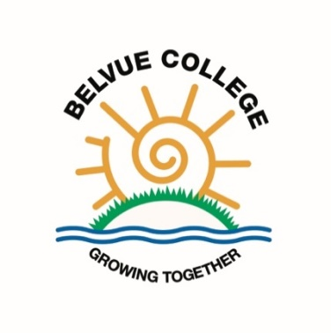

Belvue College Bank and Shop

In 2018/18 the Belvue College Bank was introduced as a way of developing our very successful house point system. House points are awarded for hard work in a particular lesson and for 100% attendance for a whole week. In the old system students received £5 for reaching 75 house points and £10 for reaching 100. This was a big incentive for some of our students, but for others the time needed to achieve this meant that it seemed unattainable.
This system was changed and now each single house point is worth 10p. Students start the year with £1 in their account and then ‘earn’ more money as their house points build up. If students save their money for the whole year they get £1 interest added to their account and can then withdraw the money. We have a KS5 student who works as the banker and collects diaries in and regularly records the amounts earned by each student. Students receive statements in their diary to let them know how much they have earned and how much they have spent.
Students also have the option to spend the money they have earned in the Belvue College Shop. This shop sells items from 50p (5 house points) all the way up to £3. The majority of items are £1. They can either buy cheaper items straight away or save up for a bigger item later. This helps to teach them that if they work hard they will earn money and then they will be able to decide if they want to save their money, spend some of it or spend all of it.
The College council state that students are pleased with the bank and enjoy knowing that they are earning money. Items suggested by students to be sold in the shop are: deodorant, shower caps, sunglasses, perfume, books, pens, etc.

