The Development of Music at Belvue High School

BRIEF DESCRIPTION OF THE PROJECT:

Over the last three years, the Music Department at Belvue High School has received a considerable amount of investment both in terms of financial input and in the form of input from new teachers and outside agencies resulting in a dramatic increase in the number of musical opportunities open to students.

We are all familiar with the notion that music can help students to increase their attainment in subjects like maths. In fact, current reviews of research suggest that while the correlation between good music teaching and spatial reasoning is very strong, evidence for music developing other areas of mathematical ability is mixed.

The strongest evidence seems to suggest the benefits of regular high quality musical experiences for low ability or disaffected students. Music provides opportunities for social bonding, inclusion and affiliation. This seems to affect aspirations which in turn enhance motivation and subsequently attainment. It has also been found to support the development of resilience, negotiation skills and trust in Looked After Children. Evidence has also suggested that high quality musical experiences may help with the development of self-regulation skills which may have implications for students with more complex severe learning difficulties or those with sensory regulatory difficulties. The importance of performances opportunities is deemed to be crucial in providing students with positive feedback and benefits that arise from this (‘The Power of Music: A Research Synthesis’ 2015, Susan Hallam, Institute of Education).

In order for our students to access these benefits the music department implemented the following actions:
- Investment in resources e.g. full size djembe drums, electric and acoustic drum kits, new keyboards and digital piano, bass guitars, a range of music technology equipment including software, switches, microphones, etc.

- Collaboration with Drake Music as part of the Exchanging Notes initiative (Birmingham University): music technology support in lessons with aim of equipping teachers with the necessary skills once the project has ended. and one to one tuition for 7 students over the course of 4 years.
- Collaboration with Drake Music as part of the Exchanging Notes initiative (Birmingham University): one to one tuition for 7 students over the course of 4 years every Wednesday. There also ‘Ensemble Days’ for these students to come together and perform as a group.
- Continuing Professional Development for the music teacher including one-to-one tailored tuition.
- Establishment of the school choir who rehearse once every week and perform in assemblies and in the community.
- Cabaret performances: the introduction of the ‘Cabaret Room’ as part of the Summer School Show where students can perform stripped back intimate performances of their favourite songs as solos or duets.
- Monday Morning Musical Assemblies: every Monday morning a small selection of students perform solos or duets in assemblies.
- The School Band: an interchangeable band of different members who perform independently of staff support using keyboards, iPads, vocals, bass guitar and drums. Performances have included ‘Hey Jude’ by the Beatles, ‘Waterloo’ by Abba and ‘Rise Like a Phoenix’ by Conchita Wurst.

THE GOOD PRACTICE IN DETAIL (how it improved outcomes for pupils)

Our collaboration with Drake Music has enabled us to work together by combining our knowledge of special educational needs with their expertise in wider music making and music technology. We are continually developing how we can fully exploit music software including ‘Ableton Live’ and range of iPad applications and an array of hardware including Sound Beam technology with adaptive switches and microphones to create accessible instruments. This has enabled us to start to overcome some of the difficulties students can face when performing as part of an ensemble. The very precious and valuable weekly one-to-one sessions that Drake Music have been able to offer 7 of our students with a keen interest in music seems to have contributed to some of the benefits highlighted in afore-mentioned research. The sessions are student led and are a consistent and reliable feature of their timetable week on week, providing ‘quality time’ and the chance to demonstrate control in their own learning.

The Drake music Ensemble Days provide a platform for the like-minded young musicians in the project to come together and practise negotiation skills and team playing as well as fostering the foundations for positive relationships outside of musical activities.

Similarly the school choir provides an opportunity for singers of all abilities to come together in a supportive and positive environment offering similar benefits to the Vertical Tutoring system. It is also an opportunity for students who prefer to stay out of the spot-light to sing and enjoy group music-making.
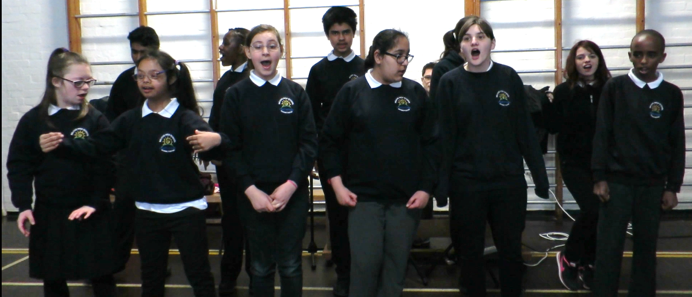

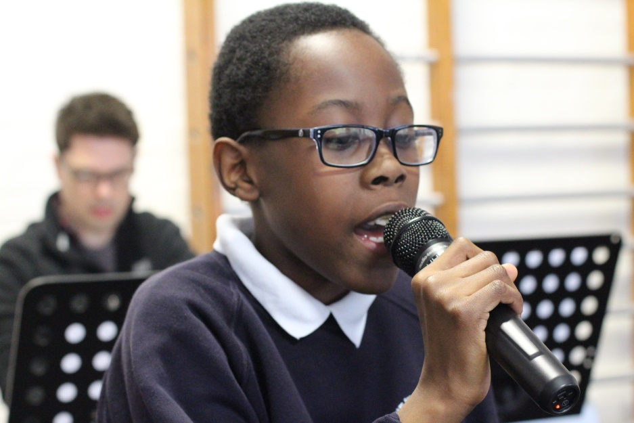
The weekly Monday Morning Musical Assemblies offer students the chance to volunteer themselves but also give a platform for students we feel would benefit from the experience of performing a solo or duet in front of the school. The songs are selected in collaboration with the students giving them control and ownership of their performance. They are also given one-to-one rehearsal times during lunchtimes to help develop their confidence and prepare themselves for their performances. As well as the immense positive feedback they get from their peers after their performances they also benefit from the special attention they receive in preparation (including being featured on posters around the school the previous week), helping them to feel noticed and valued.

The School Band offers students with particular skills in singing, drumming, bass guitar or keyboards the chance to perform whole pieces of music without musical involvement from staff during the performances helping to promote self-confidence and self-esteem. Students are sometimes selected and combined in order to promote more positive relationships and to practise negotiation skills.

Impact on pupil outcomes:

- Developed communication skills: Makaton signing, acquisition of language, voice projection
- Risk Taking: resilience, self-confidence/self-esteem, reflection, establishing identity
- Social skills: negotiation, trust, compromise, team-playing, following instructions, forming and preserving relationships
- Musical development: vocal skills, instrumental skills, aural perception skills, nurturing interest

Student A starting point profile:
Student A came in to Belvue following severe bullying in mainstream primary school and as a result found it very difficult to use or project his voice. He would freeze when asked questions and rarely initiate any kind of verbal communication. His facial expression was often ‘flat’ and he rarely showed enthusiasm or enjoyment of activities.

It was noticed that during music lessons, Student A ‘forgot’ himself and was often caught with a broad smile and singing a lot louder than he ever spoke. Now at the start of year 9, it was the music teacher suggested he sang in Monday Morning Musical Assembly. He agreed and already had a song in mind that he wanted to sing. He sang ‘I Just Wanna Run’ by The Downtown Fiction to the whole of the school on 3/10/16.

This experience promoted confidence, trust, communication skills, interpersonal skills and musical skills of rhythm and tuning as well as reading skills.

Student B starting point profile:
Student B came in to Belvue with behavioural difficulties. He was being looked after by a family member in the country. He was prone to physical outbursts as a result of extreme frustration. He seemed to find it difficult to establish relationships with staff and students.

It was noticed he had an interest in singing and was able to sing very well in tune. Initially he chose to sing ‘Steal My Girl’ by One Direction in the Monday Morning Musical Assembly. He later went on to duet with another student at the front of the school band performing ‘Waterloo’ by Abba.

This experience promoted self-esteem, sense of community, interpersonal skills (including working with others he doesn’t normally work well with), trust in adults and musical skills of singing at the correct tessitura and responding to direction.

Student C starting point profile:
Student C came in to Belvue with behavioural difficulties, often over-reacting to situations, behaving in a manner far below his maturity level, running away during lessons and struggling to build relationships with staff and students.

At first, during music lessons, he was uncooperative, silent and refused to participate. After a term it was noticed he had a particular interest in playing the keyboard. He took well to playing three note chords on the keyboard and agreed to playing as part of the school band – ‘Hey Jude’ by The Beatles. He then started to trust the music teacher and had individual one to one sessions at lunch times on his vocals. He chose the piece ‘Drag Me Down’ by one Direction and was able to participate in vocal performance. Later followed vocal performance in regular music lessons with the rest of his class. He also went on to perform the chords for ‘Waterloo’ by Abba. He also said that one day when he would be in year 11 he would sing to the rest of the school in a Monday Morning Musical Assembly.

