The Development of Community Links at Belvue High School

BRIEF DESCRIPTION OF THE PROJECT:

The school is located in the far north west of the borough on a no through road on the edge of an industrial estate. We have therefore always felt physically cut off from our local communities. This sense of isolation is further exacerbated by the fact that 57% of our students are transported here so their contact with people in our community other than school and family is very limited.
For many years we discussed this issue within the staff team and with parents, particularly around the time of student’s annual reviews where for many of students this sense of isolation was mirrored by their experiences at home. In 2008 only 5% students accessed any form of social provision such as sports clubs, youth clubs etc. This was a very big issue when it came to discussions with parents and students who were moving on from school.
The other big issue was when we came to talk about college and work options the students had very little personal experience to draw from when making choices.
Up until 2008 our main links with outside communities were principally sending 2 groups to the local college on a link course. This then became the only option for students moving onto college.
So as a school we clearly needed to redress this balance. We also had two other factors to consider. Firstly, our school population has been increasing year on year since 2008 with 110 to 165 in 2016. This meant that we were simply running out of space to accommodate all of the students particularly the students wishing to stay on in post 16 and students from other special schools wishing to join us a post 16.
Secondly since 2010 the opportunities for our students to access Level 1 vocational courses once they have left us has been drastically reduced with only 2% a year accessing and staying in these kind of courses for more than a year. Whereas before 2010 the average was 15%. This is because students now have to be of a level 1 standard in English and Maths to access these courses.
The first thing we did was to review our college link courses and evaluate whether we were getting value for money and what the students were gaining by being there. As a result of that evaluation we asked the local college to offer us more vocationally based courses rather than general education courses. Therefore, we were able to offer hospitality and catering course and an independent living course for our SLD students. We also increased our provision by paying a local provider to run bicycle maintenance; hair and beauty and child care courses.
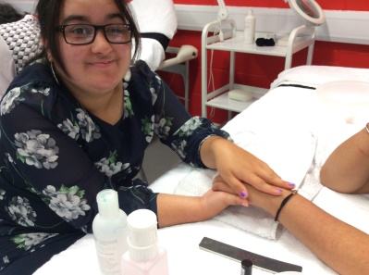
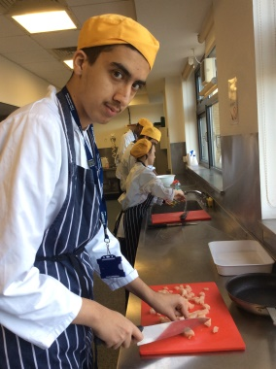
This provision was regularly monitored and evaluated. After 3 years we felt that the quality of the courses had declined and was no longer adequate at the local service provider, so by 2015 we were only using them for Hair and Beauty. This was because the level of teaching on this course remained consistently good and the fact that we were not able to provide this type of course in school.
During our evaluations in 2012 it was agreed by the SLT that we should look for vocational experiences in the areas of catering, horticulture and care for the elderly as it was felt that these provided our students with the best chances of future employment.

In 2013 we established links with Brent Lodge Park a local Zoo and recreation park and the Ealing Park Rangers team. From this we were able to send a group to work in the park making animal enclosures and to work at a Local nature reserve called The Litten. We have maintained these links with currently 4 groups of post 16’s going to both locations. Each year they follow an accredited vocational course that focus on their employability skills, their social communication and gardening skills.

Having established ourselves in the local community joining in local events and supporting other community groups it was then easier to make other links. Through the Park Ranger service, we now work with Thames 21 a charity that works to clean up our local waterways the students learn about volunteering and contributing to their local community.
Another way we have established links in the community is by being constantly on the lookout for events that we can take part in. One such event was running a Pop Up shop in West Ealing. We applied for a two week lease in 2014 and took our social enterprise of glass making into the local community. With staff and students running the shop this put our enterprise into a real vocational context and the students were able to make clear links between that experience and an increase in their own personal confidence when dealing with new situations. Staff have also been persistent in trying to establish links. One year on from the pop up shop we were able to persuade the landlord of the shop to lets us run a community social enterprise from the same premises. We have now been there once a week for the last two years where successive groups of students learn how to make glass and then run training courses to members of the public and at the same time gain a Level 1 in social enterprise.
As with pervious experiences we have then been able to establish other links. Being in a local high street means that people know more about our school and what we do. We are also able to challenge people’s perceptions about young people with learning disabilities.
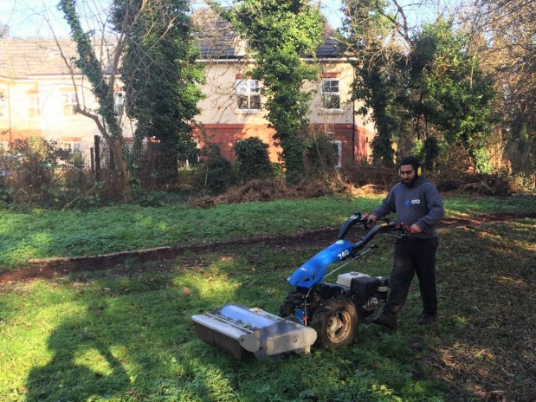
From this link we have connected to Catalyst Housing association. We now have 2 projects running with them. Firstly, they offer us a substantial and meaningful work experience currently this is in horticulture and caretaking, this then leads to paid employment with Catalyst and eventually full time work. After 2 years we have 2 students in full time employment with them. We feel this is a great achievement when only 7% of people with LD nationally are in paid employment and 80 people out of 930 in Ealing.

The second link is with Catalyst Gateway, this organisation work with local residents to improve their local areas and support vulnerable residents. This year we are jointly working with them and the Ground Work Trust to improve one of the local estates.
Finally, the other way we have established links is by simply cold calling organisations. Through this method we have established connections with both Age UK Ealing and Clementine Day care. Over the last two years we have established groups going out and working at Day care centres running or simply joining in intergenerational activities.
We also have an allotment next to our new post Centre. We take a full part in all aspects of allotment life.

Our final partnership is with Westside, a youth and community organisation based in West Ealing. The school supports our young people attend the youth club on a Thursday evening as part of extending their social outlet and friendships in the community. On a Friday a group of Post 16 spend the day at the centre running a mini-enterprise on chocolate making.

THE GOOD PRACTICE IN DETAIL (how it improved outcomes for pupils)
Whilst we acknowledge that being in the community is a huge benefit to students wellbeing we have ensured that there is progression for students within these schemes. 90% of students cite that the offsite learning is their most enjoyable activity throughout the year.
85% of student’s state that their own self confidence has improved as a result of working in the community.

Since we established our gardening activities, students are now in charge of grounds maintenance on both school sites, attending training and certification in the use of all of tools used. After a year these students go onto work experience placements with Catalyst Housing.

Students working with the elderly have an opportunity to go on work experience with the same organisation.

Two students who last year worked at the community shop have gone onto Project search (scheme where students work and study in a local business) with the local college.
All activities are Risk Assessed. All staff working offsite meet regularly with their line manager to evaluate and plan to ensure progression.
All offsite activities are accredited using Edexcel Workskills and progress either through grades of award certificate diploma.

Impact on pupil outcomes:
- 47.6% of students had a highly individualised timetable
- 2016: students achieved a minimum of 11 accreditations.
- 2016: 76.2 % of students progressed a whole grade and 23.8% within a grade in Maths
- 100% of students have an activity that is outdoors or off-site which supports their contribution to society

