E-Safety Curriculum

BRIEF DESCRIPTION OF THE PROJECT:

Our students are the generation born into the world of technology and as a school we are aware of the importance and impact it has had on their lives. Students use technology as part of their everyday lives. As a school we were conscious that our young people were particularly vulnerable - when on line - because of their learning disability and other associated complex needs. We were acutely aware of the need to ensure that our students were as digital literacy literate as possible, whilst at the same time instilling in them the knowledge and understanding that using technology also means you have to practice being safe online at all times.

THE GOOD PRACTICE IN DETAIL (how it improved outcomes for pupils)

At Belvue High School we have a rich Digital Literacy Curriculum, which supports the needs of all our students. The scheme of work covers how to use digital technology in our everyday lives, with the strong focus of how to be safe when using these tools.
E-safety Teaching and learning focuses on:
- Personal Information: Students can recall what their Personal Information is and understand the importance of keeping it safe/private.
- Strong Passwords: Some (Older students?) students are aware of the importance of creating strong passwords, where most students know their passwords should not be shared and to keep them safe from strangers and friends,.
- The use of appropriate websites and report if they see something that worries/concerns them: Our Students are happy to share and discuss their favourite websites. The older students are aware of websites that are not appropriate for their age and the majority of students know who to report their concerns.
- Seeing something on the internet or other online technology that worries them: All the students can name a person/s they trust if they see something that worries/concerns/upset them.
- Reporting things that happened online which is inappropriate and worrying to a trusted adult in and outside of school: The older students have an awareness of other ways to reporting any concerns (Childline, CEOP), and to trusted adults both at school and home.
- Following e-safety rules will help them to be safe online: The students practice e-safety rules in school. They cannot access YouTube at school. YouTube can be accessed by staff members only. Students know they cannot use Social Media in lessons.
- Being kind and polite online: All students understand that one must be kind and polite to their friends and family when online. They are aware of the consequences for being unkind.
- Good awareness of Cyberbullying: Most students have a good awareness of Cyberbullying and that being unkind to others is not accepted, students also know that if they are being Cyberbullied then it should be reported to a trusted adult.
- The older students in school who are online and have social media accounts know that posting or sharing inappropriate images of one self or others, Sexting can impact on their lives and that these images can be seen worldwide. The younger students are aware you must not show your privates to others.
- To have a clean digital footprint: Most students know that if you practice the e-safety rules it means that you have a good digital footprint. The older students are aware that anything they do online can impact on their future job and image.
- To understand that not everyone is who they say they are on the Internet (Radicalisation, Grooming): Most of the students have an understanding that people you meet online can be dangerous.
- The consequences of sharing too much about myself online: Most students know that you must be careful when sharing information online and the older students have openly expressed things that they have seen online and the consequences their peers were faced with.

The e-safety curriculum has allowed the students to understand the importance of following the e-safety rules. They also learn about E-safety in PSHE lessons.

When problems do arise, students will talk to a trusted adult and they will be guided on how to practice being safe online. Some students are also are good at supporting their peers and reporting on their behalf if an e-safety situation arises.

Parents
We hold E-safety parent sessions where we discuss current issues young people face when using technology, being a part of social media and the use of internet. Parents express their concerns that take place at home and as a group we discuss and implement strategies for individual parents to practice at home.
We have introduced a parent control app called Qustodio to the year 7 parents/carers, where they can monitor and manage their children’s online experience.
The Digital Parent magazine is distributed yearly to all parents/carers, this allows parent to be aware of any current issues and guidance they may need to support the children’s digital needs.
Belvue participated in the LGfL E-safety survey, the results inspired us to film a video discussing the outcome and how important it is for parents to be knowledgeable about what young people do online and how we can support them on being safe.
Parents have access to our school website where they can access the latest articles on E-safety and recommendations of an online E-safety course to enhance their knowledge.

Students
E-safety is part of the curriculum with differentiated key performance indicators to support the needs of all the students across all key stages.
Some KS4 students participated in a British Council project where they created a PowerPoint presentation talking about the technology they use to access their favourite games, social media sites and SMS apps to name a few. They interviewed each other and filmed and recorded the outcome their mobile using their mobile phones. All the students participated with enthusiasm as this was a part of hteir everyday life and it made the project real and personal. The students reflected by discussing the pros and cons of using their favourite website, being part of social media and they were very aware of the impact it could have on their lives emotionally and the harm it can cause to them and others.
Assemblies take place focusing on all areas of E-safety, if a specific incident arises it will be discussed in assembly. Every year we participate in Safer Internet Day which takes place in February, All Vertical Tutor Groups are given a Safer Internet pack where they discuss and participate in activities.
E-safety posters are displayed around the school and classrooms.

Staff and non-teaching staff
Esafety training takes place throughout the year and all staff members are aware of the current E-Safety issues.

Impact on pupil outcomes:

Teaching E-safety at the beginning of the school year and constant reminders in assemblies and throughout the school year, supports the students with their knowledge and understanding of general personal safety issues. Students who find it difficult to regulate their behaviour online feel safe talking to members of staff if there are any E-safety concerns. Holding E-safety parent sessions support parents to manage and guide the activity of their children’s use of Technology and the internet. Working together we can ensure that our young people have a good awareness of ‘how to keep safe’ both at school and home.
Parents collaborating together and with us, share their concerns and knowledge whilst at the same time come up with strategies to help protect and guide young people in this complex field.
Students who have needed support with their online safety will share their experience and share with their peers the importance of good E-safety practice.
Overall the students have a good awareness of what is good and bad when using Technology and the internet and if any concerns arise they know there is always someone they can go to for help.

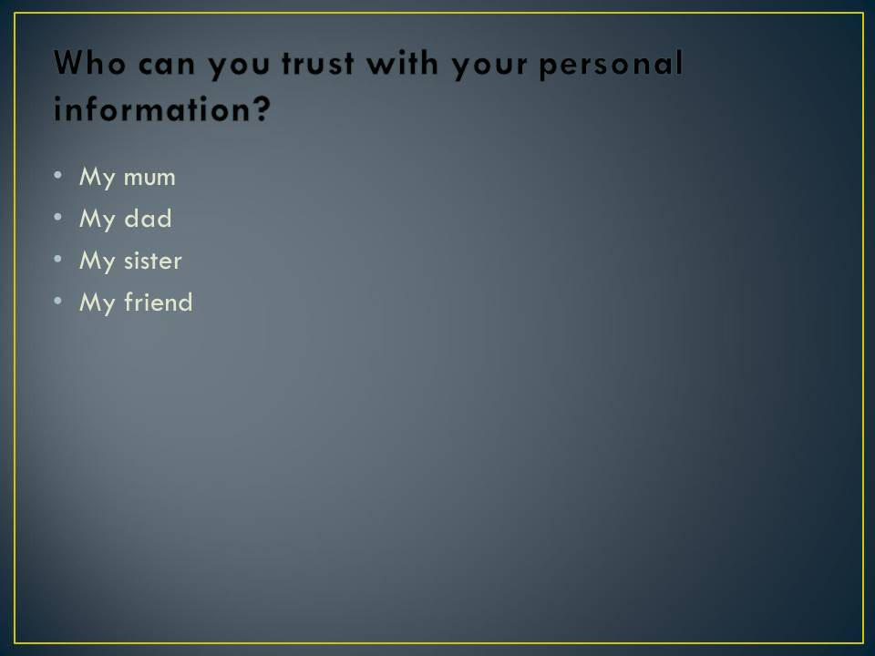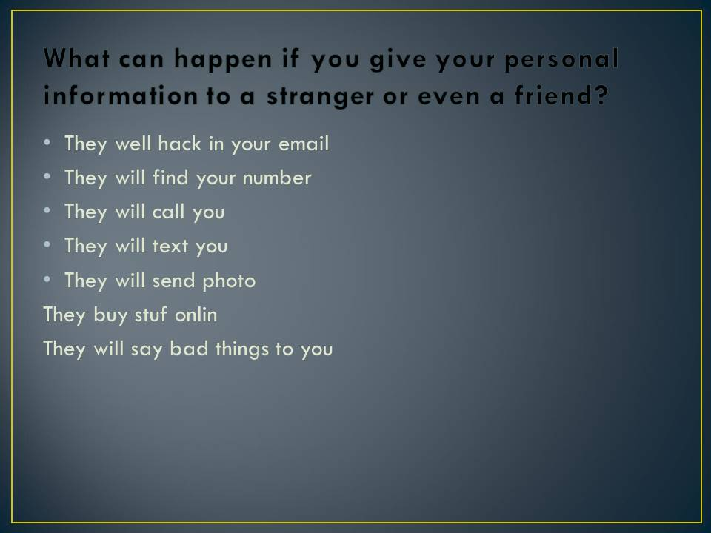

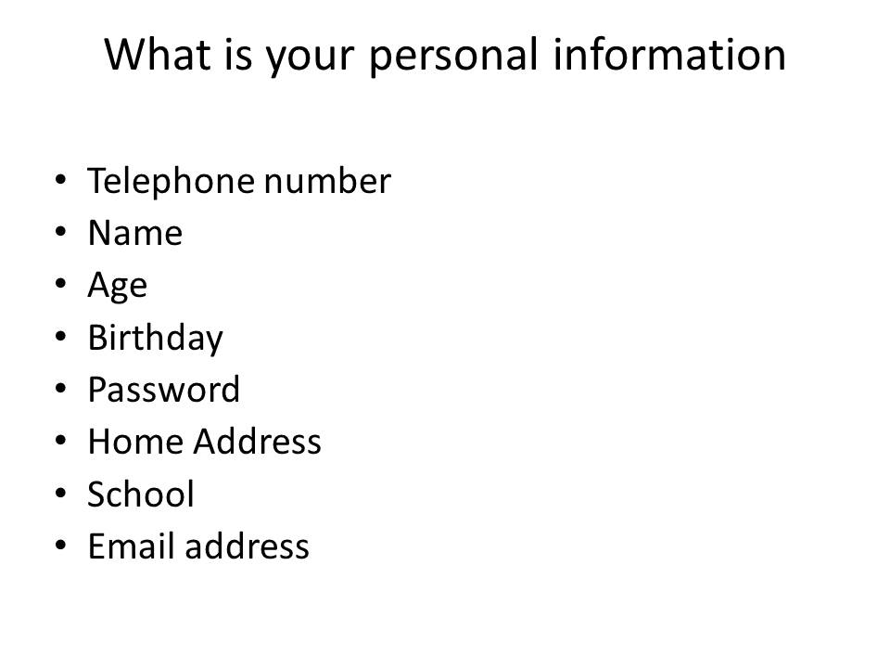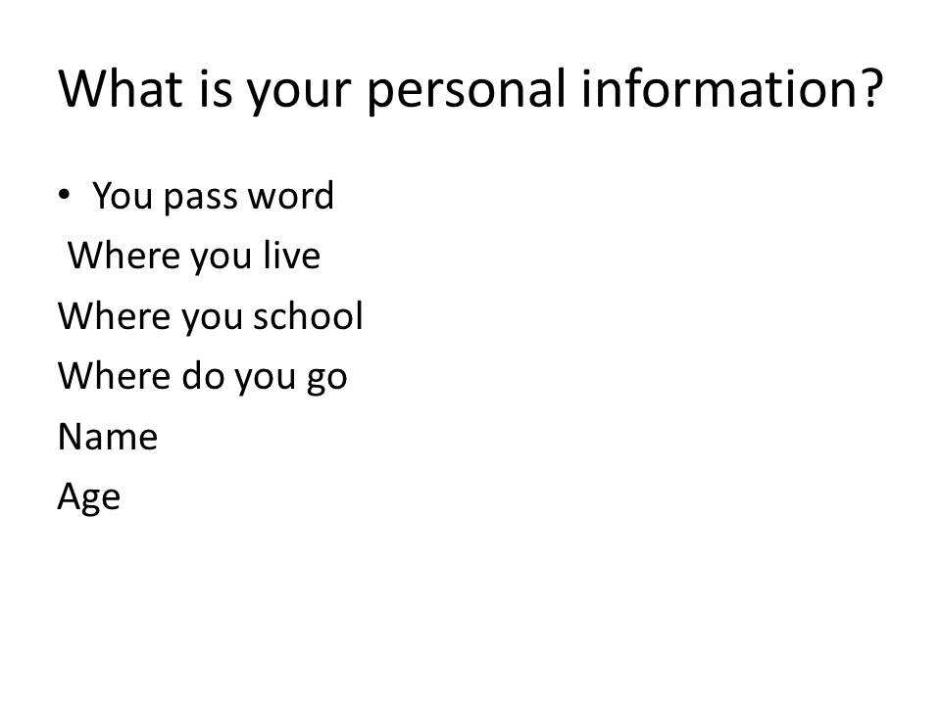

Students PowerPoint Presentation on Personal Information

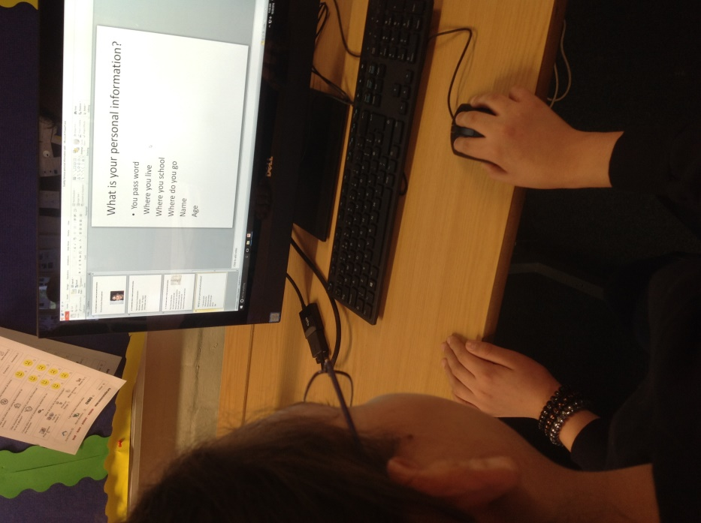

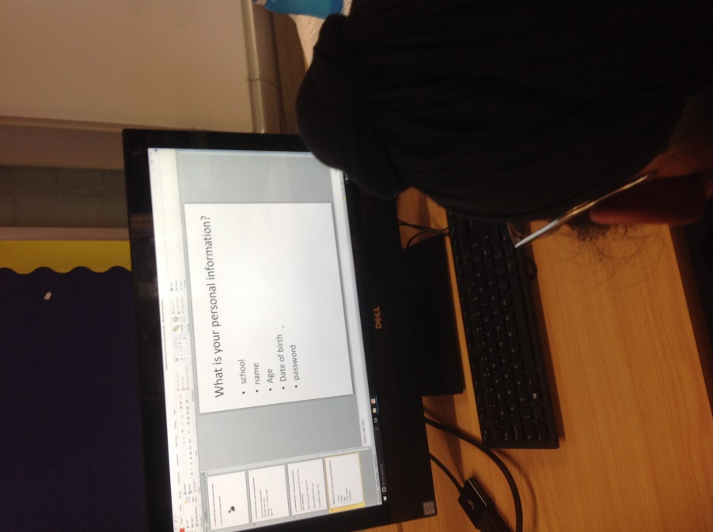

Students PowerPoint Presentation on Personal Information

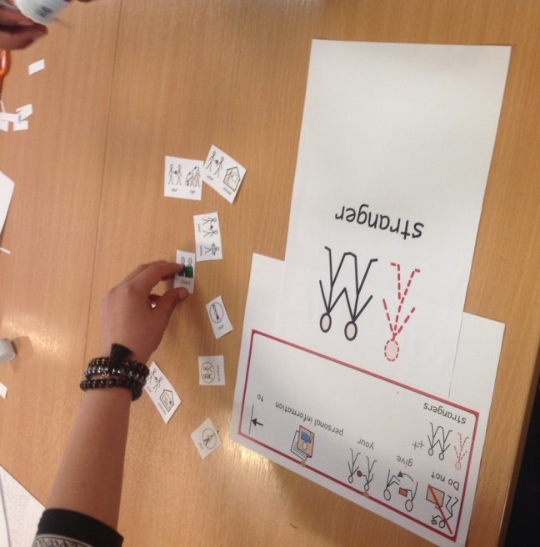

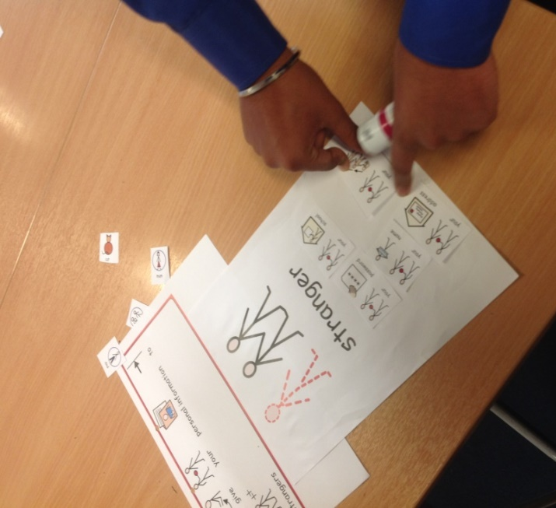

Students identifying their Personal Information that should not be shared with strangers online

