POST 16 NEWSLETTER – JUNE 2021

COURSEWORK / EXAMS
Just before the half term, students had been working hard to complete their course work and any exams they had been entered for. Now that they are back, it is time for any final pieces of unfinished work to be undertaken.

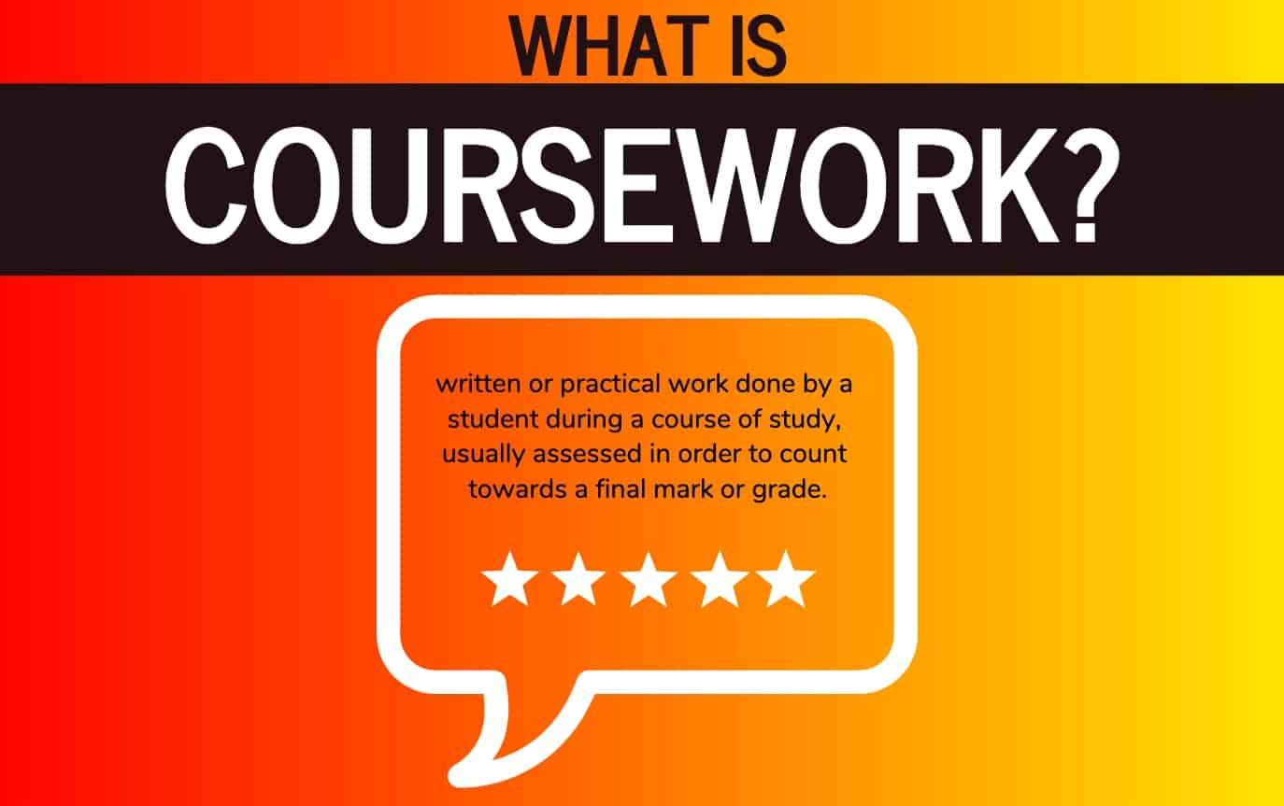

LEARNING CONVERSATIONS
During this final half term, your child’s teacher will be making contact with you in order to make arrangement for your final learning/transition conversation. This will take place via zoom or a phone call. These are important meetings so please ensure you make any appointment agreed.

LAST TWO WEEKS OF TERM
Now that the end of year date for Post 16s has been extended, until Friday 16 July, students will have the opportunity to undertake a number of enriching wellbeing activities for two weeks with their peers. A letter will follow explaining the different things that will be happening and on which days from Monday 5 – Friday 16 July.

LEAVERS GRADUATION
We are hoping to have a socially distanced leaver’s graduation on Thursday 15 July. The event will take place for leavers and their family only, at the main site where there is more space to be socially distanced and grouped as a family. If your child is leaving please ensure that you attend to support them during this important transition. More information will be made available nearer the time.

LEAVERS PROM
All leavers will have received their letters regarding this year’s Prom. Please send back your reply and pay your deposit for this wonderful and always memorable event. Any questions please call the college office.

CORONAVIRUS TESTING
If you are undertaking weekly rapid tests of your child, please make a note in their diary of the result – as simple as an X if negative. Call the college to inform us if the result is positive and keep your child at home and follow government guidance. Test kits will be sent home with your child.
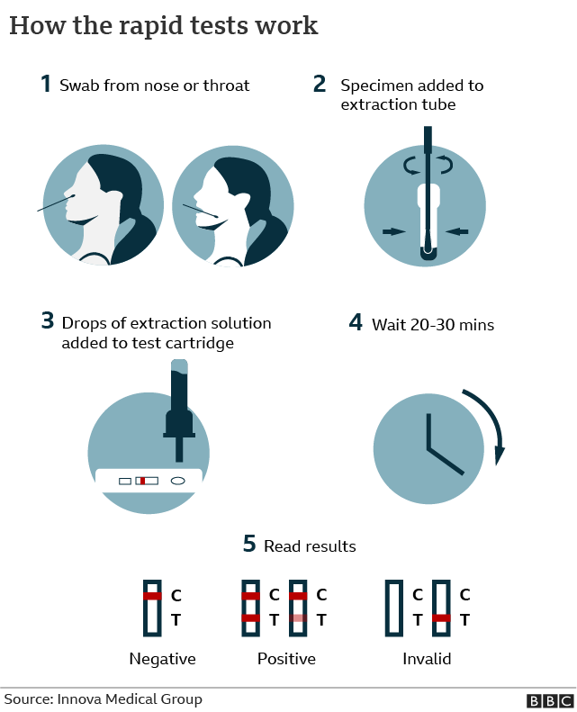

SMASHING GLASS
REMINDER: Belvue’s Glass Enterprise will be selling their products through the college. There is a mixture of jewellery (e.g. pendants/necklaces, earrings and broches) and items for the home (e.g. decorations, mirrors, coasters, small bowls) that you can buy. Prices range from £4 - £15. Please let us know if you are interested in purchasing anything. There is always a festival or celebration around the corner and it is an ideal time to buy something for a loved one or friend.

 | 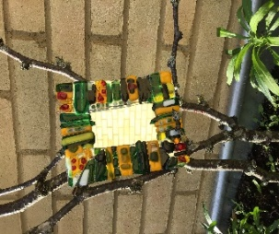 |  | 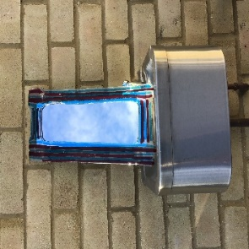

CONTACTING STAFF
If you have any concerns regarding anything while your child is at the college please contact us to book an appointment or to speak to someone on: 020 8422 0372

*ADVANCE NOTICE 2021*

Thursday 15 July – Leavers’ Graduation (at main site Rowdell Road)

Monday 5 – Friday 16 July – Fun Enrichment Activities

Friday 16 July – End of Year

Tuesday 20 July – Leavers’ Prom

Monday 13 September – Start of New Academic Year

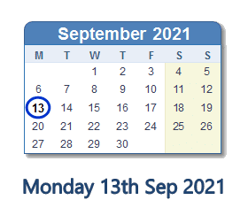

Internet and Phone Safety

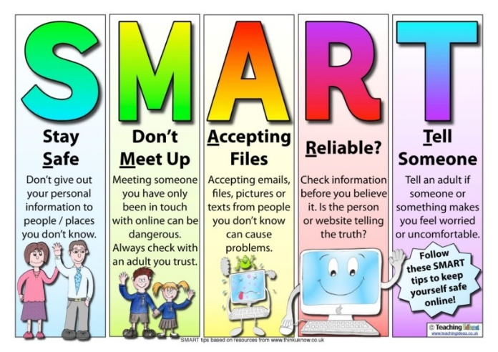
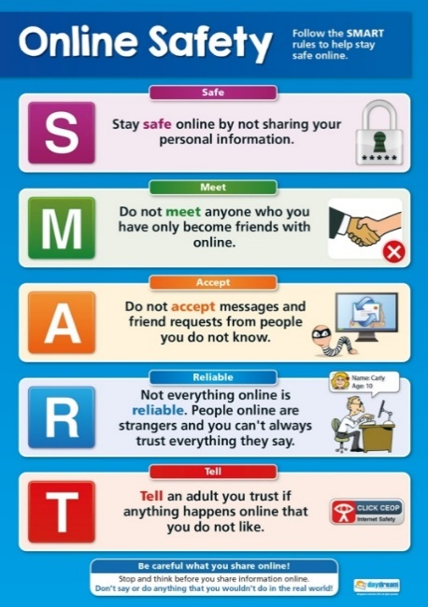
We are hearing about incidences of students using their phone and other devices inappropriately.
Please be aware that due to the age of our students the laws that apply to them are different than when they were in the main school and some things are illegal.
Remember that anything posted, uploaded or sent can be seen and will probably remain visible for years to come and can be shared by others and then by others in turn; meaning that it can end up anywhere!
Therefore, if it is something they would not like you or any other adult to see, read or hear, they should be very careful!
The police will be informed of any material passed between students that are harmful or illegal in nature.

