Belvue College Offer
2020/21

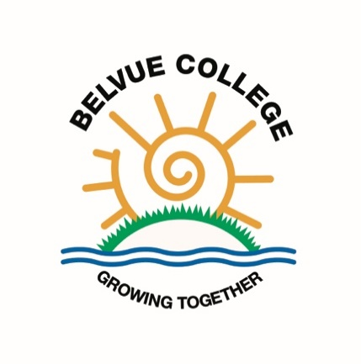

Belvue College Offer

Post 16 Intent

At Belvue College we aspire to assist young adults, by providing them with the tools to achieve their full potential and enrich their life experiences. Our curriculum is delivered through three progressive pathways that focus on developing a young person’s independence, personal and social growth, life skills, health and wellbeing needs, confidence and employment skills. We aim to create citizens who are positive, responsible, aspirational, engaged and able to integrate fully into society.

In Belvue College we will continue to grow together, while increasing our young peoples’ self-reliance, giving them opportunities to be involved in age appropriate experiences, expand their understanding of life and achieve vocational accreditations, that can support them in their future. This will be attained through actively working with our various partnerships and the local community, via social events, volunteering and work experience that all lead to developing further employment and social engagement skills.

Curriculum Pathways
The college has three differentiated Pathway Programmes, taught through core life skill topics, to meet the needs of our diverse community of learners.

Pathway Programme 1

This 3 year curriculum programme is designed for our more complex learners working below and within Entry Level 1. The learners will be taught in small groups and the sessions will incorporate input from other professional teams e.g. OT, SaLt. The curriculum is based around a supportive / inclusive learning course with its main focus centred on personal independence. It supports and builds on the development of a range of skills i.e. communication, social, health awareness, leisure, friendship and independent skills, understanding and dealing with emotions and conflict and preparation for adult life. At the end of the pathway learners will achieve an Entry Level 1 Award, Certificate or Diploma.
After Post 16 learners usually transition on to a supported inclusive learning college course.

Core Life Skills | Health & Wellbeing | Employment Skills / Supported Employment | Independence / Supported Living | Community inclusion
Reading  Writing  Time  Money  Number  Personal Passport/CV | Health and exercise  Wellbeing  Hygiene / self-care  Sex education  Keeping safe  Dealing with problems  Visiting health services  All about me  Friendships  Online safety | Following instructions  Getting things done  Looking and acting the part at work  Getting on with other people  Health and safety  Volunteering / Work skills | Home cooking skills  Kitchen hygiene  Home Skills / Looking after your home  Recycling  Travel skills / Getting out and about | Having your say  Rules  Rights and responsibilities  Basic laws  Exploring leisure activities / Socialising  Events  Trips

Pathway Programme 2

This 2/3 year curriculum programme is designed for our learners working at Entry Level. The objective of this pathway is to prepare students for life after Belvue and equip them with appropriate vocational and academic qualifications that can lead to future employment. Students will benefit from a personalised and differentiated curriculum. Learners will work closely with our community partnership links in relation to learning skills for work and possible supported internship programmes. At the end of the pathway learners will have achieved an Entry Level 2/3 Award, Certificate or Diploma.
After Post 16 learners can transition on to a ‘Bridge to Programme’ or ‘Step up to Mainstream’ course at college or a Supported Internship.

Core Life Skills | Health & Wellbeing | Employment Skills | Independence | Community inclusion
Financial skills  Presentation skills  CV & Covering letter writing  Interview skills  Career planning & interviews  Computing skills  Money  Time  Number | Personal care  Sexual health  Drug awareness  Managing risks  Online safety  Health and fitness  Friendships  Developing self  Managing social relationships  Confidence building  Dealing with problems/Wellbeing | Social skills  Volunteering opportunities  Work experience  Leadership skills  Managing behaviour  Enterprise | Travel skills  Safety in the community  Setting goals  Home skills | Citizenship  Rights and responsibilities  Laws  Community project  Exploring leisure activities  Events  Trips

Pathway Programme 3

This 2 year curriculum programme is designed for learners working within and above Entry Level 3. Students will study both academic and vocational subjects in order to achieve meaningful qualifications. The process will see learners build their communication, social, independence, emotional and employability skills and create a workable CV through their sessions in college and off-site with our community partnership links. The objective of this pathway is to offer our students direct routes into supported internship / apprenticeship programmes, ‘Step-Up to Mainstream’ college course, Level 1 college courses or employment. At the end of the pathway learners will have achieved a combination of qualifications at Entry Level 3 and/or Level 1 resulting in gaining an Award, Certificate or Diploma at those levels.
After Post 16 learners can transition on to courses such as: Art and Design, Childcare, Computing, Construction, Health and Social Care, Horticulture, Hospitality and Catering, Sport and Leisure, Internships or straight to employment.

Core Life Skills | Health & Wellbeing | Employment Skills | Independence | Community inclusion
Financial skills  Presentation skills  CV & Covering letter writing  Interview skills  Career planning & interviews  Computing  Money  Time  Number | Sexual health  Drug awareness  Managing risks  Online safety  Healthy living  Health and fitness  Friendships  Personal care  Developing self  Confidence building  Dealing with problems/Wellbeing | Volunteering opportunities  Work experience  Community links  Using equipment for work  Social skills  Managing behaviour  Leadership skills  Following instruction  Acting the part at work | Travel skills  Setting goals  Health, social and emergency service  Shopping  Cooking at home  Food hygiene  Home skills – Cleaning, washing drying and storing laundry  Safety in the home Recycling | Citizenship  Rights and responsibilities  Laws  Community project  Exploring leisure activities  Events  Trips

