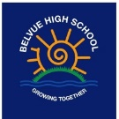

Intent

In RE we provide a curriculum that encourages students to experience, explore and engage with a broad spectrum of religions and belief systems.
Our RE is taught through sensory experiences, discussion and questioning that is designed to initiate sharing and debate, covering topics relevant to the world today. We encourage independent thought and allow our students the space to decide about, and give voice to, their own viewpoints.
Our aim is to develop reflective, discerning and religiously literate students who are able to construct informed opinions. Moreover we will focus on empowering them to demonstrate not only tolerance and respect towards the opinions of others, but also the differences between us.

Religious Education
Religious Education

Overview

Religious Education is unique in the school curriculum in that it is neither a core subject nor a foundation subject. However the 1988 Education Act states: “Religious education has equal standing in relation to core subjects of the national curriculum in that it is compulsory for all registered pupils.”
Belvue is a community school, therefore we deliver RE in line with the locally agreed syllabus, “Sowing the seeds of the future: an exploration of human beliefs and values.” Our aim is to ensure that pupils:
- Develop a knowledge and understanding of Christianity and its impact on our local community, and on our society today.
- Develop a knowledge and understanding of the other principle religious and non-religious belief traditions represented in Britain today.
- Learn to discriminate between those traditions, beliefs and practice that deserve respect, and practices and beliefs that can lead them into danger.
- Grow in their spiritual development.
- Develop a sense of awe, wonder and mystery.
- Develop skills and attitudes that will support their personal, moral, social and cultural development.
- Explore some questions of meaning and consider the different ways humankind has responded to them.
- Think about their own beliefs and values in the light of the beliefs of others—both religious and non-religious—and the values of the school community.

Cycle 1 | Festivals | The Nature of Faith | Creation Stories
 | - Judaism (Rosh Hashanah)  - Secular New Year celebrations  Lesson Focus Questions  - What is the story behind the celebration? What does it mean?  - What food do people eat? Is this different to food we eat?  - What clothing do they wear? Does this affect how they behave?  - What music do they listen to? Can you move/dance to this music?  - How is it celebrated? | - Judaism – Synagogue  - Islam – Mosque  - Buddhism – Temple  Lesson Focus Questions  - What is a/your special place? How does it make you feel?  - What can you see? Can you guess what these things are for?  - What happens here?  - Are there new smells or sounds? | - Aboriginal  - Big Bang  Lesson Focus Questions  - What can you see around you? See/Smell/Hear/Touch  - What happens in the story? Is the world perfect?  - How can we look after this world? What does the story tell us?
Cycle 2 | Festivals | The Nature of Faith | Creation Stories
 | - Islam – Eid  - Hindu – Diwali  Lesson Focus Questions  - What is the story behind the celebration? What does it mean?  - What food do people eat? Is this different to food we eat?  - What Clothing do they wear? Does this affect how they behave?  - What music do they listen to? Can you move/dance to this music?  - How is it celebrated? | - Humanist, Belief and practice  - Sikhism - Gurdwara  Lesson Focus Questions  - What is a/your special place? How does it make you feel?  - What can you see? Can you guess what these things are for?  - What happens here?  Are there new smells or sounds? | - Christian  - Big Bang  Lesson Focus Questions  - What can you see around you? See/Smell/Hear/Touch  - What happens in the story? Is the world perfect?  How can we look after this world? Does the story tell us?
Cycle 3 | Welcome/Birth rites Festivals | The Nature of Faith | Creation Stories
 | - How are babies welcomed  - Christian – Christmas  Lesson Focus Questions  - What is the story behind the celebration? What does it mean?  - What food do people eat? Is this different to food we eat?  - What Clothing do they wear? Does this affect how they behave?  - What music do they listen to? Can you move/dance to this music?  - How is it celebrated? | - Hinduism – Mandir  - Christianity – Church  - Baha’i – House of Worship  Lesson Focus Questions  - What is a/your special place? How does it make you feel?  - What can you see? Can you guess what these things are for?  - What happens here?  Are there new smells or sounds? | - Inuit  - Hindu  Lesson Focus Questions  - What can you see around you? See/Smell/Hear/Touch  - What happens in the story? Is the world perfect?  How can we look after this world? Does the story tell us?

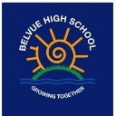
Religious Education

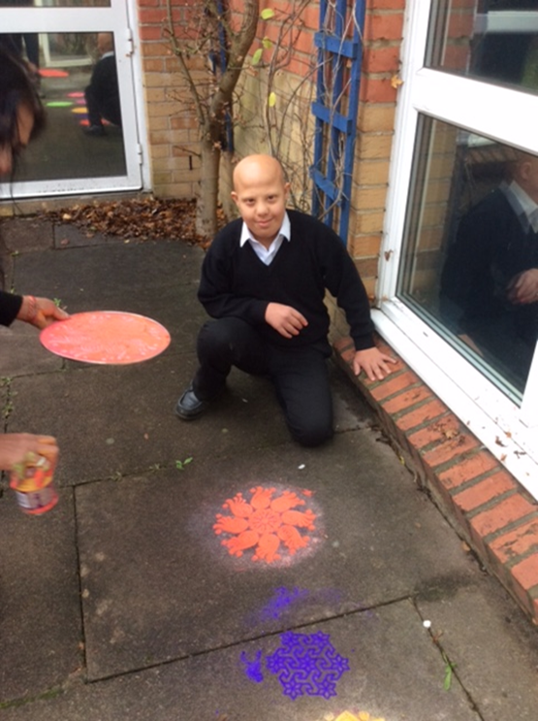
Learning about Diwali, creating Rangoli patterns

Learning about the symbols of different religions and belief systems 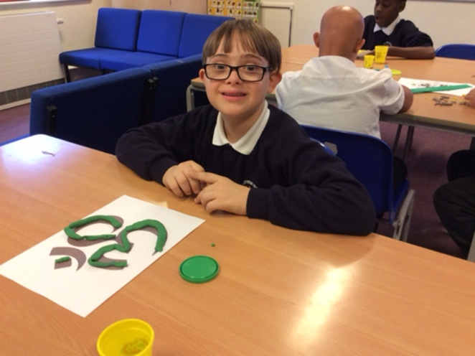
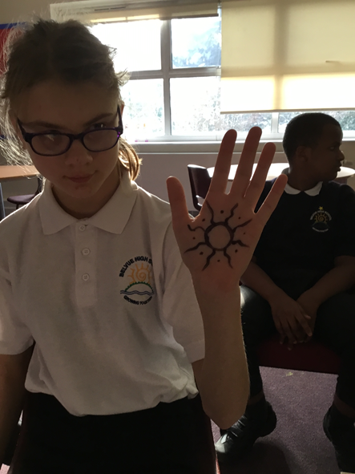
Learning about different wedding traditions such as the use of mendhi art in Islamic weddings

