POST 16 NEWSLETTER – MARCH 2022

SUPPORT FOR UKRAINE
No need to highlight the injustice and devastation of what is happening in the Ukraine, as we hear the sad news every day. On Monday 7 March we are asking parents to donate £1 for the cause and for all staff and students to wear blue and yellow in solidarity of the Ukrainian people.

KIDNEY CANCER AWARENESS
Thank you so much for your support and generous contribution for a cause that is close to our hearts. This charity is especially important for Belvue staff, as a colleague has the illness. With all your help we raised £82.50. All the money raised will go directly to the charity.
VALENTINE DISCO.
Post 16 students had a really fun Valentine Disco with lots of dancing and laughter. Students were able to buy some small items related to Valentine’s Day and each student also received a rose and a chocolate as they left. We raised an amazing £70.30.

LEARNING/TRANSITION CONVERSATIONS
Monday 28 March – Friday 1 April. Please write in your child’s diary if the original appointment date you were given is still satisfactory. If not, we will try to accommodate your choice and change the date. If your child is a leaver then the meetings will also include a discussion about your child’s transition from Belvue. Otherwise, it will be a general learning conversation. The meetings can now be held face to face and will take place be at the college.

RESIDENTIAL MEDICAL FORMS
The residential is now only a few months away. If your child is attending the trip you will have received a medical / information form that needs to be completed fully and returned. As a school we compile a spreadsheet of all the information given to ensure that we follow what parents have written. Please ensure that all the information is written correctly and that there is a second contact in case of an emergency.

EMPLOYABILITY WEEK
Monday 7 – Friday 11 March. During this week, each class will have a personalised timetable of different work opportunities to experience. Each child will produce an Employability Passport to record all the sessions that they attend. If your child already has a session off-site e.g. the Litten, Southall College, these subjects will continue as normal. Your child’s class teacher will send you a letter informing you of what your child will need to bring each day e.g. their travel card, a packed lunch, for each of the activities they will be doing throughout the week.

EALING SEN HUB
Our school are working collaboratively with a few other SEN schools in the borough, within a Hub, to organise and arrange employers to deliver presentations and practical experiences to our students, in order to enhance and develop their employability skills and understanding of the world of work.
Our second group of students, working with the Ealing Schools SEN Hub, are working with HS2 (High Speed 2). The group will be working on developing employability skills for the transport industry and exploring what the organisation has to offer in forms of job opportunities.
The previous group to work with the Hub, created the logo for the Bee Project which they discussed and designed together.

EXAMS/COURSEWORK
All students are undertaking coursework this term for their accreditations. Students undertaking the Functional Skills qualifications (working between Entry Level 1 and Entry Level 3) will not receive their results until the summer. Their work has to be sent off to the external moderator to verify any marks awarded. Students who did not pass their English or maths (by only one or two marks) will have an opportunity to retake another paper in a couple of weeks. Students who did not pass by a large number of marks, will have the opportunity to try for the qualification again next year or at their new placement if they are a leaver. The speaking and listening section of the exam will also be filmed in the coming weeks. Any certificates awarded should arrive and be posted to you in the autumn term.

COLLEGE CLUB
The Monday Cookery Club has proved to be a success. Students have enjoyed the pizza and pancakes that they have made so far and Mrs Bloomfield has many more common and interesting dishes that she would like students to try. The club finishes at 5pm – please ensure that you collect your child on time as the building also closes at that time.

MENCAP SATURDAY CLUB
The team meet at 10am at Dare2Dream, 1-2 Leeland Road, West Ealing, W13 9HH.

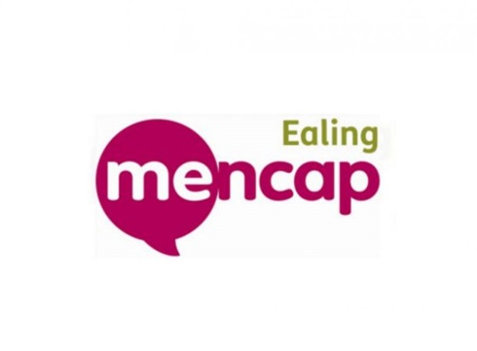
Activities, chosen by the group, include typical trips like:
- visiting local attractions,
- mini golf,
- bowling,
- trampolining,
- outdoor sports,
- companion cycling,
- entertainment venues and much more.

Attendance is free for young people not eligible for social care support.
Young people need to bring their own cold packed lunch and drinks.
The group does not meet during Easter, Christmas and Summer holidays.
Contact Aleks Rogozinska to book your place. aleksandra.rogozinska@ealingmencap.org.uk 020 8566 9575.

*IMPORTANT ADVANCE INFORMATION*

Friday 25 March End of Term @ 3:00pm
Monday 4 – Monday 18 April Easter Holidays
Tuesday 19 April College Closed-Training Day
Monday 2 May College Closed-May Day
Thursday 5 May College Shopping Day
Monday 30 May-Friday 3 June Half Term
Wednesday 22 June Leavers Graduation Presentation
Friday 24 June Last Day of College-End of Year
Thursday 30 June Prom

APPOINTMENTS
If you would like to see your child’s VT/class teacher or Miss Gibson please write a note in your child’s diary or call the college office to book an appointment.
Ken Phone Number: 020 8422 0372 / Belvue Phone Number: 020 8845 5766
belvuecollege@belvue.ealing.sch.uk

