POST 16 NEWSLETTER – NOVEMBER 2022

Welcome back; we hope you all had a lovely break!
DIWALI
We hope all of our Post 16 families who celebrated Diwali had a wonderful time during the break.

BELVUE CAFÉ
Now that Post 16 students are back at the main site they have been able to reintroduce the Belvue Café. It is a great opportunity for students to develop their work skills, especially customer services, as they serve staff a variety of high quality drinks and snacks during break times.

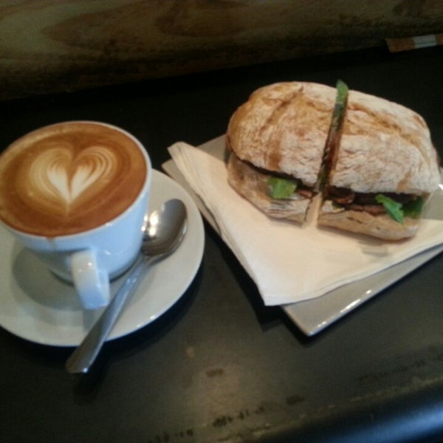

EALING SEND HUB
Belvue are working closely with the Ealing SEND Hub to develop work related learning opportunities for our students. They arrange different scenarios for organisations to support our young people in experiencing aspects of the world of work.

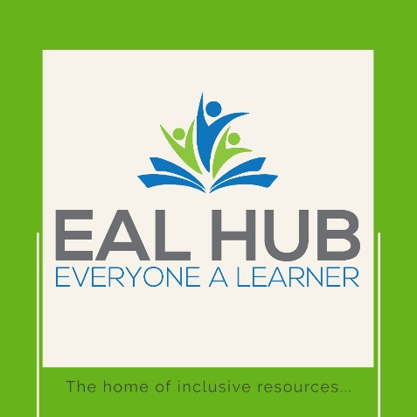

HAVELOCK
The Havelock Community Projects have started this month. A small group of timetabled students will be attending weekly to participate in the seasonal activities that the project coordinators organise. Students undertake jobs to support and improve the local community.

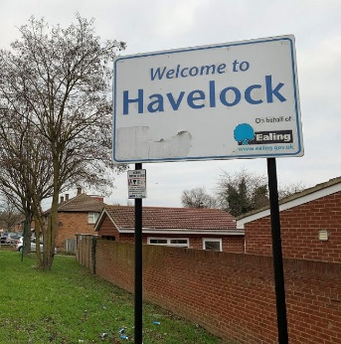
TFL TRAVEL TRAINING
This year the school are working closely with TFL and continue to work with Essex Council to help students to develop their independent travel skills. In addition, as part of the curriculum our students regularly go off site throughout the year and gain further travel skills and knowledge.

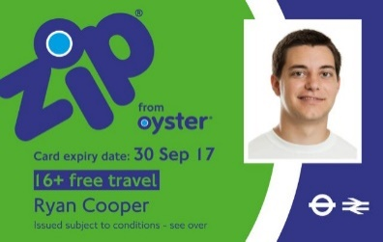
BURSARY
You will have received letters regarding the Post 16 Bursary. If your child receives Free School Meals (FSM) then they will automatically qualify. However, if your child does not receive FSM, but you can provide the appropriate evidence required then you will also be entitled to receive something.

TRANSITION EVENING
This year’s transition evening takes place on 10th November 5 – 7 pm. It will take place at the main site. This is an opportunity to obtain information regarding your child’s future after Post 16 by hearing from different organisations, including colleges, Mencap, NCS The Challenge and Connexions. You will receive more information before the event.

ANNUAL REVIEW
You will receive your child’s annual review in draft before your allocated date and other information and forms that you will need to complete which forms the parent/carer section of the annual review. Dates: Monday 12 – Friday 16 December; your child must accompany you to their annual review. Connexions will contact all leavers’ family by phone.

COLLEGE JOBS
The first round of job applicants for this year will be advertised this half term. Students will have the opportunity to apply for a number of paid jobs around the school.

*IMPORTANT ADVANCE INFORMATION*
Many of our calendar dates are different from the main school

Christmas Trips – Thursday 1 December
Christmas Bazaar (Belvue main site) – Friday 2 December 10.30-12.00
Christmas Lunch – Wednesday 7 December

END / START OF TERM
Friday 9 December – last day of term for all Post 16s. Students are expected in school on this day. Tuesday 3 January 2023 is the start of the spring term.

NIGHT CLUB
Students will remain after school until 7pm to attend an evening of fun on Thursday 26 January 2023. Post 16 students will enjoy a Night Club experience with their friends, while the younger students have Night School.

APPOINTMENTS
If you would like to see your child’s VT/class teacher or Miss Gibson please write a note in your child’s diary or call the college office to book an appointment.

Ken Phone Number: 020 8422 0372 / Belvue Phone Number: 020 8845 5766
belvuecollege@belvue.ealing.sch.uk
Please use this number to let us know if your child is running late, is ill, have an appointment or for any other reason.

