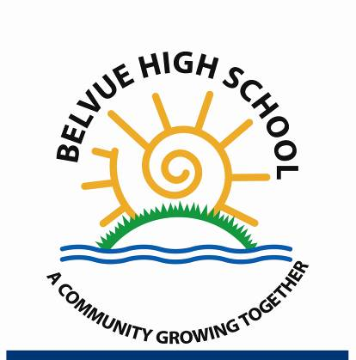
Headteacher: Ms. Shelagh O'Shea

head@belvue.ealing.sch.uk

Rowdell Rd
Northolt
Middx
UB56AG
Tel: 0208 8455766
Fax 0208 8414409

Dear Parents/Carers

I am happy to enclose your child’s subject / exam results achieved to date.
To clarify the result procedure – the majority of our students undertake Entry Level Qualifications (ELQ), basic education certificates which are below GCSEs.
Entry Level qualifications range from Entry 1-3. The main national school’s curriculum progression route is shown below. It begins at:

Entry Level 1 (E1)
Entry Level 2 (E2)
Entry Level 3 (E3)
Level 1 (L1) / GCSE D - G
Level 2 (L2) / GCSE A – C / Traineeships / Intermediate Apprenticeship

Some qualifications can also be accumulated to form an Award, Certificate or Diploma. The school also has its own Belvue Skills Certificate which is awarded to students who have achieved specific key skills in a subject that is either not accredited or in which students are working below a specific grade set.
In a student’s final year any units achieved will be combined (where applicable) to give them a closing qualification. Certificates will be presented to your child at their Leavers’ Graduation.

Warm regards

Miss Gibson

