Home
Sleep Topics
Why Do We Need Sleep?
We tend to think of sleep as a time when the mind and body shut down. But this is not the case; sleep is an active period in which a lot of important processing, restoration, and strengthening occurs. Exactly how this happens and why our bodies are programmed for such a long period of slumber is still somewhat of a mystery. But scientists do understand some of sleep's critical functions, and the reasons we need it for optimal health and wellbeing.
One of the vital roles of sleep is to help us solidify and consolidate memories. As we go about our day, our brains take in an incredible amount of information. Rather than being directly logged and recorded, however, these facts and experiences first need to be processed and stored; and many of these steps happen while we sleep. Overnight, bits and pieces of information are transferred from more tentative, short-term memory to stronger, long-term memory—a process called "consolidation." Researchers have also shown that after people sleep, they tend to retain information and perform better on memory tasks. Our bodies all require long periods of sleep in order to restore and rejuvenate, to grow muscle, repair tissue, and synthesize hormones.
How Much Sleep Do We Really Need?
Healthy sleep is critical for everyone, since we all need to retain information and learn skills to thrive in life. But this is likely part of the reason children—who acquire language, social, and motor skills at a breathtaking pace throughout their development—need more sleep than adults. While adults need 7-9 hours of sleep per night, one-year-olds need roughly 11 to 14 hours, school age children between 9 and 11, and teenagers between 8 and 10.During these critical periods of growth and learning, younger people need a heavy dose of slumber for optimal development and alertness.
Unfortunately, a person can't just accumulate sleep deprivation and then log many hours of sleep to make up for it (although paying back "sleep debt" is always a good idea if you're sleep deprived). The best sleep habits are consistent, healthy routines that allow all of us, regardless of our age, to meet our sleep needs every night, and keep on top of life's challenges every day.
FacebookTwitterEmailPrint
Popular Articles
Do Dreams Affect How Well You Sleep?
How Sleep Is Different for Men and Women
Is Your Thyroid to Blame for Your Sleep Issues?
How Sleep Affects Your Immunity
3 Signs Your Mood May Be Affecting Your Sleep
Featured Article
Image
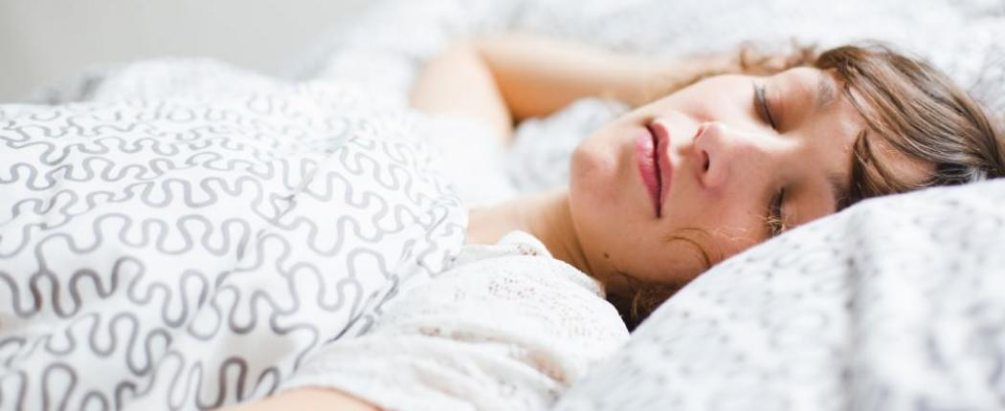
How Sleep Works
The Science of Sleep
How Much Sleep Do We Really Need?
Sleep is a vital indicator of overall health and well-being. We spend up to one-third of our lives asleep, and the overall state of our "sleep health" remains an essential question throughout our lifespan. Most of us know that getting...
Image
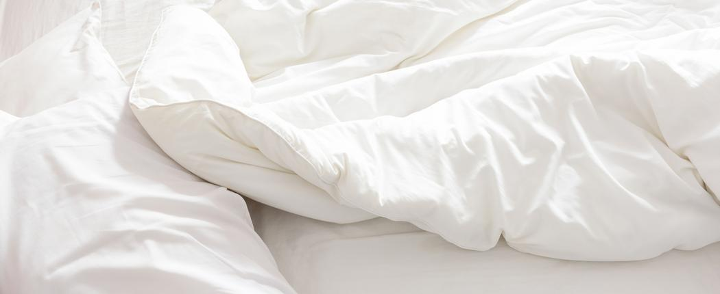
How Sleep Works
Sleep & Your Lifestyle
How Excessive Sleep Can Affect Your Metabolism
Few people worry about spending too much time in bed. An extra hour or two of stolen sleep on Sunday can feel like heaven after a long week of work and family activities. But did you know that clocking more than the recommended amount can negatively impact your health? For most adults, getting between seven and nine hours of sleep...
Children, Teens & Sleep
Sleep & Your Lifestyle
Image
Screen Time and Insomnia: What It Means for Teens
For teenagers, sleep plays a critical role in staying healthy, feeling happy, maintaining good grades, and doing well in sports....
Sleep & Your Lifestyle
Sleep Deprivation
Image
This Is Your Body on No Sleep
A missed night of sleep is a fairly common experience for young people, new parents, and all kinds of busy...
Sleep & Your Lifestyle
Sleep Health
Image
How Your Body Uses Calories While You Sleep
Burning calories is a term most often associated with aerobic exercise and physically taxing jobs. But actually, you don’t need...
Children, Teens & Sleep
How Sleep Works
Image
3 Ways to Tell a Nightmare from Night Terror
Nightmares and night terrors are both scary and can cause sleep disturbances, but they are not the same thing. Knowing...
Sleep & Your Lifestyle
Sleep Topics
Image
Night Terrors: When to Talk with a Doctor
Your child’s first night terror is disconcerting to say the least. It likely involves screaming and flailing about while asleep,...
Sleep & Disease
Sleep & Your Lifestyle
Image
Pain and Sleep
Is pain keeping you awake? Find out why pain affects sleep and what you can do to sleep better.
Sleep & Your Lifestyle
Sleep Tools & Tips
Image
What Makes A Good Night's Sleep
Great news: more than three-fourths (76%) of those surveyed say that they had a good night’s sleep at least a...
The Science of Sleep
Image
How Sleep Affects Your Immunity
When it comes to your health, sleep plays an important role. While more sleep won’t necessarily prevent you from getting...
Pagination
Load more
The National Sleep Foundation holds federal trademark registrations for “National Sleep Foundation” and other marks as noted in this website.

Sleep
Sleep Topics
Sleep Disorders

