POST 16 NEWSLETTER – JANUARY 2022

**ALL STUDENTS TO COMPLETE A REGULAR RAPID FLOW TEST**

REMINDER: TESTING
The DfE have announced that they expect all secondary schools to test pupils once during the first week back after the Christmas holidays. Please refer to our website. Like before, the testing will happen at the college for those students whose parents gave permission before. Remember, students who are 18+ and understand the process can give their own permission.
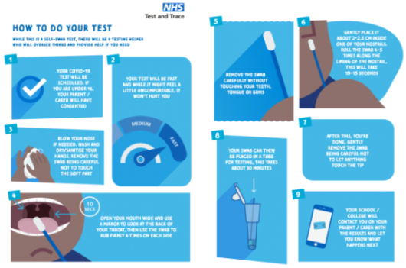
ANNUAL REVIEW
Any outstanding Annual Reviews need to be undertaken and completed before the end of this month. Please ensure that you respond to any messages sent. The meetings will take place via Zoom (if any other professionals need to be present) otherwise it can also happen over the phone.

TRANSITION EVENING
Another successful Transition Evening was held last month and as a result leavers are clearer in their choices moving forward after Belvue. Reminder: Adele Hines from Connexions will be calling parents to arrange a meeting regarding your child’s choice for September 2022 (keep her number so that you can also contact her if necessary). She will support you in the application process, if needed, and will stay in touch to ensure your child has a place from one of their chosen options. Your child will be given more information regarding the process this month.

CHRISTMAS LUNCH
Students and staff enjoyed an afternoon of fun and laughter at the Railway Hotel in Greenford. The restaurant staff were amazing and ensured we all had a great time by letting us use the entire restaurant for our own personal party. They provided large portions of tasty mains, desserts and drinks and allowed us to sing songs very loudly. Students socialised with each other, played games and took photos.
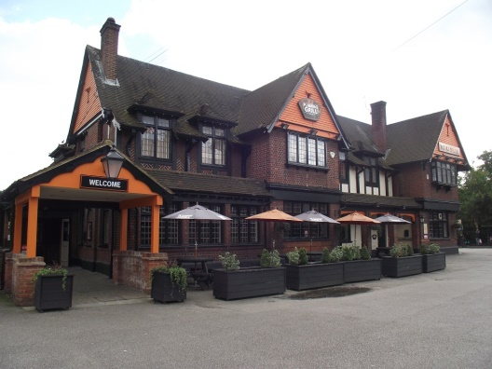
HRISTMAS TREAT
Students and staff went to Cineworld in South Ruislip to see the new Ghostbusters film. Once again we had the entire cinema to ourselves and students were able to chill and enjoy the film with their friends. Having their friends there helped any students who found aspects of the movie scary, but they were all able to laugh out loud throughout a lot of the film.

LAST DAY OF TERM
A survey was undertaken and the consensus was that all students enjoyed food from Nandos’ Therefore, as another treat, for the last day of term, we allowed each student to choose and enjoy a meal from Nando’s and to have an afternoon of fun with their friends. It was a huge success!

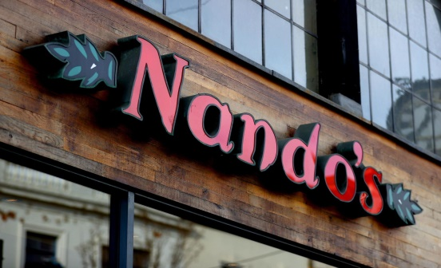

COLLEGE JOBS
New job applications come out this month and students can apply once again for any of the current positions available. Any previous successful candidates can reapply too. Application forms will be available from the college reception during the first two week back.

WORK UNIFORMS - UPDATE
Hopefully, we should now be able to get the letters and barcodes produced for the work uniforms this month and you’ll be able to pay for your child’s kit via parent pay. Once you receive your letter and have done so, the college will be informed and you will receive your child’s fleece and polo shirt. Please check your child’s timetable to know which days he/she will need to wear it. The subjects students need to wear their uniform are: Litten, Horticulture, Horsenden, Community, Haverlock and Glass.

BURSARY
All students received a bursary letter outlining the possibility of extra financial support for items such as the college work uniform and travel expenses to and from places on your child’s timetable. If after reading the letter you feel you are eligible to apply please do so as soon as possible, giving your reasons why and what you need or would like to purchase for your child. The bursary is not available for food. If you have sent back a form requesting money for food, your form will be forwarded to our family workers who will assess your situation

COLLEGE CLUBS - CANCELLED
At present there are no clubs this term. We will keep you updated on the progress of this. In the meantime, the Friendship Club will still be going ahead for those students who are involved.

*IMPORTANT ADVANCE INFORMATION*

Thursday 27 January Night Club–students stay till 7pm*
Monday 14 – Friday 18 February Half Term
Monday 7 – Friday 11 March Employability Week
Friday 25 March End of Term @ 3:00pm
Monday 28 March – Friday 1 April Transition/Learning Conversations
Monday 4 – Monday 18 April Easter Holidays

APPOINTMENTS
If you would like to see your child’s VT/class teacher or Miss Gibson please write a note in your child’s diary or call the college office to book an appointment.
Ken Phone Number: 020 8422 0372 / Belvue Phone Number: 020 8845 5766
belvuecollege@belvue.ealing.sch.uk

