POST 16 NEWSLETTER – November 2023

The start to the new 2023-2024 academic year has started very well and students have been successfully settling in to their new classes.

Just a reminder regarding uniform, hoodies, sportswear, ripped jeans, etc. are not college dress code, please ensure that your child arrives dressed accordingly.

NIGHT SCHOOL
On Thursday 23rd November students will be taking part in activities at night school. Students will stay in school until 7pm. There will be no transport on this day. Arrangements must be made to collect your child at 7pm.

RESIDENTIAL
The Post 16 residential will take place on Monday 20th May – Thursday 24th May 2024. The cost for the 4 days will be approximately £50 payable through ParentPay. The Belvue School charity have kindly contributed and subsided the price. Letters to confirm your place will be sent out in the next few weeks.

FREEDOM PASSES AND OYSTER ZIP CARDS
Please ensure that your child has an up-to-date Freedom Pass or Oyster Zip Card for the new academic term 2023/24. It is important that your child brings their card into college every day, even if they are not an independent traveller.

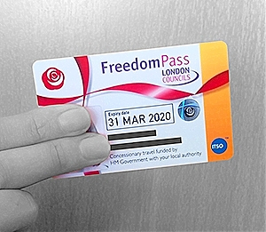

TRAVEL TRAINING
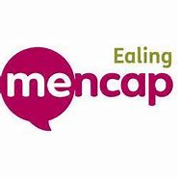
If your child is currently on school tranport and you would like to find out more information about travel training please put a note into their school diary.

TRANSITION EVENING
Thank you to all of you who attended the Belvue transition evening. This was a successful evening where parents/carers had the opportunity to explore some options of colleges.
The following organisations attended the evening: Belvue, Connexions, Ealing Green, Green Corridor, SENAS, ECAN, Westside Club, West Thames College, Choice Sl, Ealing Supported Internship, Freedom Pass Team, TFL Menotr and Great Oaks.

IMPORTANT
Please use this number/email to let us know if your child is running late, is ill or if they have an appointment.

Belvue School phone number: 02088455766

FRIDAY 15th DECEMBER @3pm
END OF TERM – last day of term for all Post 16s. Students are expected in school on this day.

MONDAY 18 – FRIDAY 22 DECEMBER
ANNUAL REVIEWS – your child must accompany you to their annual review. Connexions will be present to give you impartial advice and information about what is available for your child when they leave Belvue College.

