Belvue School



Managing Behaviour Policy

Approved by: |  | Date:
Last reviewed on: | July 2021
Next review due by: | Sept 2022

Aims
This policy aims to:
- Provide a consistent approach to behaviour management
- Define what we consider to be unacceptable behaviour, including bullying
- Outline how students are expected to behave
- Summarise the roles and responsibilities of different people in the school community with regards to behaviour management.
- Outline our system of rewards and sanctions

Legislation and statutory requirements
This policy is based on advice from the Department for Education (DfE) on:
- Behaviour and discipline in schools
- Searching, screening and confiscation at school
- The Equality Act 2010
- Use of reasonable force in schools
- Supporting students with medical conditions at school
It is also based on the special educational needs and disability (SEND) code of practice.

Contents

- Managing Behaviour Overview
- Merit System
- Tutor Time Policy - synopsis
- Classroom Energisers
- Occupational Health – Postural Control advice
- Anti-Bullying Policy
- Positive Handling Policy – synopsis

1. MANAGING BEHAVIOUR OVERVIEW

1. AIMS
A particular focus is given to the following school aims in this section
- To create a safe, warm and welcoming atmosphere
- To provide equality and diversity of opportunity for all students
- To develop the academic, physical, emotional and social potential of each student
- To make students aware of their environment and to encourage them to have consideration for others
- To enable each student to fulfil an active and satisfying role in the school and wider community both now and in the future

2. PRINCIPLES
The following principles have been agreed by the Governing Body to inform and direct this Behaviour Policy.

Behaviour is learned; all school staff are responsible for promoting, teaching and modelling a high standard of behaviour.

We believe that contextual awareness sits at the core of managing the behaviour of socially vulnerable students from ethnic minority groups such as black people.

As individual cases require, we will use a contextualised and multi-level approach to behaviour, which captures the more complex background of behavioural issues, demonstrates caring actions and encourages social and emotional learning.

The Class teacher is the key person in managing student behaviour, and he/she needs the support of all colleagues to be effective.

The promotion of good behaviour results from:

- Staff who are warm, approachable, fair and supportive and develop attuned relationships with students.
- Staff being conversant with the barriers presented by needs specific students may have.
- The taught curriculum is relevant and meaningful to all students and includes quality experiences, high expectations, consistent management and positive feedback
- Effective partnerships: students with parents, students with staff and staff with parents.
- Feeling valued with an acknowledged sense of achievement, ensuring that a range of ways of being successful are made available to students.
- An understanding of and caring for the welfare and feelings of others.
- A positive balance of rewards over sanctions.
- Sanctions are personalised to meet the needs of individual students
- Being involved and feeling committed
- Respect between everyone and towards everyone in the school community
- All members of the school community adhere to the expected and agreed standards of behaviour
- Staff remaining calm, controlled and respectful whilst managing behaviour

3. SCHOOL RULES

The following are rules which indicate unacceptable behaviour. They are seen as basic and essential to promote the principles and aims set out above. They will be implemented consistently by all staff and are not subject to any negotiation.

- Racism, bullying or any behaviour which promotes inequality or lack of respect for individuals or groups
- Fighting, retaliation in kind or any form of abuse is unacceptable under any circumstances.

For the safety of students, the following are not permitted;

- Deliberate damage to or theft of property.
- Vandalism
- Smoking, drinking or other forms of substance abuse
- Leaving class or school premises without permission.
- Climbing on the school roof, fences or other dangerous areas.
- Use of mobile phones during school hours
- Possession of any prohibited items. These are:

  - Alcohol
  - Knives or weapons
  - Illegal drugs
  - Stolen items
  - Tobacco and cigarette papers
  - Fireworks
  - Pornographic images
  - Any article a staff member reasonably suspects has been, or is likely to be, used to commit an offence, or to cause personal injury to, or damage to the property of, any person (including the student)

Any prohibited items (listed above) found in students’ possession will be confiscated. These items will not be returned to students.
We will also confiscate any harmful or detrimental item to school discipline. If appropriate, these items will be returned to students after discussion with senior leaders and parents.
Searching and screening students is conducted in line with the DfE’s latest guidance on searching, screening and confiscation

Unless specifically approved, all students will be in lessons at all times as indicated by the timetable and ready for work.
All students are expected to wear the correct uniform at all times.
Classroom and other rules, set up as described below, will always be observed.

4. CLASSROOM RULES/CHARTER

At the beginning of each school year, all class-based teachers will establish, with the various groups of students in their care, a code of conduct for their teaching area. This will be displayed in the room and be reviewed at least termly. Although classroom codes may differ, each is expected to clearly support and promote the aims and principles set out above and be written in favourable terms.

Parents
Parents are expected to:
- Support their child in adhering to the student code of conduct
- Inform the school of any changes in circumstances that may affect their child’s behaviour
- Discuss any behavioural concerns with the class teacher promptly

5. PROMOTING GOOD BEHAVIOUR - GOOD PRACTICE

GOOD PRACTICE FOR THE MANAGEMENT OF LEARNERS AROUND THE SCHOOL

Class teachers are the Key Professional within the school for the students in their class group. They must therefore carefully monitor students' behaviour in their care through the use of the school diary; data held on ‘MY CONCERN’ SIMs data on attendance and detentions; assessment information on Classroom Monitor; individual contact with the student and liaison with non-teaching staff.

The student’s diary should be used to record good behaviour. The merit system and tutor time should acknowledge and celebrate this behaviour. The individual learning intentions for each student will also be recorded in the diary.

Incidents dealt with during breaks, teaching time or at other times should be recorded on a detention slip and sent to the school office for inclusion on the SIMs database.

If students are being disruptive in lessons it is unacceptable for them to be asked to stand in a corridor outside the teaching room as all students should be supervised at all times. If students need to leave the teaching area because of poor behaviour they should be accompanied by a teaching assistant and taken to one of the following below where supervision can be maintained.

- To an appropriate vacant room or area for reflective/calm time
- The calm room for agreed time out
- To a Senior teacher or VT
- To the Headteacher.

The Class teachers should be alerted to this behaviour so that they can follow up as needed e.g. with home or with the necessary agencies.

At the end of lunch, KS3 staff should collect their class for lesson 5 from the playground. All KS3 students should be met from the playground at the end of break by their Teacher or Teaching Assistant for lesson 3. KS4 and 5 students will be expected to go to their lessons independently, where staff must be ready to receive them.

6 POSITIVE CLASSROOM MANAGEMENT

The school acknowledges that a student may have specific needs which manifest in behaviours that present barriers to inclusion in whole group learning for a prolonged period of time. In such instances a specific programme of learning will be designed, implemented and monitored with the support of the multi-disciplinary team and parents/carers.

The school has also acknowledged that a specific SEN group (students with Downs Syndrome) present specific low–level behavioural challenges. A staff member has been appointed to lead in strategies across formal and informal learning opportunities.

The following is a list of general strategies recommended to staff as good practices that should be followed to discourage unacceptable behaviour and promote a positive working atmosphere.

- Develop good pastoral support through Vertical Tutor time and the use of the merit and house system.
- Plan lessons, which take into consideration the individual learning and behavioural needs of students.
- Set realistic and achievable goals.
- Arrive punctually.
- Share the objectives, differentiated tasks, and outcomes for the session with students in formats appropriate to their learning needs.
- Ensure that all the necessary equipment required for the lesson is available.
- Ensure that Teaching Assistants are aware of their roles and are actively engaged in supporting learning throughout the session.
- Ensure that the endings of lessons are planned to ensure enough time for activities and equipment to be packed away in an orderly and safe way and to give feedback on the session regarding the main points of the lesson, good work, behaviour and merits.
- Ensure that all class rules and routines are clear and explicit and are revisited regularly.
- Encourage and praise more often than rebuke. CATCH THEM BEING GOOD.
- Move around the class regularly working with individual students and groups.
- Ensure that the potentially disruptive student is praised and acknowledged
- Be clear about expectations and set clear boundaries about task completion, and insist that they are achieved.
- Be clear and consistent about reminders, e.g. learning intentions
- Encourage students to drink water
- Have fun learning
- Spot antecedent behaviour early and deal with it using the following strategies:
staying calm
being consistent
making eye contact with the student/s
changing task
consider working partnership and change if necessary
consider the position of the student and move if necessary
moving into the students' area to be helpful and offer assistance in a non-threatening way
using humour
sending students on messages
using music
energisers
utilise postural change – see OT guidance, utilise the equipment in class
OT box or employ individual OT programmes designed for the student.

WHEN THE ABOVE APPEAR TO BE INEFFECTIVE, THE FOLLOWING LOW-LEVEL STRATEGIES MAY BE DEPLOYED TO AVOID ESCALATION OF DISRUPTIVE BEHAVIOUR.

- Stop the lesson and review the task, expectations and then resettle the group
- Energise/postural change
- Change the task for the group or individual
- Identify an individual as a source of disruption and target that student for a specific task, which might mean that student leaving the room on a message. N.B. At this stage, it is not punitive. (Prior agreement with colleagues is a valuable aid to this strategy).
- Allow students to discuss where they have gone wrong and be prepared to accept the students’ reparations.
- Use the class code of conduct and individual learning targets to remind and re-focus the student on what is expected.
- DO DOT feed the situation by becoming emotional as this will result in loss of status, power and damage to the relationship with the individual and other students in the group. It will also escalate the situation.
- DO DOT rush in if you are likely to lose control, get support from another colleague, and solve problems later.
- DO NOT put a student into a non-managed situation.
- DO NOT use sarcasm

- ADDITIONAL SUPPORT

Where students fail to respond to the positive management strategies on a regular basis then the student’s behaviour should be discussed at the next Key Stage team meeting. At these meetings, decisions will be made as to whether:
- the student continues to be monitored through the merit system
- A managing behaviour action plan is formulated – this may include referral to one of the school therapists or Family Worker
- A revised risk assessment is required

Where a managing behaviour action plan is formulated, this will be shared at the next whole school safeguarding and managing behaviour meeting. These meetings will take place on Wednesday from 3.00 to 3.45 p.m. These meetings aim to share pertinent information about student's well-being on a need-to-know basis and inform all staff of individual behaviour action plans and individual risk assessments so that consistency is maintained.

8. SANCTIONS

Sanctions should only follow the teacher's clear recognition of the offence with the student. Care should be taken to ensure the student fully understands where they went wrong and the impact of that behaviour. Shaming of the students must be avoided.

Strategies for minor infringements might normally include: -

- A private verbal rebuke and reminder of unacceptable behaviour and possible consequences
- Removal from the scene of the disruption by supervised time out for a specified period and always with work and a clear set of expectations. The teacher must always follow this up to ensure task completion and the appropriate reintegration of the student back into the class
- Message to parents in the student’s home/school diary
- Detention - loss of play at break or lunchtime. After-school detention can be given to independent travellers after notification to parents/carers via home/school diary or contact by phone if possible.
- Teachers need to be clear about whether detention time is spent completing tasks, reflecting on behaviour or whether the loss of free time is sufficient. Care should be exercised so that additional work set will not lead to students negatively perceiving a particular subject.
- A verbal behaviour contract.
- Though not frequently implemented as the need to do so is seldom, the young person is disallowed a pudding and is offered fresh fruit instead.
- Use parental support in the classroom where a parent or guardian sits in the class supporting the student

MORE SERIOUS OFFENCES MUST BE DEALT IN A MORE FORMAL WAY AND WILL ALWAYS BE RECORDED ON SIMS THROUGH THE DETENTION SLIP PROCESS.

- Logging of the behaviour on a detention slip or on “My Concern” as necessary.
- Informing parents in a formal letter and inviting parents into school if necessary.
- Withdrawal of a major privilege, e.g. bus pass; permission to go out at lunchtime and treats. Parents/carers may also curtail treats and privileges in the family setting.
- Individual behaviour programme.
- Removal from the teaching group for an extended agreed period. This will always be negotiated with the Class teacher and Key Stage Leader and communicated to parents/carers. This change will also be fed back to staff at safeguarding and management meetings
- Referral to family worker, educational/clinical psychologist, other therapists and outside agencies, leading to agreed action.
- Parents contacted immediately and removal of students from premises for a `cooling off period'. NB This action must be sanctioned by the Headteacher or Deputy Head. It must always be followed up by a behavioural contract in negotiation with parents on the students' return to school
- Suspension and exclusion - see LA guidance in the School office.

9. USE OF THE CALMING ROOM
On rare occasions when the use of the sanctions above has failed to bring about the desired outcome of appropriate behaviour for learning, the school adopts a further sanction that allows disruptive students to be placed in isolation in an area away from other students for a limited period of time in the calming/quiet room. If this action is required, a staff member will remain with the student in the room until they are sufficiently calm to return to learning with their peers. However, if the student is disruptive or violent, the staff member will wait outside the room for their safety. If the student attempts to leave the room before they are calm, the supervising staff member will close the door using the ‘dead man switch to avoid a situation where the student requires restraining. If the door is closed in this manner, this will be for the minimum time necessary for the young person to regulate. Once the young person has regained composure, the staff member can reenter the room and re-engage with the young person. The staff member will remain outside the closed door to monitor the situation and ensure the young person’s safety until it is safe to re-enter. If a young person's liberty is restricted in this manner, this will be recorded on ‘My Concern’ as a physical intervention, and the period of time that the young person was restricted will also be recorded.
When using the calm/quiet room in this way the school will:
- Act lawfully, reasonably and proportionately in all the circumstances
- Ensure the health and safety of students
- Follow any requirements in relation to safeguarding and student welfare
The school will also:
- Ensure students are kept in isolation for no longer than is necessary and recorded appropriately on ‘My Concern’.
- Ensure students' time in isolation is used as constructively as possible
- Allow students time to eat and use the toilet.
The amount of time a student spends in isolation will be determined on an individual basis by a member of the senior leadership team, depending on the student's needs. If a student is put into isolation, this will be recorded on ‘My Concern’ and monitored through the school’s safeguarding procedures. The emotional and behavioural needs of the student will also be discussed with other professionals and the student’s family,
2. MERIT SYSTEM

AIM

To provide a tool for students to monitor their own behaviour and work by receiving regular feedback from staff

OBJECTIVES

To give learners regular feedback about their behaviour and work.
To reward and acknowledge good behaviour and work
To motivate learners to improve their behaviour through reward and feedback
To keep individual records of behaviour.
To motivate learners.

ORGANISATION

Learners will be awarded merits against their weekly behaviour and learning targets.

Merits will be awarded at the end of each lesson as part of the feedback process and recorded on the merit table in the home/school diary.

Teaching and non-teaching staff are eligible to award merits.

The merits will be counted daily during Vertical Tutor time at the end of the day.

The merit totals for each child will be kept on SIMS. This information will be uploaded every week by the co-tutor.

House points can also be awarded, but only for ‘hard work’ completed. These are recorded in the student’s diary, using a sticker star.

REWARD

The decision to reward will be based on individual learners exceeding or maintaining their previous weeks merit total. If a student then reaches their target, they will receive a token which they can then exchange for a treat from the tuck shop.

Learners will be awarded a certificate for achieving bronze; silver; gold and platinum house marks. These will be presented during weekly assemblies. Monetary prices are also awarded for gold and platinum awards and saved in the student’s school bank account.

Students may also be nominated to be the recipient of the termly Jack Petchy award

3. VERTICAL TUTOR TIME – A synopsis of the ‘Vertical Tutoring’ Policy

AIMS:

- To provide a secure base for students within a family-type group established within the context of predictable, respectful relationships. From such a base student can begin to create learning relationships, build esteem and experience and engage in empathic relationships
- To develop meaningful and trusting relationships with adults so that the relationship that staff have with their students and the experience they provide for them directly shape the neural circuitry of our students’ brains
- To promote family ethos and active citizenship
- To provide opportunity for student leadership and mentoring
- Boost student voice by creating opportunities for peer mentoring and student leadership
- To offer accessible, positive role models
- To provide real opportunities for practice of social skills in preparation for adult life
- Reduce bullying
- Provide a structure in which personalization can be achieved.
- Place learning conversations and support for teaching and learning at the heart of the tutor system.
- Allow for better tracking of students’ progress, which supports appropriate academic and emotional intervention when needed
- Spread report writing over a year, to reduce stress for staff
Ethos:
At Belvue School we believe that Vertical Tutoring is underpinned by the relationships within the group which help to develop students’ emotional literacy as well as their ability to build group loyalty in a moral and social way. As a school we believe that this is not something that can be taught but, rather, something that as a school we should nurture and enable in a variety of practical and learning ways.
It is clear within our school that emotional and social skills are not taught but ultimately ‘caught’ from adults through attuned, creative and mindful relationships acted out within a supportive and positive environment where all adults are skilled in managing and recognising their own emotions and moods.
We believe that continued emotional engagement promotes neural plasticity, so that when we bring our full selves and the power of connection, we can inspire our students to rewire their brains. The concept, therefore, at the very heart of vertical tutoring is that relationships come first, not teaching relationships as a topic, but forming relationships. This is supported by neuroscientists who have found that in the presence of a ‘good enough’ other, for example a teaching assistant, mentor, tutor, new and more sophisticated neural pathways can be formed in the student’s developing brain and new patterns of relating and behaving can emerge.
Vertical Tutors, therefore, will attune to the emotional needs of their tutees to establish meaningful relationships. The ability of the tutor to emotionally mirror and read the tutees will help learners to recognise their own feelings and emotions. The school believes that the provision of merely physical and intellectual care will not foster the firing of neurons when connections in the brain change in response to experiences.
We believe that the quality of relationships in a school is critical and we ignore this truth at our peril as students with more positive child-teacher relationships are better equipped to make use of the learning opportunities available in classrooms.
Vertical Tutoring promotes in-group loyalty which is part of the moral first draft that drives behaviour. Our learners like being in groups and these have a powerful shaping influence on behaviour.
Vertical Tutoring is a system of deep emotional intelligence that will grow naturally into spiritual intelligence over time.
Within Vertical tutoring at Belvue School everyone is a teacher, a leader and a learner so that everyone gets to practise, develop and experience emotional well-being in naturally occurring healthy relationships.
Vertical tutors act as role models, as we believe that adults that model what they are teaching about in emotional literacy are more likely to see the students doing what the adults are teaching and, thus, adults truly become neuro-sculptors of our future.

The full policy is available on teacher/policy/vertical tutoring

4. ANTI-BULLYING POLICY

At Belvue School, we are committed to creating a school where young people and staff feel secure and happy, where there is an atmosphere that is caring, protective and supportive and where no one is humiliated, abused, threatened or intimidated. We are determined to create a climate where bullying in all its forms is readily recognised and swiftly dealt with. We are publishing these guidelines to staff, parents, carers and students so that we share an understanding of the nature of bullying and agree on how best to deal with any incident.

Bullying

Bullying is the deliberate use of inappropriate behaviour with the intention of hurting another person which results in pain and distress to the victim. It takes many forms but can include some of the following:

Type of bullying | Definition
Emotional/psychological | Being deliberately unfriendly, excluding, tormenting, racial or gender taunting, strategies that damage a person’s self-esteem.
Physical | Any use or threat of violence such as hitting, kicking, pushing, taking another’s belongings, any use of violence
Racial | Racial taunts, graffiti, gestures
Sexual | Explicit sexual remarks, display of sexual material, sexual gestures, unwanted physical attention, or inappropriate touching, inappropriate looks, homophobic comments.
Direct or indirect verbal | Name-calling, sarcasm, spreading rumours, teasing, gestures and raising voices inappropriately etc.
Cyber-bullying | Bullying that takes place online, such as through social networking sites, messaging apps or gaming sites

Individuals or groups can carry out bullying, and bullies often try to implicate by association on-lookers or ‘non-participants into their activities. One aspect of bullying that is often overlooked is the role of those who are not directly involved in bullying but whose acceptance or compliance makes them complicit participants in the bullying process.

The witness and ‘acceptance’ of bullying behaviour by ‘non-participants make’ those on-lookers party to bullying. Conversely, if groups or individuals challenge bullying behaviour, we all help to reduce the incidence of bullying and create the climate of tolerance and acceptance we desire. Bullies depend on the silence of their victims, and we need, therefore, to ensure that every young person and adult within the school community knows how to respond to any evidence of bullying. They should feel confident that all reports are treated quickly and effectively.

At Belvue, we undertake to:

- Follow the Behaviour Management Policy of recording incidents on My Concern

- Operate a simple and effective reporting and recording procedure on SIMs using the detention slip to record all incidents.

- Regularly review the incidents recorded on Myconcern.

- Deal with all reports speedily, fairly and positively.

- Take account of any evidence and all views.

- Provide anonymity for the victim wherever possible.

- Offer support and advice to victims.

- Offer support and advice to the perpetrator/s.

- Ensure that all parties are kept informed.

- Make referrals for both victim and perpetrator/s to relevant agencies where appropriate

Bullying of one student by another/others at Belvue is a very rare occurrence, partly because of high staff/student ratios. Students are never left unattended, i.e. without an adult present, and therefore, opportunities for bullying are greatly reduced. However, where bullying is an issue, the following procedures will apply: -

- All incidents will be recorded on “My Concern”
- The first incident will be reported to the teacher, who will deal with it on the spot, talk to both parties and explain the school policy – that bullying is unacceptable. Serious incidents will be dealt with in a more formal way, in line with the Behaviour Management Policy. All incidents will be recorded on a detention slip. The perpetrator will be encouraged to explore, identify and name the other student's feelings. The perpetrator will then be encouraged to meet with the other student to make apparitions, supported by a trusted adult. From those discussions, it is expected that a consensus of appropriate attitude and consideration will be agreed upon as future guidance for the perpetrator in relation to the affected student and other peers.

- Any subsequent incidents will be recorded and monitored by the student’s class teacher. The class teacher will undertake work during PSHE time to address bullying issues.

- Continued incidents will need to be brought to the attention of the Assistant Head Teachers or Headteacher depending on the seriousness.

- If the bullying behaviour does not stop, then parents/carers of the perpetrator/s will be asked to come into the school to discuss the situation. A strategy will be developed with the consent of all parties to deal with the problem, e.g. a Behaviour Management programme. Any strategies agreed will be shared with all staff.

- Every effort must be made to help the perpetrator/s change their behaviour e.g. referral to the Family Worker/Counsellor/Clinical Psychologist.

- If no change has occurred, then external support from outside agencies, including Social Care as the behaviour may be indicative of neglect/abuse or Contextual safeguarding issues.

NB Some students will exhibit ‘aggressive’ behaviour because of their SEN. (This is not the same as the action of a student who exerts a deliberate act of intimidation or power). Every effort will be made to reduce such challenging behaviour by consistently using strategies outlined in that individual’s behaviour management plan and risk assessment.

7. SYNOPOSIS OF GUIDING PRINCIPLES FOR POSITIVE HANDLING/RESTRICTIVE PHYSICAL INTERVENTION

- Any restrictive physical intervention should be consistent with the legal obligations and responsibilities of school staff and the rights and protection afforded to people with learning disabilities under the law.
- Working within the ‘legal framework’ schools are responsible for providing care, including restrictive physical intervention, which are in the student’s best interests.
- The school is responsible for ensuring staff are trained in physical intervention. Senior Leaders and Middle Managers will be trained as a measure of priority.
- Restrictive physical interventions should only be used in the student's best interests and as a last resort.
- Students should be treated fairly and with courtesy and respect.
- Students should be helped to make choices and be involved in making decisions that affect their lives.
- There should be experience and opportunities for learning provided through the structured and unstructured curriculum that are appropriate to the student’s interests and abilities.
- Challenging behaviour can often be prevented by carefully managing the young person within the school context. Advice from the school’s multi-disciplinary team will always be sought
- The interaction between environmental conditions and personal tolerances should be explored for each individual student who presents challenging behaviour, and environmental conditions should be modified to reduce the likelihood of challenging behaviour occurring.
- Antecedent behaviours should be identified, and prevention procedures agreed to ensure that problematic episodes are supported appropriately with non-physical intervention before a student becomes violent or aggressive.
- For each student that presents a challenge, there should be individualised strategies for responding to violence and aggression that, where appropriate, should include direction for using restrictive physical interventions.
- Risk assessments will inform staff how to respond effectively to students who are likely to present violent or reckless behaviour whilst ensuring the safety of all concerned.
- Restrictive physical intervention should only be used with other strategies to help students learn alternative, non-challenging behaviours.
- Planned restrictive physical intervention should be justified in respect of what is known of the student from a formal multi-disciplinary assessment, alternative approaches that have been tried, an evaluation of the potential risk involved and references to a body of expert knowledge and established good practice.
- Restrictive physical intervention should be regularly reviewed during the termly learning conversation with parents/carers.
- Physical intervention should not involve unreasonable risk and potential hazards associated with the use of restrictive physical intervention. Such practice will, therefore be explored using a risk assessment procedure.
- Restrictive physical intervention will only be used with minimum reasonable force.
- The use of restrictive physical intervention should be sanctioned for the shortest period of time consistent with the individual needs of the young person.
- Restrictive intervention must not cause pain or work against joints.
- Advice should be sought from the multi-disciplinary team to identify contraindications to restrictive physical intervention before they are approved.
- Students who receive restrictive physical intervention should be routinely assessed for signs of injury or psychological distress.
- The Headteacher and Governors are responsible for developing and implementing policies on the use of restrictive physical intervention
- The use of restrictive physical intervention is laid out in the Positive Handling/Restrictive Physical Intervention Policy that the Senior Leadership Team and Governors annually review.
- The Senior Leadership Team are responsible for ensuring that all incidents involving restrictive physical intervention are clearly, comprehensively and promptly recorded on “My Concern”.
- All students and their families have ready access to the school’s complaints procedure published on the school website.

Date of policy: July 2020

Date of review: Sept 2024

Classroom Energisers

The following energisers require no preparation, pens or paper! References are provided for additional reading.

Water
Have water available in your room throughout the day. Water activates the brain and will keep students alert and refreshed.

Line Ups
Ask students how quickly they can line up in order of their height, hair length, family size, etc. Challenge them to do this activity without speaking.

One to One
Ask students to stand up and walk around the room. On the call of ‘one to one’ they are to choose and face a partner. Pairs must act upon a command that you call out. i.e.elbow to elbow
Knee to knee
Ankle to ankle
Chin to chin

When the command had been carried out, students start walking around again. Call out ‘one to one’ frequently in order to make the activity as quick as possible.
Icebreakers, Energisers and Warm-ups, Tacade, 1997
Quack
Ask everyone to space out and invite them to bend over and place their hands on their knees or ankles. They are to look between their legs whilst walking backwards and every time they bump into someone they are both to shout ‘Quack!’ They then move on to bump into someone else. Tacade, as above

Quick Draw
The teacher has a long list of objects (ice cream, moon, cat, fish and chips, bicycle, TV, etc). One student comes over and is told an object from the list. This student must attempt to draw it until someone guesses what it is. Then, the next person goes out and gets something to draw from the list. Can be made more difficult using titles of chart hits, TV shows, and movie stars.

Copy Cat
One student goes out of the room while the rest of the class picks a leader. The student comes back and stands in the middle of the circle. The rest of the class then must copy everything the leader does, i.e. scratch head, blink, snap fingers. The student in the middle has to spot them. When spotted, the copycat can go out of the room and a new one chosen.

Touch
The teacher announces ‘everyone touch blue’ or another colour or object in the room. Students then touch something on another person. There are lots of variations, i.e., ‘touch a knee with your elbow’, touch an ear with your shoulder’, ‘touch a button with your nose’

Hangman
Students to choose vocabulary (words, phrases) from work they are currently studying.

Musical movement breaks
Following/giving verbal commands and actions to music.

https://www.learningstationmusic.com/

Occupational Therapy Programme – Postural Control

School Wide Occupational Therapy Strategies:

- Visual cue cards for students and teacher to refer too (Enclosure 1 and 2).
- Teacher completing a whole class periodic posture check with reference to
cue cards.
- Teaching staff agreeing with students, a discrete, non-verbal prompt (e.g. a gentle tap on the student’s shoulder) for staff to use to prompt a student to sit appropriately.
- Postural warm-up exercises led by teacher (Enclosure 3):
- Start of Lesson 1.
- Start of Lesson 3.
- Start of Lesson 5.
- The incorporation of a ‘Postural break activity ideas’ in-between prolonged
table top activities (choose from a list of different activities on
Enclosure 4).
- The incorporation of therapeutic activities into PE lessons as discussed with
Mr. Tim O’ Rourke (activity ideas sheet – Enclosure 5).
- Reinforcement of goals incorporated into merit system (students to place
ticks on success chart at the end of each lesson to further encourage body
extension).

Please liaise with OT if you feel individual students require differentiated goals.

Class Postural Goals:

- All students to be able to sit upright and symmetrical for 5 consecutive minutes.
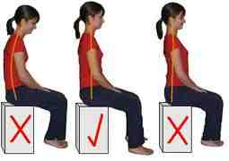

All students to get into the ‘table work position’ in preparation for table top activities.
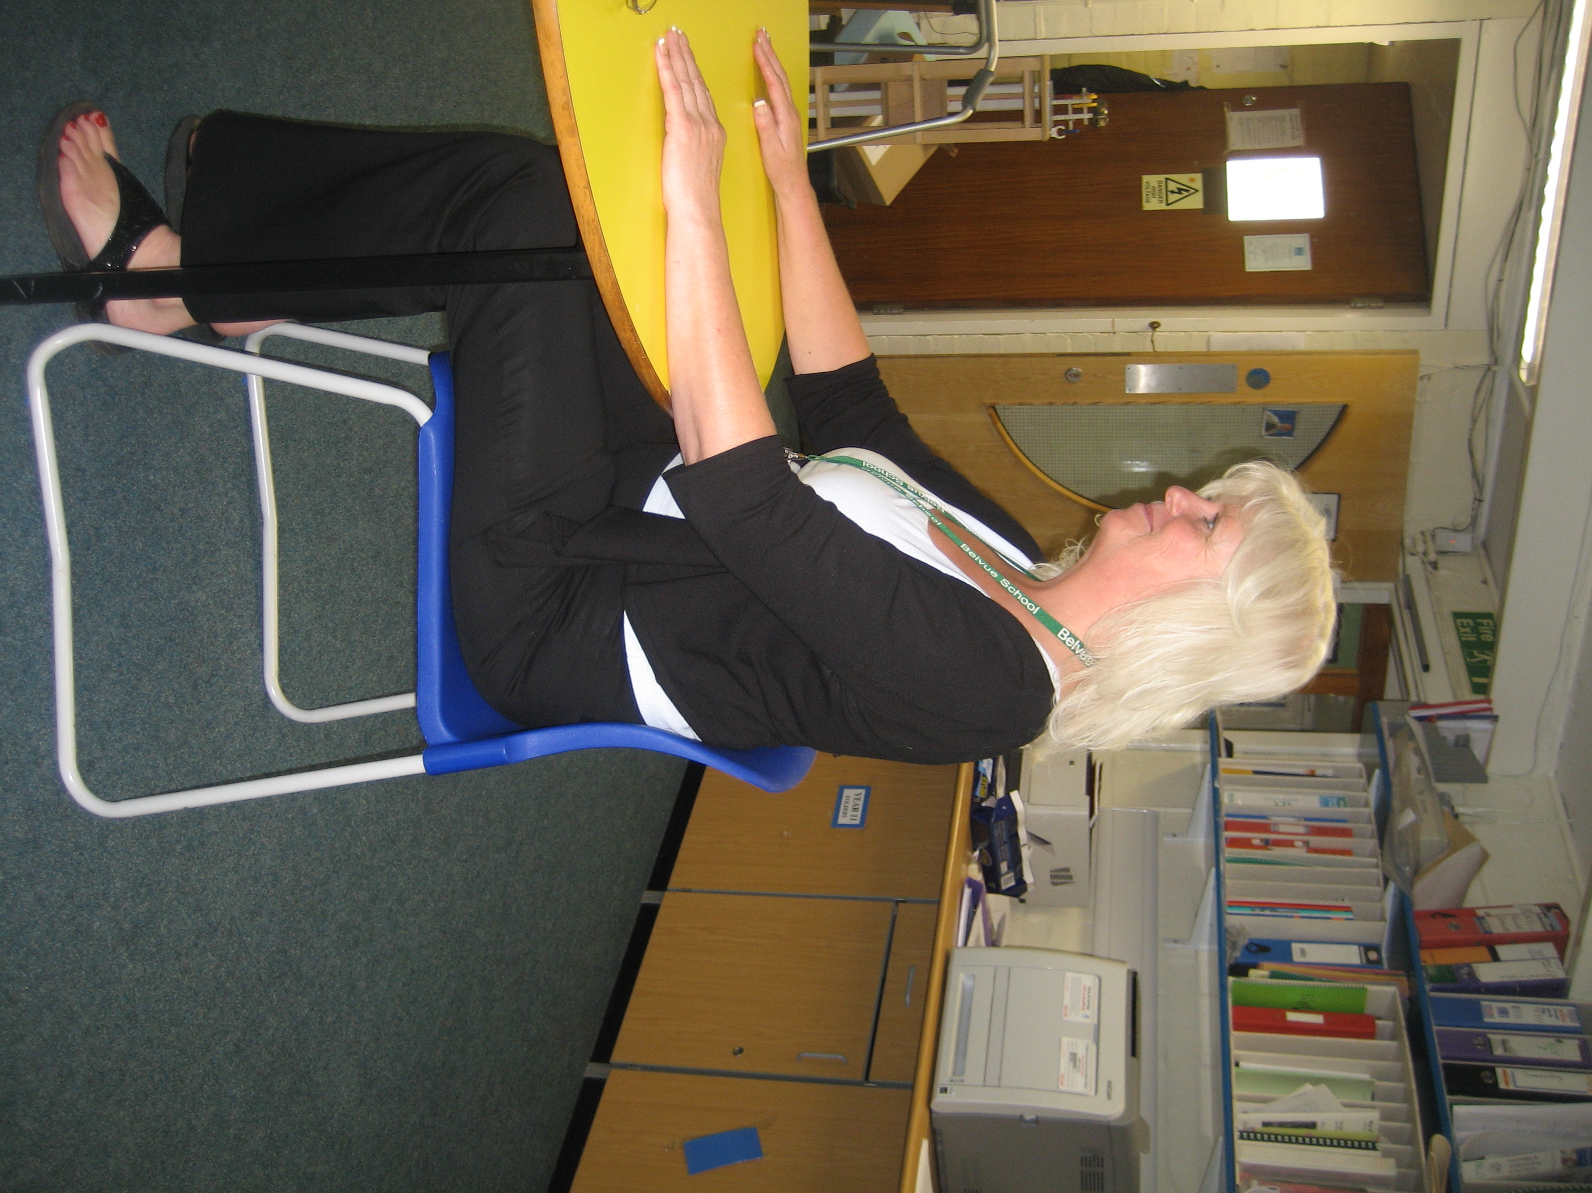

Table work position
  - Chair under table,
  - Bottom back in chair,
  - Feet flat on floor,
  - Arms on the table.

Good Sitting

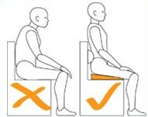
Good Sitting

(Enclosure 2)

Postural Warm-up Exercises:

Stretching

- Whilst standing upright – make yourself as tall as you can by reaching with both hands above your head as high as you can. | 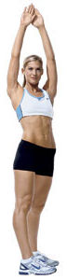
- Stretch one arm at a time up and over your head and hold for 5 seconds. Then do the same with your other arm. | 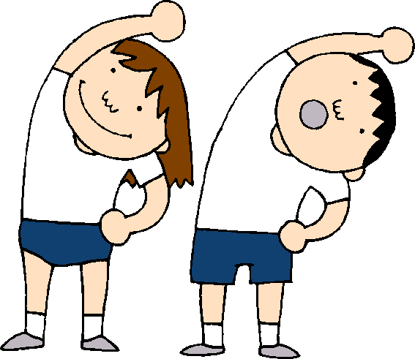
- Reach one arm across your body to the opposite side and hold for 5 seconds. Then swap arms. | 
- Touch opposite foot with opposite hand twice. | 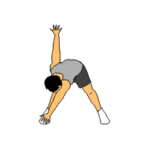
- Whilst chair sitting, keep your feet still and turn at the waist to bring both hands to one side of your body. Hold this position for 5 seconds. Then repeat taking both hands to the other side. Hold for 5 seconds. | 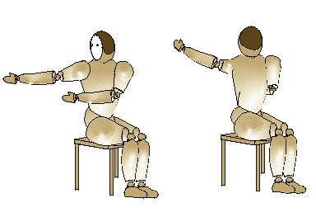

Alternative Alerting Strategies Pending Students’ Ability Levels:

- Store regularly used items at different heights within a brightly coloured / stimulating area of the classroom for the student to collect.
- Large movements in the air re action songs
- Stretch up to pop bubbles blown in the air
(Enclosure 3)

Posture Break Activity Ideas.

Choose one of the following activities for completion during breaks in-between table top activities (for safety, please ensure students only use stable and static furniture whilst completing the following activities):

Drawing / writing upon a vertical surface or cleaning class board. | 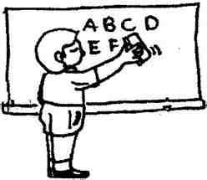
Holding items against gravity whilst handing them out to peers. | 
Encouraging students to help rearrange equipment / tables / chairs (as appropriate for their age), in preparation for learning activities. | 
5 x wall or table push-ups.  - Stand with toes touching wall  - Take one step backwards.  - Arms at shoulder level, shoulder width apart.  - Keep bottom in a straight line with shoulders and ankles.  - Discourage students from rushing the push-ups. | 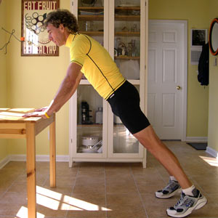  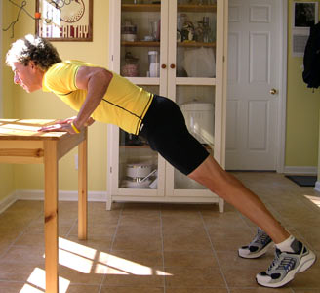  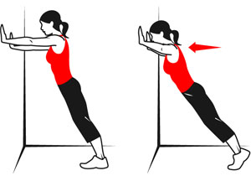
5 x Chair press ups. | 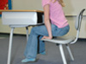
Trying to touch both shoulders to touch the ear on the same side of the body 5 times. | 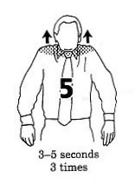

(Enclosure 4)

