POST 16 NEWSLETTER – NOVEMBER 2021

Welcome back; we hope you all had a lovely break!
DIWALI
We want to wish our college community who celebrate Diwali to have a wonderful time this week. We will be thinking of you.

BREAST CANCER AWARENESS
Last month the college held a fund raising day to support people suffering from breast cancer. The college was decorated in pink and students and staff came dressed in pink too and were able to buy cakes and treats all related to the theme. The day was a huge success and the college raised £150 for the cause.
Look out for more information in one of our blogs this month.

RESIDENTIAL
Letters for the summer 2022 residential have now been sent out. There are only a few places left, but if they are not filled the trip may not be able to go ahead and that will be a real disappointment. Remember to send back your form to gain one of the places before it is too late.
This is a trip that all students will remember as they have the chance to be away and have fun and relax with their friends.

COVID TESTING
You will be aware that cases of Covid are increasing again and this has a big impact on the whole school community. We continue to take every precaution in keeping students and staff safe. As a result, windows and doors will be open as usual to increase ventilation and therefore students need to bring in a jumper or can wear coats in class to keep warm. In addition, we encourage you to continue to carry out testing of your child twice a week (if this is something which you are prepared to do) and write a note in his/her diary of the result. If your child tests positive then follow government guidelines and keep your child at home for the recommended number of days.

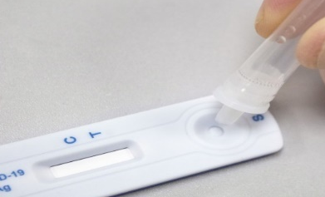
COLLEGE JOBS
In the last newsletter we were happy to announce the first round of our chosen job applicants for this term. However (unfortunately), only the SMSA Apprenticeship Post has been effective to date. As a result, it means that other student applicants who had applied and who would have been chosen to start in the spring term, may be able to start sooner.
A special shout out to the successful candidate undertaking the SMSA Apprenticeship Post in 5JG, as he has been doing an absolutely amazing job and cannot be praised enough by students and staff – well done!

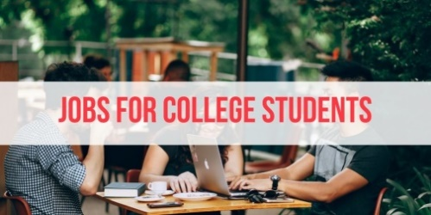

WORK UNIFORMS - UPDATE
Thank you for your patience in this matter. The uniforms should be arriving shortly and once they are in, you will receive your child’s fleece and polo shirt with a letter that you will need to sign and return.
COLLEGE BLOG
Each week on the school website, there is information about some of the things that are happening in Post 16. Please ensure that you take a look each week to read about what the students have been doing.

HOMEWORK
Please support your child to complete any homework they may be given or to go through any of the ideas and exercises in your child’s diary. If your child is on the list to be travel trained, in the process of being travel trained or they just want to become more independent, give them as many opportunities to do so in and out of the home – even if it is more time consuming for them to do it. It will give them a sense of achievement and you’ll also see how much they can actually do! In the long run it will benefit everyone. Your child undertakes many tasks in and out of college and we will endeavour to always push and stretch them to do so much more.

TRANSITION EVENING
This will now be taking place in December just before your child’s annual review so you will hear up-to-date information that will help with your child’s future choices, especially if this is their last year. The event will probably take place via Zoom again this year (more information nearer the time). This is an opportunity to obtain information regarding your child’s future after Post 16 by hearing from different organisations, including colleges, Mencap and Connexions. We recommend that you attend this important evening.

ANNUAL REVIEW
You will receive your child’s annual review in draft before your allocated date and other information and forms that you will need to complete which forms the parent/carer section of the annual review. Dates: Monday 13 – Friday 17 December; your child must: accompany you to their annual review, be seen on the Zoom call or be with you and heard in a phone meeting. Connexions will contact all leavers family by phone.

COP26 WALK
COP26 awareness week is running until 12th November. We will be participating in the Giant Walk to School campaign in support of COP26. On Friday 12th November we encourage students where possible to take the bus, train or walk to College. If you do drop your child to College, maybe park a little further away and walk the last part. We will be talking with the students during the week about the importance of climate change and how active travel can help this.

BEHAVIOUR OUTSIDE COLLEGE
College staff are dealing with a lot of student issues that are occurring outside of our educational setting. These incidences are happening at weekends and during the holidays. We have previously stressed that we take these matters seriously and if you feel that an issue is of a serious concern involving your child, please do not wait to inform us but contact the police.

*IMPORTANT ADVANCE INFORMATION*
Many of our calendar dates are different from the main school

Christmas Trips – Wednesday 1 December
Christmas Bazaar (Belvue main site) – Friday 3 December 10.30-12.00
Christmas Lunch – Wednesday 8 December

END / START OF TERM
Friday 10 December – last day of term for all Post 16s. Students are expected in school on this day. Wednesday 5 January 2022 is the start of the spring term.

APPOINTMENTS
If you would like to see your child’s VT/class teacher or Miss Gibson please write a note in your child’s diary or call the college office to book an appointment.

Ken Phone Number: 020 8422 0372 / Belvue Phone Number: 020 8845 5766
belvuecollege@belvue.ealing.sch.uk
Please use this number to let us know if your child is running late, is ill, have an appointment or for any other reason.

