POST 16 NEWSLETTER – APRIL 2023

To all our families celebrating Eid

#

EMPLOYABILITY WEEK
Students enjoyed another successful Employability Week. Each class was involved in several different employment experiences, learnt various new skills, and built on others.

RESIDENTIAL
The Post 16 residential is fast approaching, and students are excited about this opportunity to spend time away with their friends. Please ensure that if your child is attending the trip, you complete and return all the necessary forms. If you have any questions regarding the residential, please do not hesitate to call and ask.

EXAMS/COURSEWORK
The accreditation and Functional Skills deadline for students to complete their coursework and exams is in May and June. Student grades will be awarded in the autumn term. Students who do not pass their Functional Skills English or Maths exams will have the opportunity to try for the qualification again next year or at their new placement if they are a leaver. Any certificates awarded should arrive and be posted to you in the autumn term.
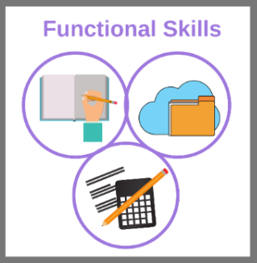

*IMPORTANT ADVANCE INFORMATION*

Monday 4 – Monday 18 April Easter Holidays
Tuesday 19 April College Closed-Training Day
Monday 2 May College Closed-May Day
Monday 30 May-Friday 3 June Half Term
Wednesday 21 June Leavers Graduation Presentation
Thursday 29 June Prom
Friday 30 June Last Day of College-End of Year

APPOINTMENTS
If you would like to see your child’s VT/class teacher or Mr Peterson please write a note in your child’s diary or call the college office to book an appointment.
Ken Phone Number: 020 8422 0372 / Belvue Phone Number: 020 8845 5766
belvuecollege@belvue.ealing.sch.uk

