POST 16 NEWSLETTER – JANUARY 2023

CHRISTMAS LUNCH
Students and staff enjoyed an afternoon of fun and laughter at the Railway Hotel in Greenford. This is our second year of using this venue and we are delighted to announce that once again the restaurant staff were amazing and ensured we all had a great time. They allow us to use the entire restaurant for our own personal party and provided large portions of tasty mains, desserts and drinks for everyone to enjoy. Students socialised with each other, played games and took memorable photos.
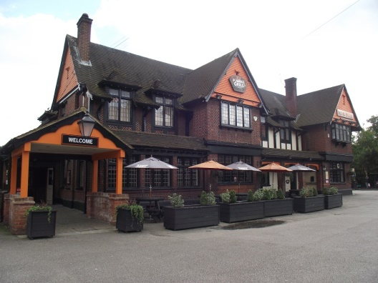

CHRISTMAS TREAT
This year students and staff from each class organised their own Christmas trips, instead of having a whole Post 16 treat. It meant that students were able to chill and enjoy the activities they chose together with their friends.

ANNUAL REVIEWS
The majority of annual reviews took place last month. Any outstanding Annual Reviews need to be undertaken and completed before the end of this month, so please ensure that you respond to any messages sent regarding a new appointment.

WINTER FAYRE
The Belvue Winter Fayre was a wonderful event for all who attended! Thank you for your support and generosity.
The stalls were manned by students and staff selling food items, gifts, raffle prizes, etc. and all resulted in a fantastic monetary collection for the school community.

BURSARY
Bursary emails have now been sent out for applicable students outlining the amount your child will be receiving. If your child receives free school meals and you have not received an email, please email/contact Mr Peterson to let him know, so that he can chase it for you.

LEAVERS CHOICES
If your child is a leaver this June 2023, then spring is an important time for you. If you do not already know, find out what level your child is working at (e.g. Pre-Entry Level, Entry Level 1) and visit different colleges, explore different supported learning courses online and examine different internship opportunities. In additions, Connexions will be available to advise and support you with the process. In addition, the school will also arrange some college visits and will send out the open days of local colleges (they are also online on the college websites).

*IMPORTANT ADVANCE INFORMATION*

Thursday 24 January Night Club–students stay till 7pm
Monday 13 – Friday 17 February Half Term
Monday 6 – Friday 10 March Employability Week
Monday 27 – Friday 31 March Transition/Learning Conversations
Friday 31 March End of Term @ 1:00pm
Monday 3 – Friday 14 April Easter Holidays
Friday 21 April Training Day – School Closed
Monday 1 May May Day – School Closed
Monday 29 May – Friday 2 June Half Term
Wednesday 21 June Leavers Presentation/Graduation Evening
Thursday 29 June Post 16 Prom
Friday 30 June End of Term

APPOINTMENTS
If you would like to see your child’s VT/class teacher or Mr Peterson please write a note in your child’s diary or call the college office to book an appointment.
Ken Phone Number: 020 8422 0372 / Belvue Phone Number: 020 8845 5766
admin@belvue.ealing.sch.uk

