The cost of the uniform is
POST 16 NEWSLETTER – DECEMBER 2021

**ALL STUDENTS IN POST 16 MUST HAVE A VALID OYSTER CARD/FREEDOM PASS**

OFSTED
As you will be aware the school had their Ofsted on the 23rd and 24th November. A big thank you to all parents/carers and students who completed the Ofsted questionnaires about the school and to staff for all the hard work they undertake routinely in supporting and teaching our young people. A special thanks to students in Post 16 who met and had a discussion with the inspector. We should know result before the Christmas break.
BURSARY
All students received a bursary letter outlining the possibility of extra financial support for items such as the college work uniform and travel expenses to and from places on your child’s timetable. If after reading the letter you feel you are eligible to apply please do so as soon as possible, giving your reasons why and what you need or would like to purchase for your child.

VISITING PERFORMANCE
At the end of November, we had a special performance by ‘Face Front’ a group of inclusive actors. The play was about transition from school to adult life, where the audience explore how to make positive outcomes through changing the actions of the characters. It explores the issues for a group of young people with learning disabilities, and includes multiple communication tools including music, movement, poetry, Makaton and film. The performance and discussion session afterwards were enlightening and very informative for our learners.

TESTING
The DfE have announced that they expect all secondary schools to test pupils once during the first week back after the Christmas holidays. Like before, the testing will happen at the college for those students whose parents gave permission before. A letter will also be sent home to confirm that you still give your consent. Remember, students who are 18+ and understand the process can give their own permission.
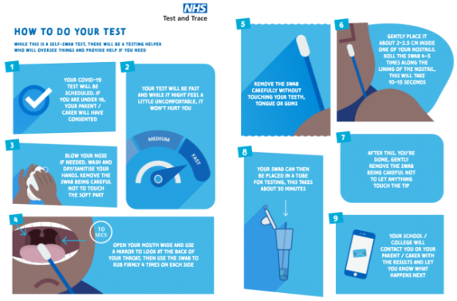

COLLEGE JOBS
The autumn student jobs finish at the end of this term and new students can apply for the current positions and a new addition. However, the previous successful candidates can reapply too. Available jobs for the spring term will be: SMSA, premises, gym and library apprentice. Application forms will be available during the first week back at college in January.

RESIDENTIAL
Date: Monday 16-Friday 20 May 2022. The wonderful news of the residential being free instantly increased the number of students wanting to attend. However, it needs to be pointed out, that if your child has serious behaviour issues, which will affect the overall enjoyment of the group, they will not be able to attend. More information will be given much nearer the time, including the medical forms, swimming permission, kit list, etc.

WORK UNIFORMS - UPDATE
Great news! The uniforms have finally arrived. The cost of the uniform is £22. Letters with the Parent Pay barcodes are being generated and should receive these by the end of term. Once we have received payment, your child will be able to collect their fleece and polo shirt. Please check your child’s timetable to know which days he/she will need to wear it. The subject’s students need to wear their uniform are: Litten, Horticulture, Horsenden, Community, Haverlock, Glass and any other activities being undertaken off-site.

CHRISTMAS LUNCH-subject to change
Wednesday 8 December. We are hoping to have Christmas Lunch off-site in Greenford for all Post 16 students and staff. They will be treated to a 2 course Christmas meal (meat or vegetarian option) and drinks. The theme this year will be for students to wear their favourite jumper or a Christmas jumper. We want the event to be as inclusive as possible for everyone. It will be an afternoon of socialisation and fun for all students as they enjoy a lovely meal and spend time with their friends.

TRANSITION EVENING
Thursday 9 December from 5-6:30 over Zoom. It is an important opportunity to hear up-to-date information that will help with your child’s future choices after Belvue especially if this is their last year. You will hear from different organisations, including colleges, Mencap and Connexions. A text will be sent out with the zoom link on the day. We recommend that you attend this key evening.

CHRISTMAS TREAT – subject to change
Friday 10 December. Unfortunately, the previous date was cancelled, but we finally managed to arrange another for the last day of term. The treat will be for the whole college to go to the cinema (Cineworld in Ruislip). Your child will need and to bring a face mask and a packed lunch on the day; students on free school meals will receive a packed lunch from the college.

ANNUAL REVIEW
Monday 15-Friday 19 December. You will receive your child’s annual review in draft before your allocated date. Please ensure that you complete any relevant sections – both yourself and for your child. Unfortunately, due to the current Covid situation all annual reviews will either take place over the phone or via Zoom. Reminder your child must be seen on Zoom or be with you and heard in a phone meeting. Please confirm the choice you would like in your child’s diary by writing: AR=Zoom or AR=Phone.

*IMPORTANT ADVANCE INFORMATION*
Many of our calendar dates are different from the main school

Christmas Lunch – Wednesday 8 December
Transition Evening – Thursday 9 December
Christmas Treat – Friday 10 December: New date
Night Club – Thursday 27 January: students stay till 7pm
Half Term – Monday 14 – Friday 18 February

END / START OF TERM
Friday 10 December – last day of term for all Post 16s. Students are expected in school on this day. Wednesday 5 January 2022 is the start of the spring term.

APPOINTMENTS
If you would like to see your child’s VT/class teacher or Miss Gibson please write a note in your child’s diary or call the college office to book an appointment.
Ken Phone Number: 020 8422 0372 / Belvue Phone Number: 020 8845 5766
belvuecollege@belvue.ealing.sch.uk

