POST 16 NEWSLETTER – JUNE 2023

We sincerely apologise for the delay in releasing the June newsletter. However, we assure you that the content is still as informative as ever!

LAST DAY OF TERM
Another academic year has gone by so quickly and FRIDAY 30 JUNE is the last day of term for all students. School will finish at 3:00pm as usual. If your child is staying at Belvue for another year, then we look forward to seeing them on Monday 11 September at the main Belvue site on Rowdell Road. If your child is a leaver please provide them with a large bag during the last week of school, as they will have things they may want to take home with them.

SHOPPING TRIP
Post 16s students had their annual shopping trip and fun was had by all. The range of items bought always were varied. Students enjoy being able to browse the shops with the friends, try on items and then buy what they like. It’s an experience that many of our young people do not get, as they may only ever go shopping with their family. They enjoyed being able to show each other what they bought and being able to express their likes and dislikes on certain things.

RESIDENTIAL
The annual Post 16 residential was another huge success! All students and staff had an amazing experience. Students enjoyed the week spending time with their friends and staff and undertaking a number of different activities. Students were able to go to the seaside, swim in the on-site swimming pool, enjoy daily evening activities including a number of different shows and a disco, and also had the opportunity to eat out in a restaurant and in their caravan with their friends. The experiences and life skills gained will be remembered for a long time!

LEAVERS GRADUATION
For those parents who managed to come to this important and extremely special occasion were able to see their child dressed in their graduation finery. We had 42 leavers this year and they all looked amazing! This memorable evening allowed students to share their unforgettable moments, say thank you to staff and family and say goodbye to Belvue as we shared a small glimpse into their lives with us (photos of themselves from when they first started at Belvue until now). It was followed by light refreshments and an opportunity for students to throw their hats up in the air and to take photos with their family, friends and staff.

SOUTHALL TASTER DAY
There is a transition event happening at Southall College on Friday 23rd June. Students who will be attending Southall College in September will have a taster day at the college. The day will include a class-based session, a tour of the site and lunch in the college café. This is an excellent opportunity for students to visit and familiarise themselves with their new college before they start in September.

TRAVEL TRAINERS EVENT
Belvue students took part in creating a video to promote travel training. They assisted and supported the team in putting together this vital and informative ‘pack’ that will hopefully ensure more young people take up the service. Being an independent traveller, as well as being a fundamental life skill, is a rite of passage for many of our young people, which makes them feel more mature and like the young adult that they are.

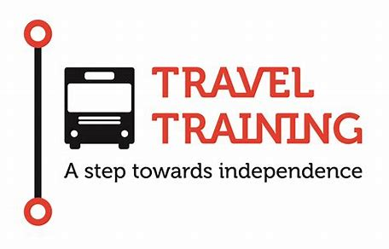

PROM
Monday 26 June is the date for this year’s Prom. This is a wonderful time for students to dress to impress and have an evening of fun, food and dancing with their friends. There is no cost for the event. This will include an amazing range of entertainment for your child: pre-drinks and snacks, celebratory photos, an evening meal, drinks, a disco and a goody bag.

BENEFIT LETTER
This is the time when the benefits office will be contacting certain families regarding what their child will be doing or where they will be going (e.g. which placement) in September 2023. Some letters will say that your child’s benefit will be stopping on a date in September. Please do not worry. After the holidays, we will have letters available for you to send off with your forms or we will help you to complete your form if you require. Just contact us to let us know. Those moving on to college can undertake the process in their new college/setting.

FREEDOM PASS/OYSTER CARD
Please check and ensure that your child has a valid up-to-date Freedom Pass or Student Oyster Card 16+ or 18+, whichever applies at the time. All students need to have one for the beginning of the new academic year starting in September for Belvue, and for any leavers, for the new placement they will be transitioning onto.
If you need support with completing any of the forms let us know.

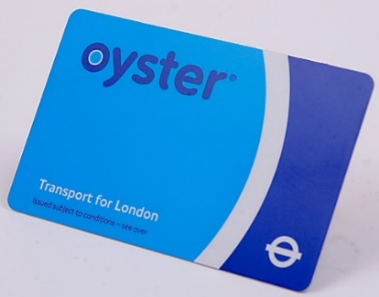

LEAVERS AND COLLEGE
We have been hearing that some families have not received any conformation and are still unsure about a college placement for their child for September 2023. Unfortunately, the colleges seem to be getting slower at processing application and passing on this information, as they are overwhelmed by the increase in numbers. Adele from Connexions is on hand to answer any queries you may have, but to assure you, it is still early days and you may not hear anything until August.

*IMPORTANT ADVANCE INFORMATION*

Monday 11 September 2023 Start of Term
Monday 23 – Friday 27 October 2023 Half Term
Monday 30 October 2023 Occasional Day/Closed

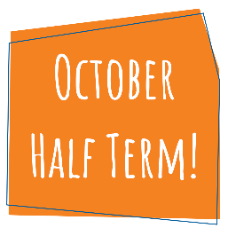

APPOINTMENTS
If you would like to see your child’s VT/class teacher or Miss Gibson please write a note in your child’s diary or call the college office to book an appointment.
Ken Phone Number: 020 8422 0372 / Belvue Phone Number: 020 8845 5766
belvuecollege@belvue.ealing.sch.uk

