POST 16 NEWSLETTER – MAY 2022

**LAST DAY OF TERM-FRIDAY 24 JUNE**

BENEFIT LETTER
This is the time when the benefit office will be contacting certain families regarding what their child will be doing or where they will be going (e.g. which placement) in September 2022. Some letters will say that your child’s benefit will be stopping on September 5th. Please do not worry. After the holidays, we will have letters available for you to send off with your forms or we will help you to complete your form if you require. Just contact us to let us know.

RESIDENTIAL
Monday 16 – Friday 20 May. Students will leave the college at 9:15 am. Your child will need to bring a full packed lunch and any snacks. If your child is bringing any medication, please ensure that it is put into a bag with the packaging clearly labelled with their name, the exact amount to be given (and when) is highlighted and identified accurately. If your child is allowed to go into the pool or sea, ensure that they have a swimsuit and an extra towel.

EXAMS/COURSEWORK
We are in the final stages of students’ coursework and exams. The work all needs to be completed, marked and sent to the examiners by summer half term. We will receive the results in the summer and certificates in the autumn term. Any leavers certificates will be posted out to them by November.

LEAVERS GRADUATION
Wednesday 22 June @ 4-6pm???. If your child is a leaver please ensure that you keep this significant day in your diary. It will be a memorable evening for leavers to say goodbye to Belvue and to share their memories of their life with us. Leavers will have the opportunity to see images of themselves from when they first started at Belvue until now. There will also be light snacks and drinks and time to say goodbye to friends and staff.

PROM
Thursday 30 June is the date for this year’s Prom. This is a wonderful time for students to dress to impress and have an evening of fun, food and dancing with their friends. The cost of the evening will be about £15. This will include an amazing range of things for your child’s entertainment: pre-drinks and snacks, celebratory photos, an evening meal, drinks, disco and goody bag.

WESTSIDE YOUNG PEOPLES CENTRE
Address: Churchfield Road, W13 9NF
Young people with additional needs support can attend:
Monday after school sessions 3:30-6:00pm: Term time only – Ages 11-16
Wednesday evening sessions 6:30-9:00pm: Weekly - Ages 11-25

- Cooking & baking sessions
- Recording music in the on -site music studio
- Arts & crafts
- Group games, activities and competitions
- Sport, physical activity & sessions in the on-site gym
- Computer games & computer suite access
- Recreation room – pool/basketball/table tennis/table football

MENCAP SATURDAY CLUB
The team meet at 10am at Dare2Dream, 1-2 Leeland Road, West Ealing, W13 9HH.

Activities, chosen by the group, include typical trips like:
- visiting local attractions,
- mini golf,
- bowling,
- trampolining,
- outdoor sports,
- companion cycling,
- entertainment venues and much more.

Attendance is free for young people not eligible for social care support.
Young people need to bring their own cold packed lunch and drinks.
The group does not meet during Easter, Christmas and Summer holidays.
Contact Aleks Rogozinska to book your place. aleksandra.rogozinska@ealingmencap.org.uk 020 8566 9575.

FREEDOM PASS/OYSTER CARD
Please check and ensure that your child has a valid up-to-date Freedom Pass or Student Oyster Card 16+ or 18+, whichever applies at the time. All students need to have one for the beginning of the new academic year starting in September for Belvue, and for any leavers, for the new placement they will be transitioning onto.
If you need support with completing any of the forms let us know.

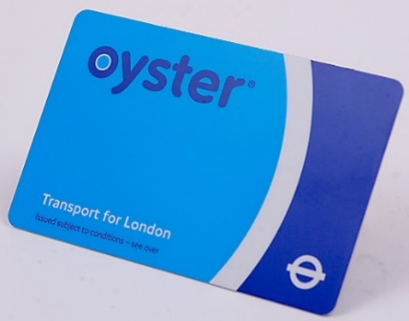

SHOPPING TRIP
We are pleased to announce that we will be having the Belvue Post 16 shopping trip on Thursday 5 May to Harrow Shopping Centre. A letter will have been sent out to each class with the arrangements of the day. This will be a relaxed trip where students can have fun shopping with their friends.

*IMPORTANT ADVANCE INFORMATION*

Monday 2 May College Closed-May Day
Thursday 5 May College Shopping Day
Monday 30 May-Friday 3 June Half Term
Wednesday 22 June Leavers Graduation Presentation
Friday 24 June Last Day of College-End of Year
Thursday 30 June Prom

APPOINTMENTS
If you would like to see your child’s VT/class teacher or Miss Gibson please write a note in your child’s diary or call the college office to book an appointment.
Ken Phone Number: 020 8422 0372 / Belvue Phone Number: 020 8845 5766
belvuecollege@belvue.ealing.sch.uk

