Intent
Theatre is at its best when it excites and incites. Theatre provokes action, it challenges complacency, it demands attention and challenges ways that things have always been done. It is a rebellion, a voice, a focus, an engagement, a solution, a platform for everyone and anyone. Nobody is exempt.
The Drama Department at Belvue High School is committed to delivering a curriculum that at its core lies play. It serves to enrich and empower all of our learners.
The aims are to develop self –discipline, team work and communication and to nurture a sense of self and belonging to a group/community.
Through creating, performing and evaluating their own and others’ work, it is hoped that the curriculum will inspire our Belvue learners to value their experiences, take risks, explore and give a platform for their voices and stories to be heard.
Overview

Drama is divided into THREE key areas in line with the National Curriculum:

- Physical
- Vocal
- Performance
Weekly Drama lessons for Key Stage 3 are structured to embed the three key areas, and are recorded on Classroom Monitor and Individual Learning journeys. A weekly lesson is dedicated to these three key areas, where students work in small groups and receive 1:1 input from class teachers and TA’s. Students explore various drama activities and tasks to develop performance skills and to support them with cross-curricular skills e.g. Speaking and listening, working as a team, storytelling, confidence, and developing presentation skills.
Over a 2 year period, Key Stage 4, MLD students follow the WJEC accreditations in exploring physical and vocal techniques as well as performing in front of an audience. Learners will work towards achieving an Entry 2/3 in the following areas or will receive a Belvue certificate in:
- Using the voice in a dramatic context
- Using the body in a dramatic context
Contribute to the creation of a group drama presentation
Drama

KS4  OPTIONS | Autumn | Spring | Summer
Year 1  (WJEC ENTRY 2) | Explore using the Voice in a dramatic context | Explore using Body in a dramatic context | Explore and contribute to the creation of a group drama
Overview | Working towards their accreditation for WJEC, students will explore and use different types of vocal skills in situations. They will explore vocal skills to enhance emotions and work towards finding variety in vocal characterization and role play.  To achieve this, students will participate in a range of games, role-plays, improvisation and text/script work.  Using techniques from various practitioners e.g. Laban voice work which focuses on the 8 Efforts (press, punch, float, glide, dab, flick, slash and wring) - into vocal variety or expressive exploration as well as Arthur Lesaac, whose voice text teaches the “feeling process” for discovering vocal sensation and developing tonal clarity, articulation, and better connection to text and rhythms in speech.  It is hoped that learners will recognise that the voice is the most human of instruments and will support their personal development as a versatile and curious performer/actor. Alongside proficiency and confidence in traditional performance contexts, this WJEC course encourages learners to explore a diverse range of avenues in a quest to discover their own unique voice.  Autumn | Students will explore using contrasting physical skills in different situations.  They will explore physical skills to show contrasting moods/emotions and work towards presenting contrasting roles/characters through the use of physical skills.  To achieve this, students will participate in a range of games, role-plays, improvisation and text/script work.  Using techniques from various practitioners e.g. Jacques Lecoq whose “comic book” style encourages physical exploration, learners will explore body language and explore tableaux and physical technique.  It is hoped that learners will recognise that the body has a language of its own and can present feelings and moods.  The WJEC course encourages learners to experiment, explore and evaluate physicality and use it to tell stories and differentiate between characters.  Spring | Students will explore creating/devising a piece of theatre to perform in front of an audience.  They will create characters and develop a storyline with a beginning, middle and end.  They will make contributions to group discussions and contribute to the development of a storyline or plot.  Working collaboratively with others to allocate roles within a group, they will sequence ideas and select a costume for an individual role to be performed.  They will also suggest costumes for other roles to be performed.  Students will select personal props for themselves and others in their group.  Students will work on skills to perform a role expressively. They will rehearse collaboratively with their groups and work towards producing a focused performance of a role as planned, in front of an audience.  Autumn
Year 2 (WJEC ENTRY 3) | Implement using the Voice in a dramatic context | Implement using Body in a dramatic context | Implement and contribute to the creation of a group drama
 | Students will implement and identify and use different types of vocal skills in situations in depth. They will explore vocal skills to enhance emotions and work towards finding variety in vocal characterization and role play.  Working towards their accreditation for WJEC, students will Identify and use different types of vocal skills in situations. They will explore vocal skills to enhance emotions and work towards finding variety in vocal characterization and role play.  To achieve this, students will participate in a range of games, role-plays, improvisation and text/script work.  Using techniques from various practitioners e.g. Laban voice work which focuses on the 8 Efforts (press, punch, float, glide, dab, flick, slash and wring) - into vocal variety or expressive exploration as well as Arthur Lesaac, whose voice text teaches the “feeling process” for discovering vocal sensation and developing tonal clarity, articulation, and better connection to text and rhythms in speech.  Work will be collated and submitted to the WJEC for accreditation. | Students will be able to use contrasting physical skills in different situations and implement physical skills to show contrasting moods/emotions. They will work towards presenting contrasting roles/characters through the use of physical skills in depth.  To achieve this, students will participate in a range of games, role-plays, improvisation and text/script work.  Using techniques from various practitioners e.g. Jacques Lecoq whose “comic book” style encourages physical exploration, learners will explore body language and explore tableaux and physical technique.  Work will be collated and submitted to the WJEC for accreditation. | Students will be able to create/devise an in depth piece of theatre to perform in front of an audience.  They will create characters and develop a storyline with a beginning, middle and end.  They will make contributions to group discussions and contribute to the development of a storyline or plot.  Working collaboratively with others to allocate roles within a group. They will sequence ideas and select a costume for an individual role to be performed.  They will also suggest costumes for other roles to be performed.  Students will select personal props for themselves and others in their group.  Students will implement the skills they have learnt over 2 years and perform a role expressively. They will rehearse collaboratively with their groups and produce a focused performance of a role as planned, in front of an audience for assessment.  Work will be collated and submitted to the WJEC for accreditation.

Drama

Rehearsing for Cinderella. Chloe plays one of the Ugly sisters.
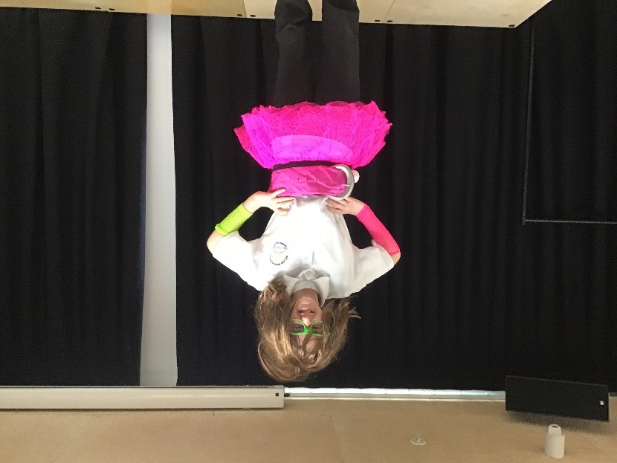
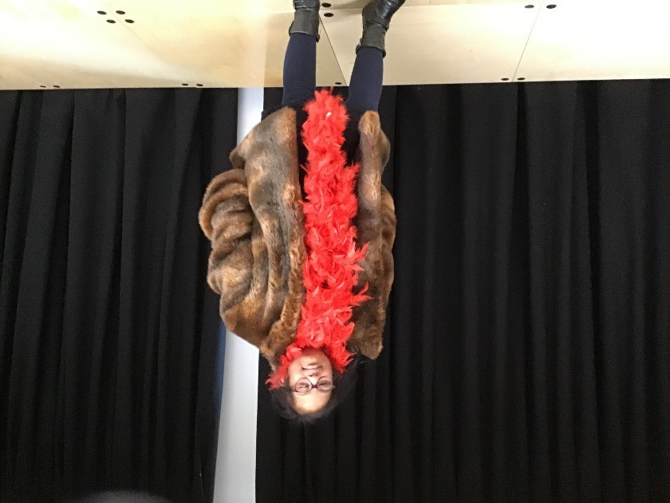
Rehearsing for Cinderella. The nasty step-mother.

Pranav. Playing the narrator in Cinderella
