POST 16 NEWSLETTER – MAY 2021

DIARIES
Students will be able to take their diary home from this month and we know that they are really excited about this. Please ensure that your child remembers to bring their diary back every day and use it once again for any messages or queries you may have regarding anything college related.

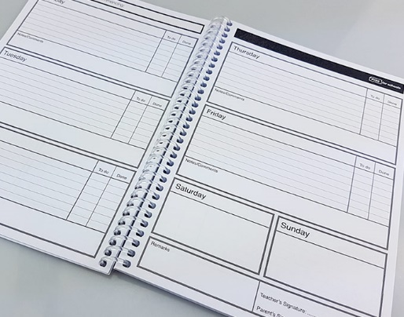

ELECTION DAY – COLLEGE CLOSED
Belvue College will be used as usual as a Polling Station on Thursday 6 May. There will be no college on that day. Students who attend Hospitality and Catering at Southall College will have to attend the course as usual. We will let you know if there are any changes.

IMPORTANT UPDATE – LAST DAY OF TERM
Important date change – we are pleased to announce that the end of year date for Post 16 students has been extended to Friday 16 July. Please ignore the previous date of Friday 25 June.

LEAVERS GRADUATION
We are hoping to have a socially distanced leaver’s graduation on Thursday 15 July. The event will take place for leavers and their family only at the main site where there is more space to be socially distanced and grouped as a family.
More information will be made available nearer the time.

LEAVERS PROM
Great news for our leavers this year; we will be having a leavers prom!
We have managed to arrange and secure a local venue willing to hold a prom during this period. The cost of the event will be £15 a head for an evening of fun. Students will enjoy a tasty meal, a lively disco and have memorable photos taken.

CORONAVIRUS TESTING
Any students that had agreed to a test, have been given a number of rapid tests to take home. Hopefully they were able to undertake the tests successfully independently or with your help.
The government will also be rolling out this service to adults too, so it will become more of a regular process that all people get used too.
This is a personal choice and we are aware that not all students are able to do so.
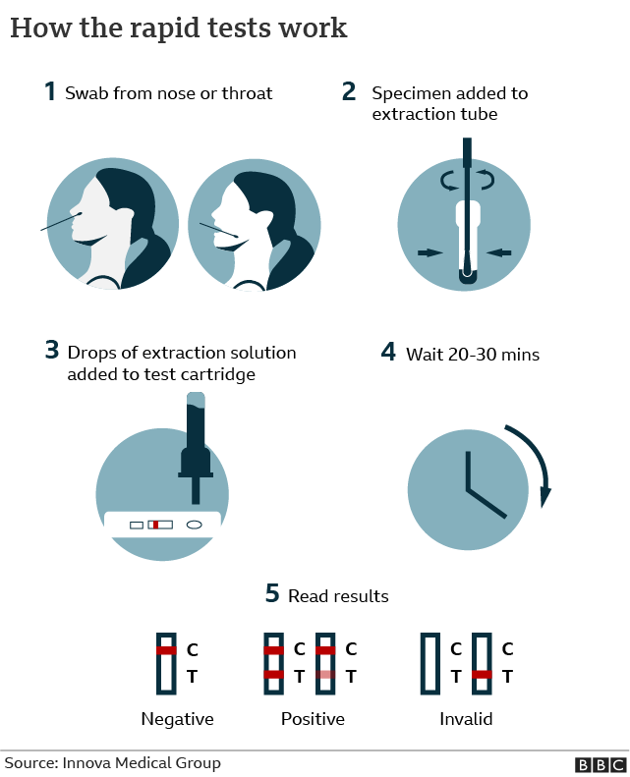

COURSEWORK / EXAMS
In the next few weeks students will be working hard to complete their coursework and exams. Although the government have allowed certain allowances for particular exams and qualifications the work still has to be undertaken and either filed away or made available for external moderation. If your child is undertaking a Functional Skills qualification please ensure that they are doing additional work at home e.g. learning their spellings, timetables, writing sentences, reading, etc.

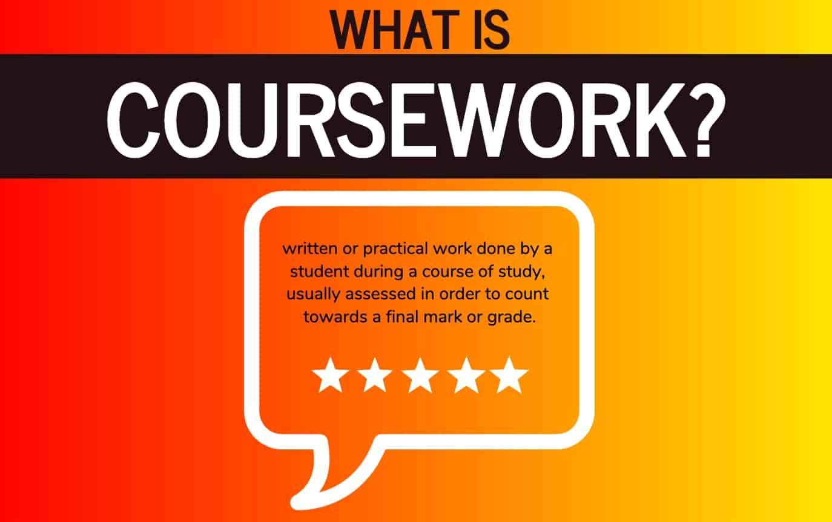

SMASHING GLASS
Belvue’s Glass Enterprise will be selling their products through the college. There is a mixture of jewellery (e.g. pendants/necklaces, earrings and broches) and items for the home (e.g. decorations, mirrors, coasters, small bowls) that you can buy. Prices range from £4 - £15. Please let us know if you are interested in purchasing anything. There is always a festival or celebration around the corner e.g. Mother’s Day and it is an ideal time to buy something for a loved one or friend.

 | 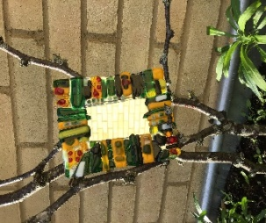 |  | 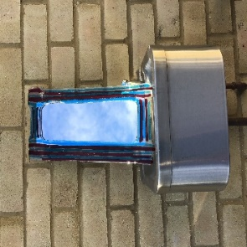

CONTACTING STAFF
If you have any concerns regarding anything while your child is at the college please contact us to book an appointment or to speak to someone on: 020 8422 0372

*ADVANCE NOTICE 2021*

Monday 31 May – Friday 4 June – Half Term

Thursday 15 July – Leavers’ Graduation (at main site Rowdell Road)

Friday 16 July – End of Year

31/05 - 04/06

Internet and Phone Safety

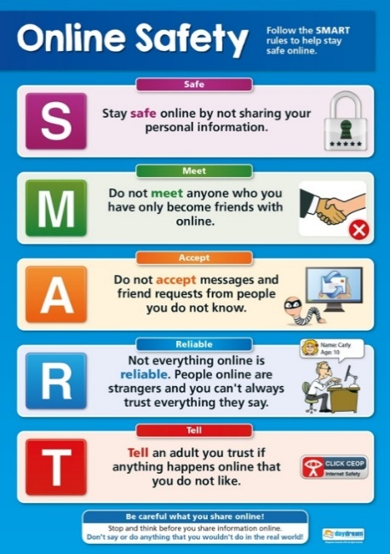
We are hearing about incidences of students using their phone and other devices inappropriately.
Please be aware that due to the age of our students the laws that apply to them are different than when they were in the main school and some things are illegal.
Remember that anything posted, uploaded or sent can be seen and will probably remain visible for years to come and can be shared by others and then by others in turn; meaning that it can end up anywhere!
Therefore, if it is something they would not like you or any other adult to see, read or hear, they should be very careful!
The police will be informed of any material passed between students that are harmful or illegal in nature.

