POST 16 NEWSLETTER – DECEMBER 2022

**FRIDAY 9 DECEMBER - LAST DAY OF TERM**

BELVUE CAFÉ
The new Post 16 Belvue Café has been a huge success with staff commenting and complimenting students on their hard work and customer service. It is proving a great opportunity for students to develop their work skills, especially customer services, as they serve staff a variety of high quality drinks and snacks during break times.
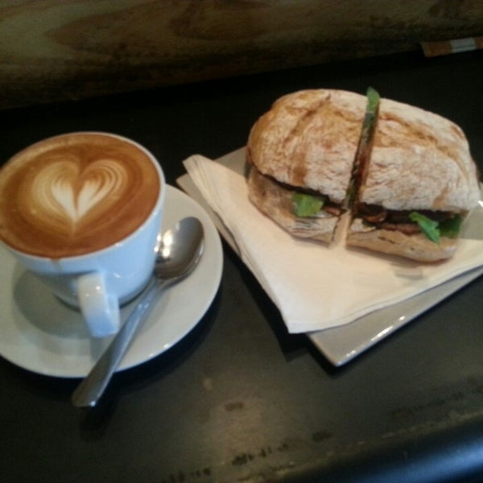
BURSARY
Bursary letters are now being processed. Anyone who receives Free School Meals will automatically qualify, anyone who sent in evidence to support a claim will have their paperwork examined and you’ll all hear about the outcome soon.

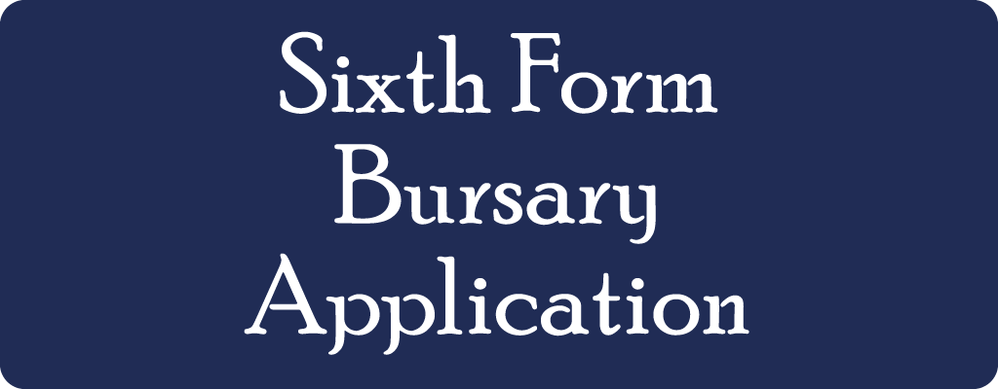

VISITING PERFORMANCE
On Monday 5th December ‘Move 22’, a performance group, will be coming in to school to present a work-related performance for our students. The performance will educate and highlight to students the subject of work.
Move 22

CHRISTMAS BAZAAR-REMINDER
DATE: Friday 2 December 10.30-12-00. Come along and buy some gifts and get some real bargains as you support the school and students with all they have organised and created for the day.

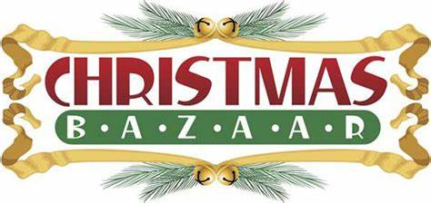
TRANSITION EVENING
This year’s transition evening was another success, even though the date had to be moved. We were finally able to hold the event once again the in main school hall with the organisations attending in person and not over a Zoom call. Information regarding your child’s future after Post 16 was heard by different organisations, including colleges, Mencap, NCS The Challenge and Connexions. Any comments regarding the evening would be greatly appreciated
.

ANNUAL REVIEW
Dates: Monday 12 – Friday 16 December. You will have received your child’s annual review date and the paperwork in draft, as well as other forms that you will need to complete which forms the parent/carer section of the annual review.
Reminder: your child must accompany you to their annual review. Connexions will contact all leavers’ family by phone and may also attend the annual review to answer any of your questions.

WORK UNIFORMS
Great news! The uniforms have finally arrived. You will receive your child’s fleece and polo shirt with a letter that you will need to sign and return. Please check your child’s timetable to know which days he/she will need to wear it. The subjects students need to wear their uniform are: Litten, Horticulture, Horsenden, Community, Haverlock and Glass.

CHRISTMAS LUNCH
Date: Wednesday 7 December. Christmas Lunch will be held at the Railway Hotel in Greenford for all Post 16 students and staff. They will be treated to a Christmas meal (meat or vegetarian option), a choice of dessert and drinks. The theme this year will be for students to wear their favourite jumper or a Christmas jumper. We want the event to be as inclusive as possible for everyone. It will be an afternoon of socialisation and fun for all students as they enjoy a lovely meal and spend time with their friends.

CHRISTMAS TREAT

Date: Thursday 8 December. Each class this year will organise their own Christmas treat. Each class will receive their own personal letters about the day regarding transport, Freedom/Oyster Cards, lunch, etc. It will be a time of celebration and fun, when students can spend their time socialising with their peers.

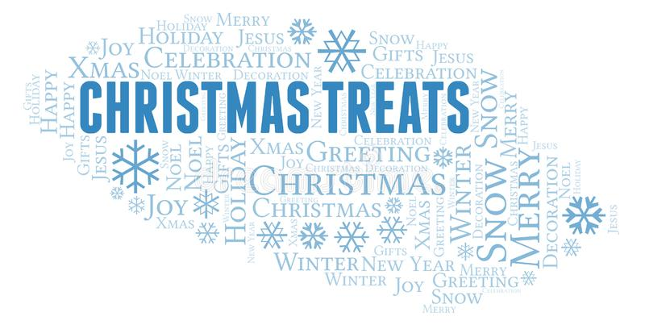

*IMPORTANT ADVANCE INFORMATION*
Many of our calendar dates are different from the main school

Night Club – Thursday 26 January: students stay till 7pm
Students will remain after school until 7pm to attend an evening of fun on Thursday 26 January 2023. Post 16 students will enjoy a Night Club experience with their friends, while the younger students have Night School.

APPOINTMENTS
If you would like to see your child’s VT/class teacher or Miss Gibson please write a note in your child’s diary or call the college office to book an appointment.
Ken Phone Number: 020 8422 0372 / Belvue Phone Number: 020 8845 5766
belvuecollege@belvue.ealing.sch.uk

