**Intent**

The aim is for post 16 students to be responsible for the catering at Belvue College.

The Post 16 catering at Belvue College @ Ken Acock began life in September 2015. The idea originated when the school was given the chance of having a separate site for our Post 16 students. The concept was then discussed and developed in detail as an amazing vocational opportunity for our students to learn how to prepare and cook food, in an industrial kitchen, for a large number of people. It also allowed them to gain meaningful life skills and qualifications.

It was decided that although the food at Ken Acock would be entirely vegetarian, students would still learn about where meat or fish could be added or substituted, if they were to prepare and cook the meal for themselves or others at home. It was also recommended that a specific session/s during the year be allocated to show students how to prepare and cook meat and fish simply and accurately.

Furthermore, at the Ken Acock centre the menus and recipes that our students learn to cook follow a seasonal theme (we are fortunate to have a local allotment to grow produce) to encourage a greater understanding of food groups.

In addition, the college receive a variety of food products, from the local Felix Project charity, which allows our students to work with staff creatively to produce additional meals separate from their regular recipes and menu.

The aim of each catering session is to equip our students with the practical skills, knowledge and confidence in order to independently create drinks and snacks and enjoy cooking meals for themselves and others. Students build on their previous skills learnt in KS3/4 to follow simple recipes using kitchen equipment safely and respect basic kitchen rules relating to health and safety and hygiene, in line with each of their individual abilities.



Catering



Catering

Five (out of the six) Post 16 classes have a specific day in which they are timetabled to cater for the groups studying at the college each week. The allocated class work together by dividing weekly jobs among themselves to prepare the room and table, prepare and cook the food, wash up equipment and finally to sit and eat together with staff encouraging conversation and table etiquette.

The sessions are planned to ensure that students experience as much practical experiences as possible. This gives our students the maximum opportunity to prepare and cook food safely and practice and improve their cooking skills and other life and social skills. As a result students should feel more competent which will therefore increase their confidence and desire to cook. Being able to cook quick and cheap meals from scratch is an even more valuable life skill. Post 16s catering at the college will gainvaluable *‘understanding of how to economise when planning meals to cook at home’* and decrease the need to rely on ready meals or junk food, which is a growing cause of obesity and other health issues with young people today.

:



Catering

Sasha breaking eggs when preparing banana bread.

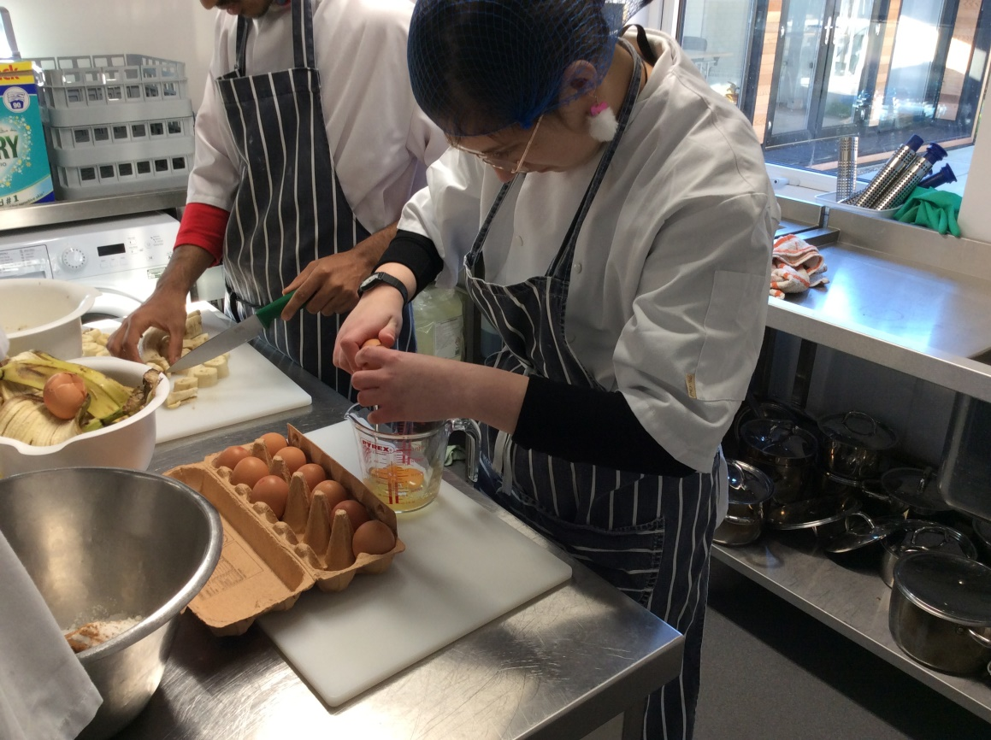

Thanushan cooking vegetable stew on the hob.

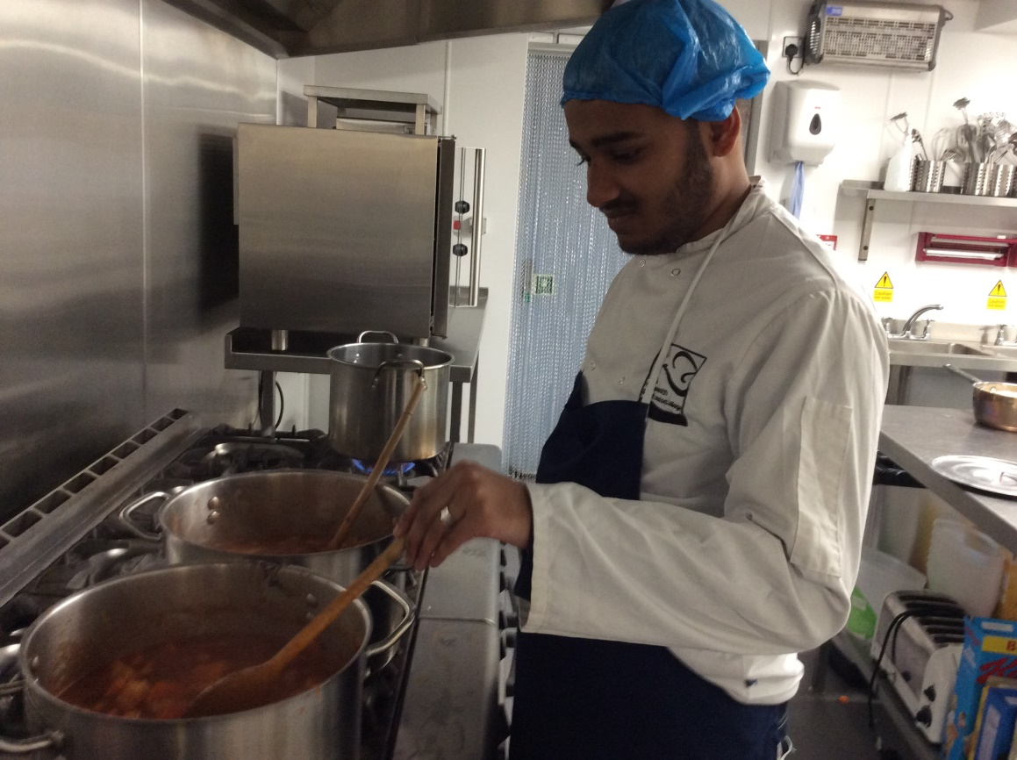

Sameer is peeling carrots while preparing vegetable hotpot.

