POST 16 NEWSLETTER – APRIL 2022

**LAST DAY OF TERM FRIDAY 24 JUNE**

BENEFIT LETTER
This is the time when the benefit office will be contacting certain families regarding what their child will be doing or where they will be going (e.g. which placement) in September 2022. Some letters will say that your child’s benefit will be stopping on September 5th. Please do not worry. After the holidays, we will have letters available for you to send off with your forms or we will help you to complete your form with a simple guide.

LEARNING/TRANSITION CONVERSATIONS
Monday 28 March – Friday 1 April. Thank you to all our parents/families who attended the spring transition/learning conversations. Our staff really enjoy the relaxed interactions with students and their families discussing a range of personal information, as well as sharing educational updates and feedback about individual students. If your child is a leaver you will have discussed your child’s transition options and requests. If your child is staying at Belvue you will have been reminded that from September your child will be attending Post 16 at the main Belvue site on Rowdell Road.

EMPLOYABILITY WEEK
This year’s Employability Week was a huge success. Students engaged with a range of employers (e.g. working in green spaces, retail, hospitals) and learnt a number of employment skills through a number of practical sessions (e.g. first aid, CV writing, interview skills, catering) to help them in the future. Students also visited different places of employment including the Fair Shot Café specialising in supporting young adults with a learning difficulty to have meaningful paid employment.

EXAMS/COURSEWORK
All students’ coursework and exams should be completed, marked and sent to the examiners by summer half term. We will receive the results in the summer and certificates in the autumn term. Any leavers certificates will be posted out to them by November.

MENCAP SATURDAY CLUB
The team meet at 10am at Dare2Dream, 1-2 Leeland Road, West Ealing, W13 9HH.

Activities, chosen by the group, include typical trips like:
- visiting local attractions,
- mini golf,
- bowling,
- trampolining,
- outdoor sports,
- companion cycling,
- entertainment venues and much more.

Attendance is free for young people not eligible for social care support.
Young people need to bring their own cold packed lunch and drinks.
The group does not meet during Easter, Christmas and Summer holidays.
Contact Aleks Rogozinska to book your place. aleksandra.rogozinska@ealingmencap.org.uk 020 8566 9575.

RESIDENTIAL
Monday 16 – Friday 20 May. Thank you for returning your child’s medical form for the upcoming residential. There will be more information nearer the time with final instructions. In the meantime, if you have any queries please do not hesitate to contact the college or write a note in your child’s diary.

TRAVEL TRAINING
If your child is on school transport and you are interested in travel training, please contact the college and we will put you in touch with the travel trainers. They will send you a form to complete and will contact you when everything has been processed. Your child will need to have a valid Freedom Pass / Oyster Card before the process can begin.

FREEDOM PASS/OYSTER CARD
Please check and ensure that your child has a valid up-to-date Freedom Pass or Student Oyster Card 16+ or 18+, whichever applies at the time. All students need to have one for the beginning of the new academic year starting in September for Belvue, and for any leavers, for the new placement they will be transitioning onto.
If you need support with completing any of the forms let us know.

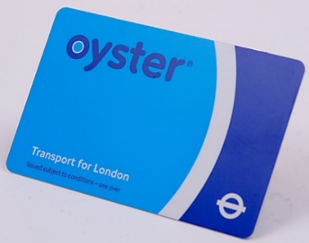

LEAVERS GRADUATION
Wednesday 22 June is the date of the Leavers’ Graduation. If your child is a leaver please ensure that you keep this significant day in your diary. It will be a memorable evening for leavers to say goodbye to Belvue and to share their memories of their life with us. Leavers will have the opportunity to see images of themselves from when they first started at Belvue until now. There will also be light snacks and drinks and time to say goodbye to friends and staff.

PROM
Thursday 30 June is the date for this year’s Prom. This is a wonderful time for students to dress to impress and have an evening of fun, food and dancing with their friends. The cost of the evening will be about £12. This will include an amazing range of things for your child’s entertainment: pre-drinks and snacks, celebratory photos, an evening meal, drinks, disco and goody bag.

*IMPORTANT ADVANCE INFORMATION*

Monday 4 – Monday 18 April Easter Holidays
Tuesday 19 April College Closed-Training Day
Monday 2 May College Closed-May Day
Thursday 5 May College Shopping Day
Monday 30 May-Friday 3 June Half Term
Wednesday 22 June Leavers Graduation Presentation
Friday 24 June Last Day of College-End of Year
Thursday 30 June Prom

APPOINTMENTS
If you would like to see your child’s VT/class teacher or Miss Gibson please write a note in your child’s diary or call the college office to book an appointment.
Ken Phone Number: 020 8422 0372 / Belvue Phone Number: 020 8845 5766
belvuecollege@belvue.ealing.sch.uk

