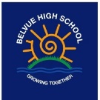

Intent

In RE we provide a curriculum that encourages students to experience, explore and engage with a broad spectrum of religions and belief systems.
Our RE is taught through sensory experiences, discussion and questioning that is designed to initiate sharing and debate, covering topics relevant to the world today. We encourage independent thought and allow our students the space to decide about, and give voice to, their own viewpoints.
Our aim is to develop reflective, discerning and religiously literate students who are able to construct informed opinions. Moreover we will focus on empowering them to demonstrate not only tolerance and respect towards the opinions of others, but also the differences between us.

Religious Education
Religious Education

Overview

Religious Education is unique in the school curriculum in that it is neither a core subject nor a foundation subject. However the 1988 Education Act states: “Religious education has equal standing in relation to core subjects of the national curriculum in that it is compulsory for all registered pupils.”
Belvue is a community school, therefore we deliver RE in line with the locally agreed syllabus, “Sowing the seeds of the future: an exploration of human beliefs and values.” Our aim is to ensure that pupils:
- Develop a knowledge and understanding of Christianity and its impact on our local community, and on our society today.
- Develop a knowledge and understanding of the other principle religious and non-religious belief traditions represented in Britain today.
- Learn to discriminate between those traditions, beliefs and practice that deserve respect, and practices and beliefs that can lead them into danger.
- Grow in their spiritual development.
- Develop a sense of awe, wonder and mystery.
- Develop skills and attitudes that will support their personal, moral, social and cultural development.
- Explore some questions of meaning and consider the different ways humankind has responded to them.
- Think about their own beliefs and values in the light of the beliefs of others—both religious and non-religious—and the values of the school community.

Cycle 1 | The Nature of Faith | Relationships and beliefs (Marriage) | Ethics and Equality Charity
 | Islam/Judaism/Buddhism  Lesson Focus Questions  - What do people celebrate? Why?  - How do people celebrate? How do I like to celebrate?  - Does everyone live in the same way? Why? | Christianity/Humanism/ Hinduism  Lesson Focus Questions  - Who do I care for?  - How do I interact with the people I care for? Do my beliefs change this?  - What do other people think? | Islam/Sikhism/  Humanism  Lesson Focus Questions  - What is right or wrong?  - What are the differences in us?  - Who needs help? Why?  - How can we look after others?
Cycle 2 | The Nature of Faith | Relationships and beliefs (Marriage) | Ethics and Equality Charity
 | Christianity/  Humanism/ Hinduism  Lesson Focus Questions  - What do people celebrate? Why?  - How do people celebrate? How do I like to celebrate?  - Does everyone live in the same way? Why | Sikhism/Judaism/  Buddhism  Lesson Focus Questions  - Who do I care for?  - How do I interact with the people I care for? Do my beliefs change this?  - What do other people think? | Buddhism/Christianity/Non-religious views  Lesson Focus Questions  - What is right or wrong?  - What are the differences in us?  - Who needs help? Why?  - How can we look after others?

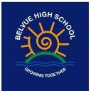
Religious Education

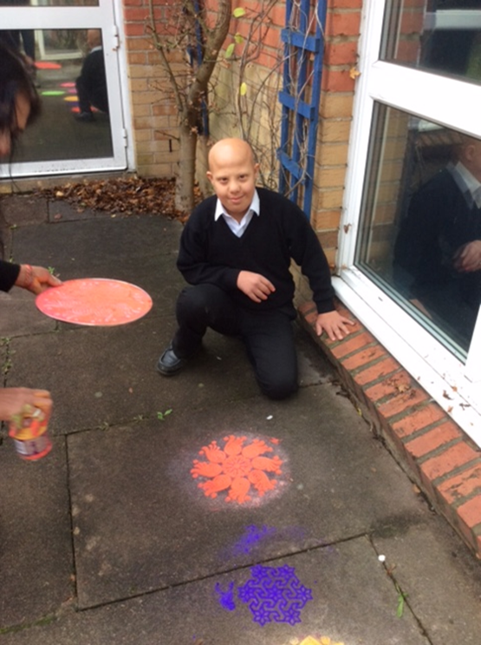
Learning about Diwali, creating Rangoli patterns

Learning about different Birth rites through role play such as what happens at a Christian Baptism 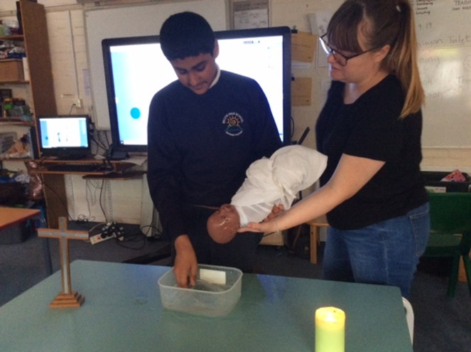
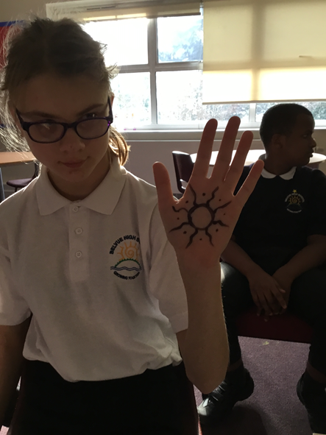
Learning about different wedding traditions such as the use of mendhi art in Islamic weddings

