Intent

In Food Technology we want to empower, excite and educate our students about food. We will give them vital life skills, encourage their creativity, develop their senses and expand their knowledge and experiences of food. By the time our students leave Belvue we want them to be as independent as possible: to be able to prepare food for themselves; to understand how to keep themselves healthy and to experience the social benefits of cooking and enjoying food with others.
Students will become familiar with the kitchen environment and develop an understanding of the safety and hygiene risks.
Students will learn to recognise and use basic kitchen equipment and basic ingredients. We aim to broaden student’s food experiences and enable them to enjoy multi-cultural dishes. Students will learn about the importance of a healthy balanced diet.
They will be encouraged to use cross-curricular skills, they have learned through English, Maths and Science lessons, when following and adapting recipes.
Students will also learn how to work as part of a team and enjoy the pleasures of eating and cooking together.

Food Technology

Food Technology

Overview :

Food technology involves seven key interwoven areas:

- Hygiene
- Safety
- Ingredients
- Equipment
- Food preparation
- Basic cooking
- Nutrition

Weekly Food Technology lessons are structured to embed these seven key areas. Hygiene and safety are rigorously reinforced on a weekly basis. Students are introduced to a variety of ingredients and equipment and there properties and uses are explored and explained. Food preparation methods are modelled and practised. These routinely entail knife skills, grating, peeling, weighing and measuring. Students are taught how to read and follow an ordered recipe. When cooking, students learn how to use the oven, hob, toaster or microwave safely and effectively. During lessons opportunities are taken to address the nutritional value of ingredients and meals. Fundamental skills, ingredients or principles from recipes are commonly repeated lesson to lesson to ingrain learning, facilitate progress and ensure sequentiality.
Key Stage 4 students follow the Edexcel Skilled for Life Programme of accreditations.
Cookery club helps to further students’ abilities, knowledge and enjoyment when working with food in a more informal and relaxed ambiance.

Term: Autumn | OVERVIEW: | Cross-curricular | Term: Spring | OVERVIEW: | Cross-Curricular
MLD:  - Hygiene and safety: handwashing; fastening aprons; using sharp & hot equipment, avoiding slips, trips & falls.  - Hygiene & safety: food storage  - Cleaning: washing up, drying up & cleaning surfaces  - Cleaning and drying: dish cloth and tea towel  - Basic recipes – hob, oven, grill & microwave  - Ingredients and nutrition: identifying ingredients  - Knowing your way around the kitchen |  | - Speech & Language  - Fine Motor Skills  - Listening & sequencing skills  - Geography & PSHE (multi-culturalism);  - Reading; Sequencing  - Science: heating  - PSHE- Healthy Eating  - Memory & listening skills | MLD  - Hygiene and safety – working safely in the kitchen  - Food labelling and safe storage  - Cleaning and drying  - Basic recipes – oven/grill  - Ingredients and nutrition: nutrient groups  - Weighing & measuring : measuring jug & weighing scales  - Taste testing  - Cross-curricular activities (incorporating Maths & Science) |  | - Listening and comprehension  - Sequencing  - Science: cross- contamination  - Geography & PSHE (multi-culturalism);  - Reading & Sequencing  - Science: cooking & nutrients  - PSHE – nutrition  - Maths – units; addition  - English- sensory describing
SLD:  - Hygiene and safety  - Cleaning and drying  - Simple snacks and meals – hob, oven, grill & microwave  - Ingredients and nutrition: healthy / unhealthy?  - Basic weighing and measuring |  | - Speech & Language  - Fine Motor Skills  - Listening & sequencing skills  - Geography & PSHE (multi-culturalism);  - Reading; Sequencing  - Science: heating  - PSHE- Healthy Eating  - Memory & listening skills  - Maths: units & addition | SLD:  - Hygiene and safety  - Cleaning and drying  - Food storage  - Simple snacks and meals – hob, oven, grill & microwave  - Ingredients and nutrition  - Basic weighing and measuring  - Taste testing |  | - Speech & Language  - Fine Motor Skills  - Listening & sequencing skills  - Geography & PSHE  - Reading; Sequencing  - Science: heating  - PSHE- Healthy Eating  - Memory skills  - Maths: units & addition
SLD complex  - Hygiene and safety: washing hands; aprons on  - Cleaning and drying  - Basic snacks and meals: toaster & hob  - Ingredients and nutrition  - Counting: sets of ingredients |  | - Speech & Language  - Fine Motor Skills  - Listening & sequencing skills  - Reading; Sequencing  - PSHE- Healthy Eating  - Memory & listening skills  - Maths: sets; counting | SLD Complex  - Hygiene and safety: washing hands; aprons on ; hair tied back  - Hygiene and safety  - Cleaning and drying  - Snacks and meals: eggs  - Ingredients and nutrition  - Counting  - Tasting |  | - Speech & Language  - Fine Motor Skills  - Listening & sequencing skills  - Reading; Sequencing  - PSHE- Healthy Eating  - Memory skills  - Maths: counting  - English: sensory describing

Sumer | OVERVIEW: | Cross-Curricular
MLD:  - Hygiene and safety: bacterial growth  - Cleaning and drying : antibacterial spray, using appropriate cleaning products  - Basic recipes – hob, oven, grill & microwave  - Weighing and measuring  - Introducing new ingredients  - Adapting recipes |  | - Listening and comprehension  - Sequencing  - Science: conditions for bacterial growth  - Geography & PSHE (multi-culturalism);  - Reading & Sequencing  - Science: cooking & nutrients  - PSHE – nutrition  - Maths – units; addition  - English- sensory describing
SLD:  - Hygiene and safety: keeping clean  - Handwashing, aprons on, slips & trips  - Cleaning and drying  - Simple snacks and meals – using hob, oven, grill & microwave  - Counting and measuring  - Following simple recipes |  | - Speech & Language  - Fine Motor Skills  - Reading, Listening & sequencing skills  - Geography & PSHE (multi-culturalism);  - Science: heating  - Maths: units; counting
SLD complex  - Hygiene and safety: hand washing and aprons on  - Cleaning and drying  - Basic snacks and meals – using toaster, hob, oven, grill & microwave  - Counting and measuring  - Following simple recipes/visual or verbal instructions |  | - Speech & Language  - Fine Motor Skills  - Listening & sequencing skills  - Reading; Sequencing  - PSHE- Healthy Eating; staying safe  - Memory skills  - Maths: counting  - English: sensory describing

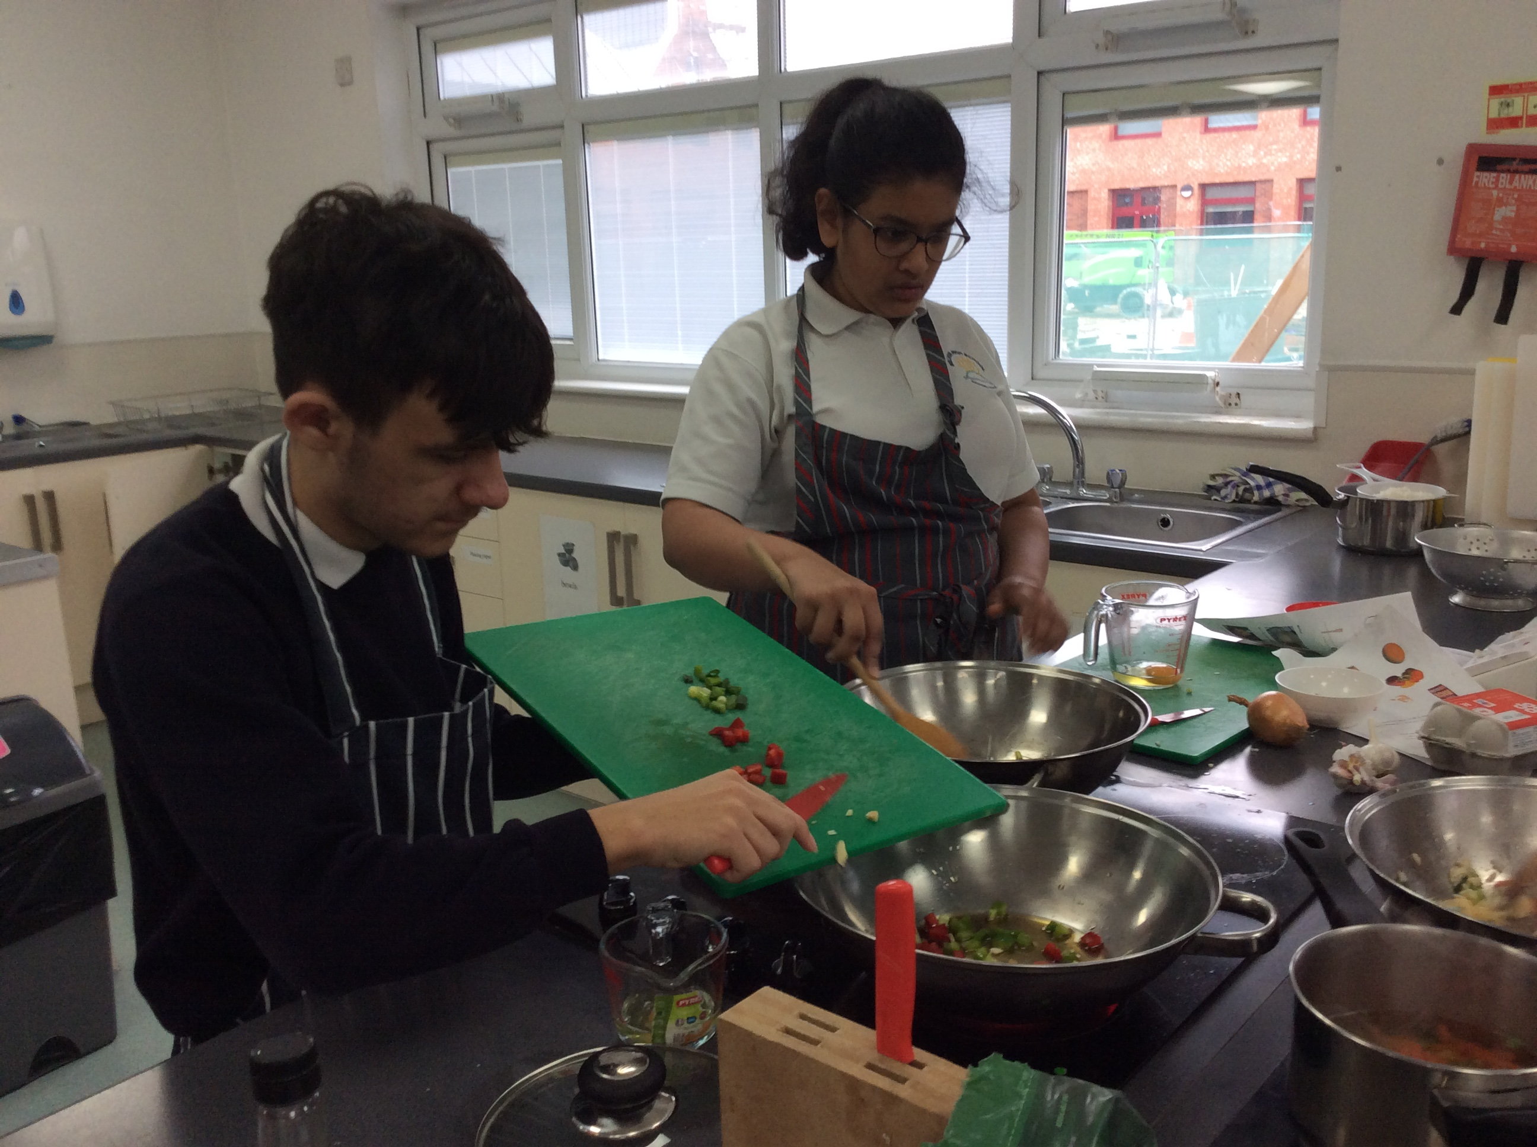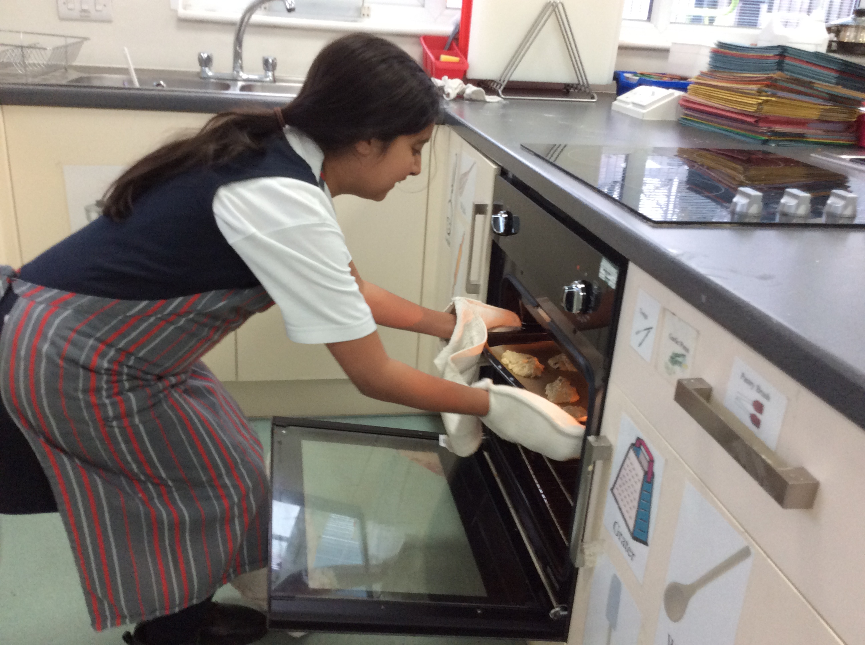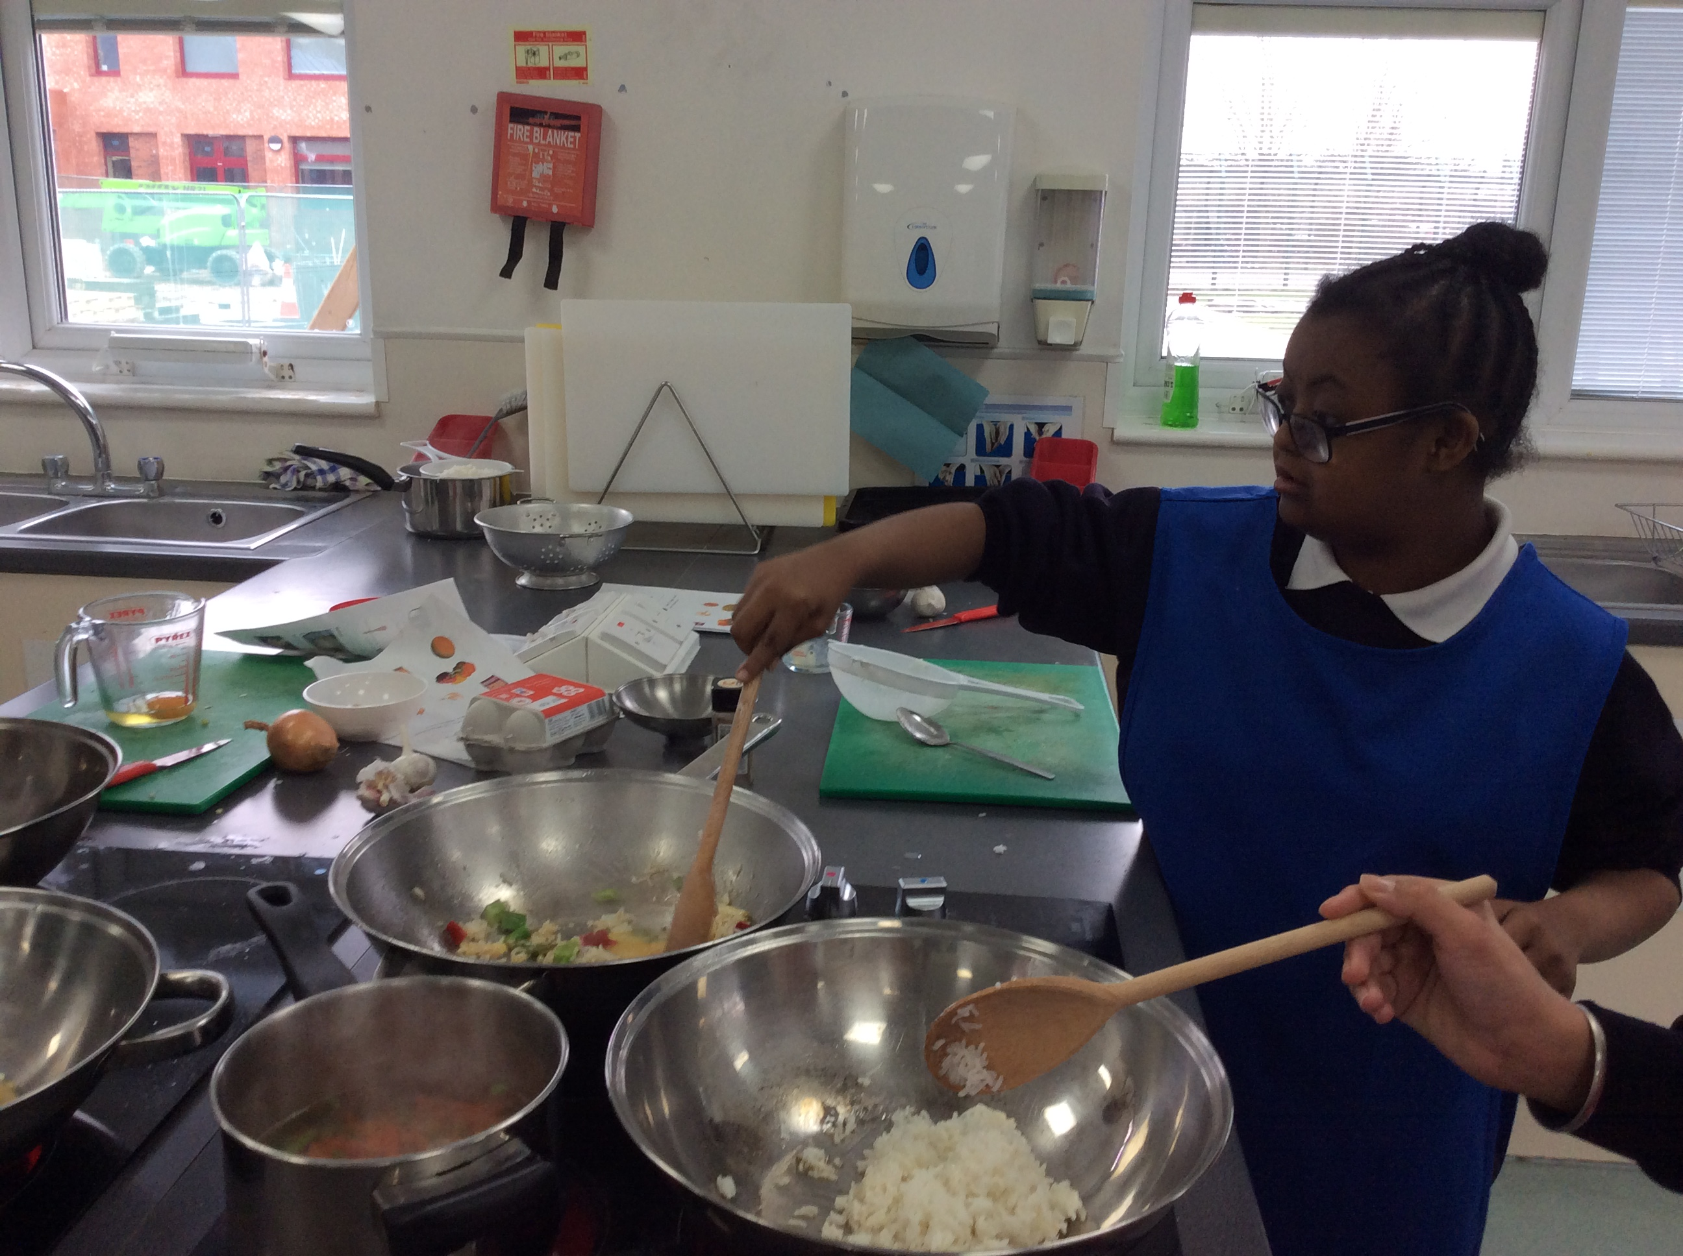
Food Technology

