Belvue High School SEN - Information Report

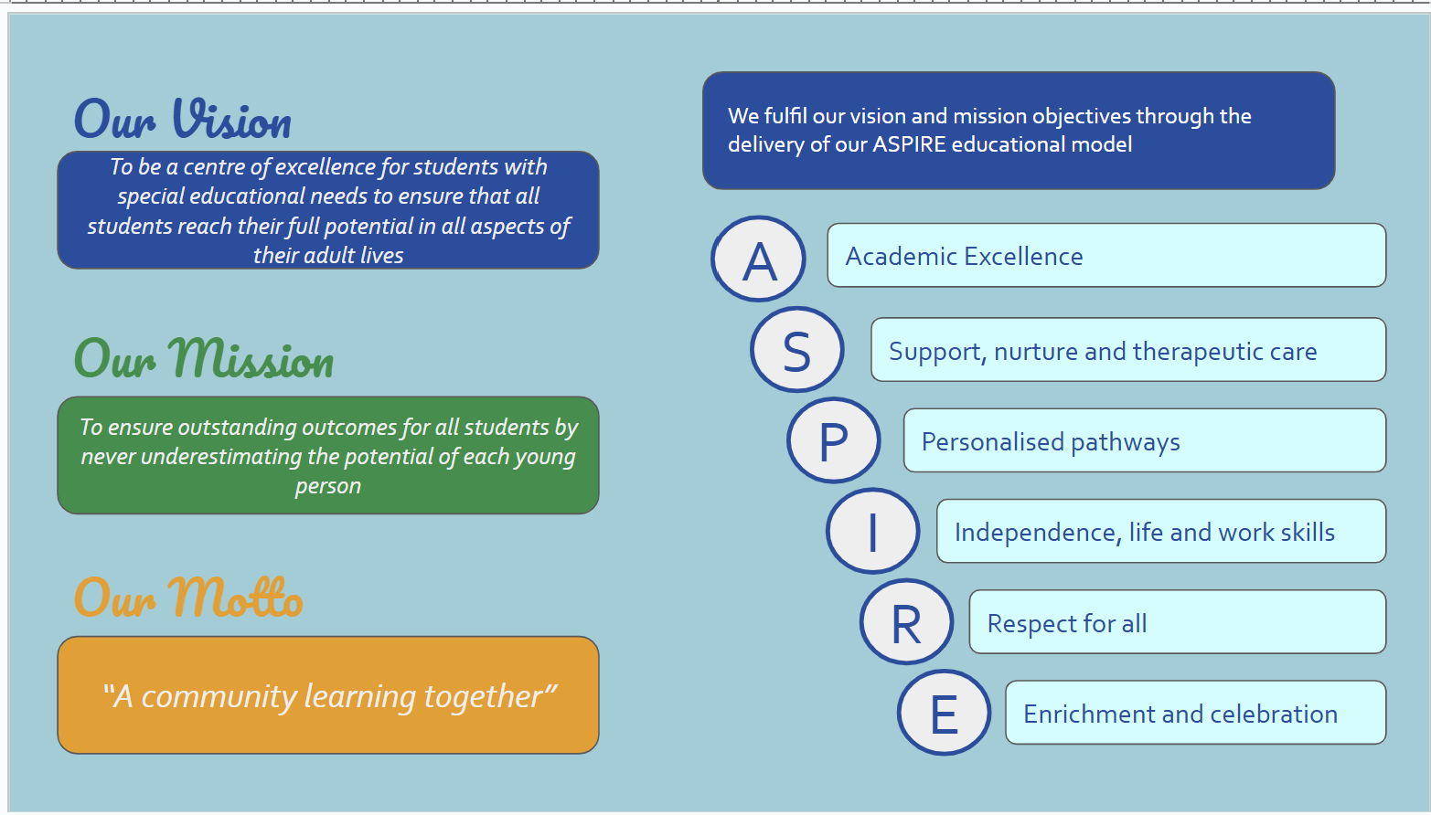

All schools must aim to meet the needs of pupils with Special Educational Needs and/or Disabilities to ensure that they make the best possible progress in school. The following is a summary of the many services Belvue School provides, to ensure young people make good and outstanding progress towards a fulfilled and successful life

SEN INFORMATION REPORT
Special Educational Needs provided for:
Belvue school is a special school for young people aged 11-19 with a moderate to severe learning difficult and associated needs including ASD. It’s a special place that offers individualised learning in small groups, supported by a range of therapies and other interventions as required.

Policies for identifying children and young people with SEN and assessing their needs.
Identification and assessment of pupils’ needs

- Regular review and assessment of pupils individual needs are ongoing
- The class teacher will liaise with relevant school based professionals and Local Authority SEND officers to facilitate any changes to the statement/EHC
- weekly staff meetings review pupil concerns and behaviour plans for relevant pupils; pupils who are identified as needing specialist provision will be referred to the relevant agency by the class teacher or linked family worker.
- A transparent referral system ensures that staff and home concerns are analysed by relevant specialists and if they meet established thresholds will result in additional support, monitoring and intervention being provided where possible
See Assessment Policy (available on the school website)
See SEN policy (available on the school website)
Arrangements for consulting young people with SEN and involving them in their education
The school provides the following support:
- Formal Parent/Carer meetings e.g. Termly Structured Conversation/Annual Review to which young people are invited to attend and contribute
- Pupil questionaires including an annual questionnarie as part of the review process
- School Council to support young people voice their opinions about the school
- Joint setting of weekly targets for behaviour and learning with class teacher and pupil
- Maths and English targets set yearly and reviewed and updated termly.
Arrangements for assessing and reviewing children and young people’s progress towards outcomes.
Parents and young people meet formally with their class teacher termly to discuss progress towards PLIMs targets. Young people meet annually with their class teacher to discuss progress towards the outcomes identified in the Education, Health and Social Care Plan.
Young people are assessed termly using Earwig KPIs and progress against their PLIMs targets. This information is shared with parents at the termly learning review.
See Assessment Policy (available on the school website)
Arrangements for supporting children and young people in moving between phases of education.
All children joining or leaving Belvue High School participate in a carefully planned transition programme to support their move between phases of education.

Pre-Admission and Induction
Preparation for entry to Belvue High School begins as early as possible. Prior to accepting a place, parents, carers and their child are invited to visit the school. This visit provides an opportunity to meet key staff, tour the facilities and gain an understanding of the school’s ethos and provision.

Once the school is names on a child’s Education, Health and Care Plan (EHCP), pupils are invited to visit the school for a further induction visit.

Information Gathering
The school’s Transition Coordinator visits feeder schools to observe and gather information about each pupil’s learning profile, as well as their medical, sensory, emotional and social needs.
Transition Events and Activities
The Transition Manager also coordinates a programme of transition events throughout the year, ensuring that all prospective pupils are supported in joining these. Transition opportunities may include:
- Participating in sporting, music, and arts activities
- Attending lessons and school lunches
- Watching the school summer show
First Day and Early Support
On the pupil’s first day at Belvue High School, parents and carers have the opportunity to meet their child’s class teacher to raise any questions or concerns. Following the first month, a transition meeting is held with a senior leader, class teacher and the assigned family worker. This meeting provides a review of the transition process and focuses on the individual needs of the child, starting an ongoing dialogue between school staff, parents and carers.
Moving to Mainstream High School
If, through this dialogue, it is agreed that a pupil may benefit from a move to a mainstream school, the school’s Transition Co-ordinator will, in consultation with parents, carers, and the receiving school, design a structured transition plan. This plan will outline the educational aims of the integration, the length of the transition period, transport requirements, and any support that will be provided.
Transitions Between Key Stages
Pupils moving between key stages within Belvue School will have opportunities to spend time with their new class prior to the move. Pupils with more complex communication and learning needs will also receive a personalised transition passport containing photos and key information about their new class or college.
Preparing for Leaving School
Pupils preparing to leave school will be supported through a range of targeted transition opportunities. These include:
- Attending a local college link course in their final year
- Meeting with the school’s Connexions Officer
- Participating in school-organised transition events
- Visiting local colleges and other post-16 providers
- Undertaking work experience placements (if appropriate)
- Liaising with adult services to support a smooth transition into adulthood
Preparation for adulthood.
Preparation for Adulthood
Preparation for adulthood begins as soon as pupils join Belvue School in Year 7.
All termly and annual review targets are aligned with the overarching outcomes outlined in the Preparing for Adulthood framework.
Curriculum and Opportunities
Pupils at Belvue High School participate in a wide range of tailored interventions to support their adult life. These include engaging in school-based mini-enterprises such as glass-making, horticulture and running the stalls at fayres. Pupils also gain valuable community experience by running a pop-up shop, working with elderly people and participating in community projects at Horsenden Farm. In partnership with Ealing Park Rangers, pupils also take part in conservation work at Hanwell Zoo.
By Key Stages 4 and 5, pupils access a broad range of vocational courses, some of which are delivered in partnership with local colleges. These courses include:
- Work Experience
- Catering and hospitality
- Independent living skills
- Hair and beauty
Work-Related Learning and Transition Support
From Year 7 onward, all pupils complete their own transition review as part of the Work-Related Learning curriculum, ensuring that all learning is focused on future adult outcomes.
The school collaborates closely with partner agencies to enhance this provision:
- Working with RESPOND and Image in Action to help pupils become sexually responsible.
- Partnering with the Local Authority independent travel trainers to support all pupils in becoming independent travellers.
- Liaising with Youth and Connexions to facilitate the Duke of Edinburgh Award and other leisure activities outside of school.
- Coordinating with local businesses to offer meaningful work experience placements for pupils in Key Stages 4 and 5.
College and Post-16 Transition
In Key Stage 5, pupils have the opportunity to participate in college link courses and complete work experience. Visits to a range of local Post-16 providers ensure that they can make informed decisions about their future. Our strong partnerships with local colleges help prepare pupils for a successful transition to further education. We collaborate closely with the local authorities' careers services to ensure that all students have an interview about their future and support students and families throughout the different stages of the transition process. Additionally, we host an annual transition event where local providers present their services to families.
Annual Reviews and Ongoing Support
From Year 9 onward, transitional reviews are a core part of each pupil’s annual review process. Pupils meet regularly, both individually and in groups if appropriate, with the school’s Connexions advisor to explore options for further education, employment, independent living and leisure. Learning conversations with parents and carers take place at these reviews, and multi-agency working is initiated as required.
To further support transitions, the school provides:
- Social skills and communication groups
- Individual and group Connexions advisor meetings
- Transition visits to Post-16 providers
- Opportunities for extended work experience in Key Stages 4 and 5
See Post-16 Policy (available on the school website)
See Work Experience Policy (available on the school website)

The approach to teaching children and young people with SEN
Each class is led by a teacher and supported by two teaching assistant, with a Minimum of 6 pupils or a maximum of 14 pupils per teaching group. All staff participate in an ongoing and extensive programme of professional training and development.

In line with national guidance, the school adopts a multi-disciplinary approach. Staff work collaboratively with a range of professionals, including Occupational Health, Speech and Language Therapists, Music Therapists, Educational Psychologists and Counsellors. Individual therapy programmes, including behaviour support, are integrated into lessons wherever possible to enhance the learning process.

Teaching is delivered through a balance of whole-class and small-group instruction. Short-term interventions in literacy and Maths are offered and reviewed via our internal referral system. The core subjects of Mathematics, English are typically taught by the class teacher, while specialist subject teachers deliver the full range of National Curriculum subjects.

Assessment for learning is embedded across the curriculum. To support pupils in reviewing their own progress, each student is provided with a personal learning journey for every subject studied.

The Key Stage 4 and 5 curriculum offers a broad range of vocational education options, such as Hospitality and Catering, Horticulture, Construction and Retail. The school also maintains strong links with a number of mainstream secondary schools to provide flexible integration and reintegration opportunities.

Additionally, the school offers a rich extended schools programme to enhance the curriculum. These opportunities include sessions in music, cooking, sport, forestry and conservation.
The different types of support that may be available for young people at this school?
Area of needs | Whole school ethos and  practice | Possible focussed support for some children’s additional needs | Possible support and intervention for a small number of children.
Social, mental and  emotional health needs | - Consistent application of the school’s behaviour policy  - A positive supportive and nurturing environment  - PSHE curriculum  - Vertical tutoring/Family group  - A commitment to a range of therapeutic interventions | - Early identification of need  - Support and advice from outside agencies  - Adapted curriculum to enhance engagement  - Targeted support to build relationships and social engagement  - Access to trained family workers, mentors, counsellors, and therapists to reduce barriers to inclusion | - Interventions using the "assess, plan, do, review" cycle  - Referrals to CAMHS with parental engagement  - Therapeutic group sessions to promote social skills and emotional resilience  - Personalised adjustments to the environment and unstructured times  - Behaviour/Pastoral Support Plans
Speech, language,  communication and  interaction Needs | - Emphasis on developing speaking and listening skills across the curriculum  - SALT trained staff | - 1:1 phonics support  - Personalised classroom support  - Word-finding and Makaton signing groups  - SALT interventions led by school staff | - Speech and Language Therapist-led interventions  - Targeted small-group teaching  - Access to personal ICT or adapted equipment  - Support from EP
Autistic spectrum Needs | - Structured day  Positive behaviour management  - Learning styles recognised and supported  - Differentiated lessons and visual supports | - Modified curriculum to suit learning style  - Individual coaching from class teacher and class tutor  - Supportive tools (visual timetables, social stories, workstations) | - Targeted small-group interventions  - Personalised intervention from SENs team  - Additional teacher and TA support  - Adapted communication systems and ICT
Cognitive and  Learning/Moderate  Learning Difficulties | - Differentiated, skills-based curriculum  - Multi-sensory learning approaches  - Development of visual, auditory, and kinaesthetic skills | - Modified curriculum to suit needs  - Targeted intervention programmes and small-group learning  - Personal learning plan with specific goals  - Learning support and access to adapted ICT  - 1:1 or small-group reading and literacy support | - Smaller teaching groups and extra teaching assistant support  - Specialist teaching  - Educational Psychologist input  - Personalised ICT and adapted recording options  - OT advice and intervention
Sensory and physical  needs (e.g. hearing,  visual impairment,  multi-sensory, physical  and medical needs | - Specialised equipment and seating  - Personalised care plans and SALT-trained staff  - Adapted curriculum and sensory profiles  - Partnership with Ealing’s integrated disability services | - Modified learning environment  - Therapy team support and OT interventions  - healthcare plan management  - Liaison with medical professionals and school nursing team | - Individual protocols and care plans  - Adjustments to the school environment and resources  - Personalised therapy programmes by qualified therapists  - Access to external advice and outreach from Ealing’s SENs team

The expertise and training of staff to support young people
All staff at Belvue High School have extensive experience working within the field of Special Education. Many hold Master’s degrees in Special Education or related disciplines, including Speech and Language Therapy (SALT) and TEACCH (Treatment and Education of Autistic and related Communication-Handicapped Children).

Our staff receive weekly training led by a range of professionals to continuously enhance their skills and keep practice up to date.
How we evaluate the effectiveness of our work:
- The school collaborates closely with the Local Authority’s School Improvement Partner, who monitors our work on a termly basis.
- Ofsted judged Belvue as “Good” with many outstanding features.
- Progress data is carefully analysed by school leaders and Governors.
- Parental feedback is gathered via annual questionnaires and at review meetings.
- Pupil voice is also gathered through regular questionnaires.
- Progress is reviewed regularly in Learning Conversations with parents and carers to ensure pupils make the best possible progress.
- Pupils accessing the National Curriculum at Level 1 and above in Key Stage 4 take accredited Entry Level qualifications.
- Further information on assessment and monitoring can be found in the school’s Assessment and Marking Policy.
Support for improving emotional and social development
Each pupil is part of a Class groups that meets twice a day. This system is built on fostering relationships that promote emotional literacy and strong moral and social group bonds.

We believe that emotional and social skills are caught, not taught, nurtured through positive, supportive relationships with adults who are highly attuned to the pupils’ emotional needs. By fostering deep connections and consistent care, class groups shapes the brain and behaviour of our learners, helping them grow into more emotionally aware and socially engaged young people.

Class groups:
- Develop emotionally supportive relationships with tutees
- Help pupils recognise and manage their own feelings
- Model empathy and positive interaction
- Encourage loyalty and social responsibility

We believe this emotionally intelligent model naturally develops into spiritual intelligence over time and is foundational to good teaching and learning.
How the school involves other bodies, including health and social care, local authority support services and voluntary sector organisation in meeting young people ‘s SEN and supporting their families.
Belvue School is supported by a range of on-site and visiting health professionals:
- Speech and Language Therapists
- Occupational Health Practitioners
- Clinical and Educational Psychologists
- Music Therapists
- Psychotherapists and Counsellors

Families can be referred to these professionals as required and can request a referral at any time.

The school also:
- Works closely with the School Nurse and visiting health specialists (e.g. diabetic and epilepsy nurse specialists).
- Employs Family Workers who liaise with all local and out-of-borough social care teams.
- Works closely with ESCAN (Ealing Service for Children with Additional Needs), including Educational and Clinical Psychologists.
Arrangements for handling complaints from parents about the provision made at the school
If parents or carers have any concerns about their child’s attainment, progress or wellbeing, they are encouraged to speak directly to the class teacher.

If a pupil’s progress is insufficient despite support, we will liaise with the Local Authority to review the EHCP.

As a special school, all Governors oversee SEN provision, so there is no separate SEN Governor. Information on the Governing Body can be found on the school website.
If you need to make a complaint
If parents wish to make a formal complaint or appeal a decision:
- Follow the school’s complaints procedure (available on the school website).
- Appeal to the SEN and Disability Tribunal against a Local Authority decision.
- Bring a disability discrimination claim against the school or Local Authority.
- Contact the Local Government Ombudsman with any complaints about school or LA services.

